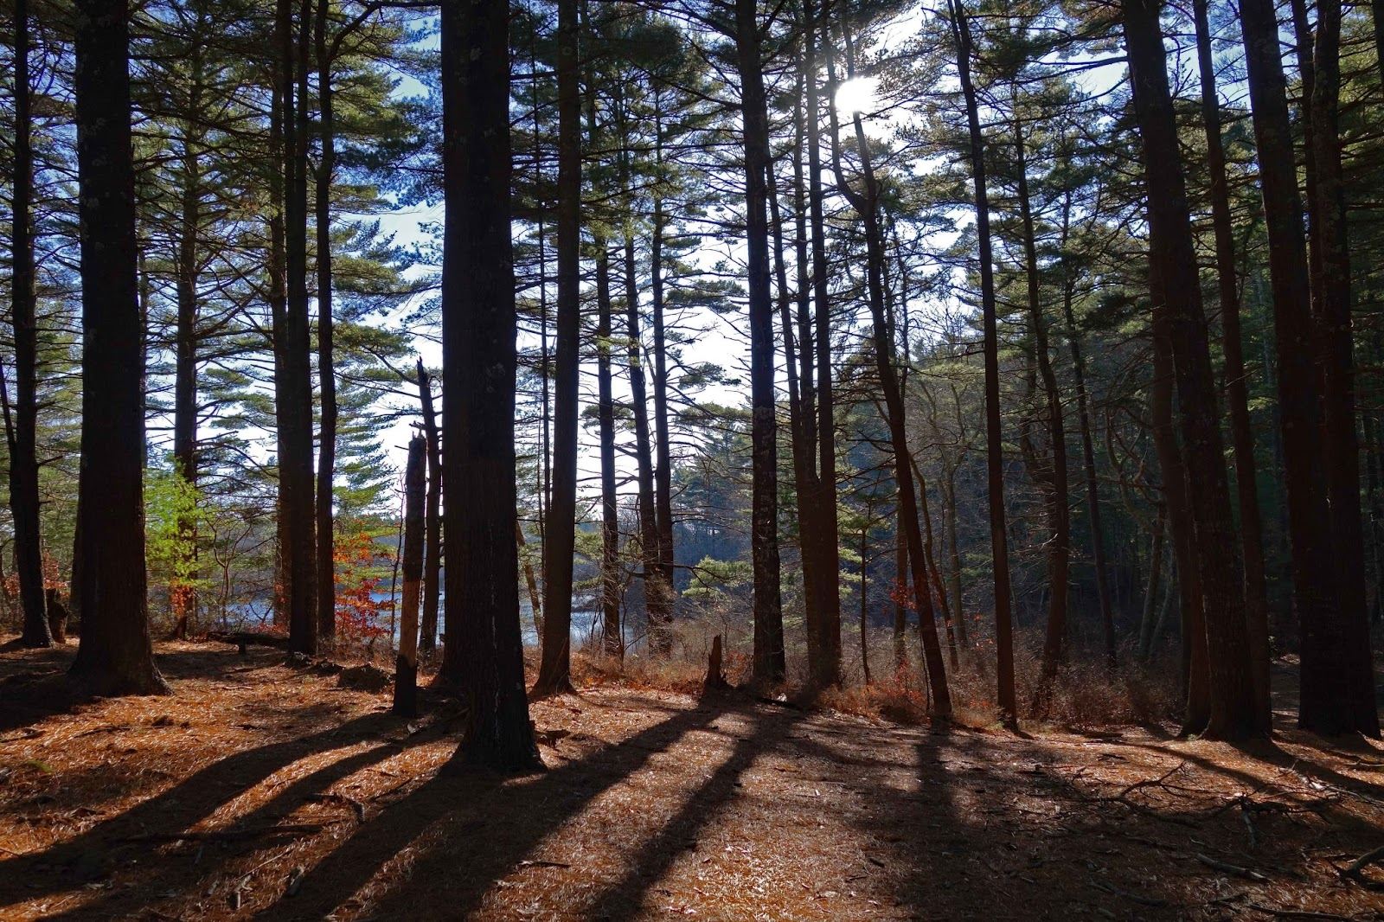

Northeast Self Advocates’

Leadership Retreat

DATE: Wednesday, June 26th

TIME: 11AM-4PM Cost: $5 (lunch)

WHERE: 84 Nelson St, Georgetown

Join self-advocates from the Northeast Region for a day to share your ideas, have fun and work together. We’re meeting at beautiful Camp Denison. To sign up call or e-mail Bridget at bridget@ma-advocates.org or 781-789-4274.

