Massachusetts Developmental Disabilities Council’s
Disability Related Bill Sharing Session.

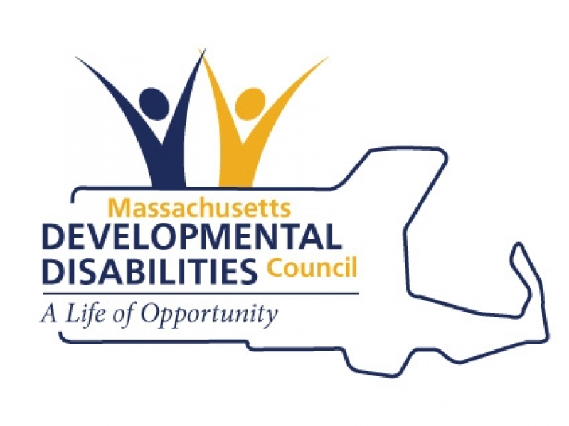

Date: Wednesday, February 6th
Time: 12:00 – 1:30 PM
NEW Location: 100 Hancock Street, Quincy, MA. 1st floor conference room
Parking: Visitor’s lot parking; if full, proceed forward to gate to get buzzed in to main lot

This event provides the opportunity for both policy makers and disability advocates to present disability related bills to the Council’s Policy Committee and the general public to gain support. It's also a great opportunity for disability advocacy organizations, legislators, and the general public to network and learn more about disability legislation that has been filed in the new session.

If you plan on presenting a bill, please send a copy of the bill text and fact sheet (if available) to Kristin Britton (Kristin.Britton@state.ma.us) by Friday, February 1st.

