Hello Northeast Folks,
Welcome to the month of April, which is the official start of Spring. Yay! I bet we are all looking forward to some warm weather, and sunshine.
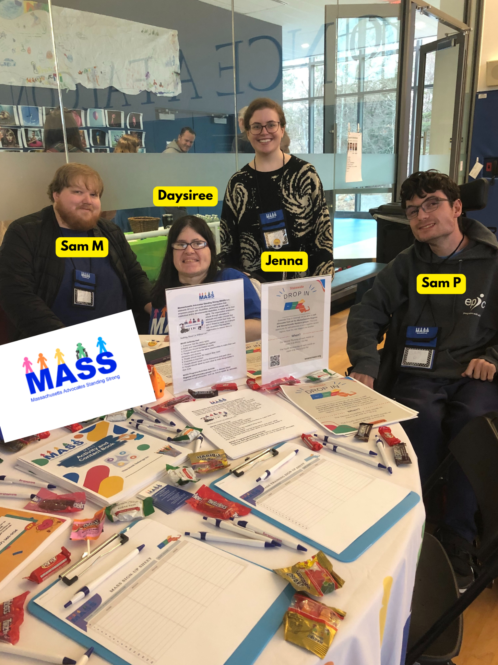
During the month of March, we had the wonderful opportunity to attend the Cotting School Transition Fair at Lexington. Regional facilitator Sam Muench, Regional Sergeant at Arms Daysiree, and peer Trainer Sam Paster all attended to represent the Northeast Region and MASS. Any opportunity to attend an in-person event is always welcomed! It was absolutely fun!

