Thank you to everyone who attended Rainbow events this June!

At our Virtual Pride Brunch we created this flag to show who we are in the Rainbow Groups:

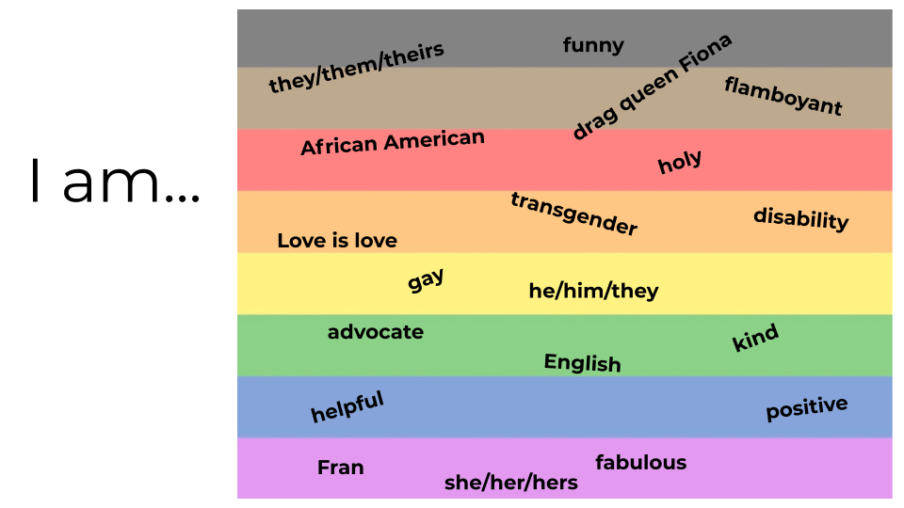

We hope to see you at our next online meeting on July 27th at 5:30pm-7pm

