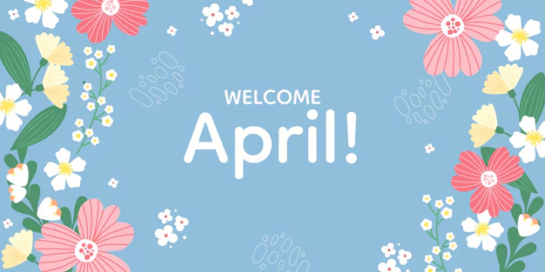
Hello Southeast Region,
Hope everyone had an awesome St. Patrick’s day. First of all I want to start off with some good news…this month we are going to have the Southeast Regional Meeting in person! It will be at the Lakeville Public Library. There will be a flyer in your email with all the information. We will also include the flyer down below too! I hope you will come and join us!
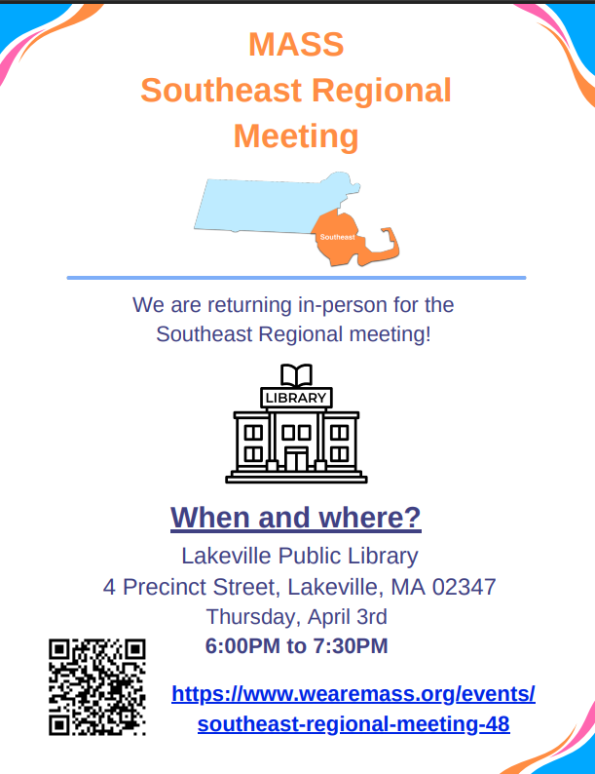

In other events, MASS went to the legislative reception. Just want to congratulate Senator Robyn K. Kennedy and Representative Sean Garballey for winning their awards and thank them for their work with people with disabilities!
We are still planning for the speed-friending event, but it will now be in June. We will let you know when we get more details.
I am still planning to do podcasts/interviews for the MASS Flash. If you are interested please let me know! You can contact us through the info@wearemass.org email address.

I hope everyone has a great Easter and stay safe everyone!


- Al, Southeast Regional Facilitator

