
Happy April from Central Region!
Central had a busy month of March, and we look forward to a busy April too!
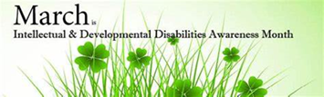
March was Intellectual and Developmental Disabilities Awareness Month and we also rocked our socks for
World Down Syndrome Day on March 21st. 
Some of us went to Legislative Day at the State House. Jillian talked with her legislator and got VIP parking! We saw a lot of people we knew, and we had a good time there! In March our Chill and Chat with Coffee group was all about St. Patrick’s Day and Mardi Gras! John also did some breathing and stretches with us. We had a lot of fun!
The Center for Living and Working gave a nice presentation on their services and advocacy at our March 25th regional meeting. At regional, we also have legislative updates with Justin, SDM updates with Beth, SARTAC updates with Kristin, MASS updates from Jillian and Jackie, and transportation updates from Jillian and others!
In April we celebrate World and National Autism months. 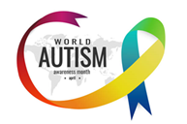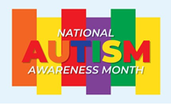 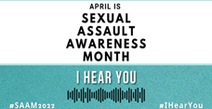 April is also Sexual Assault Awareness month.
And on April 20th each year we have coffee in memory of Janet Laperle. We call it “Janet Day”!
In April we are also looking forward to a transition fair at Open Sky and legislative breakfasts in Central.Come and join us for our April Chill and Chat with Coffee on April 3rd! Bring your coffee or other favorite drink! We always have some fun and games! Happy April, everyone!


