Director of Community Engagement

Who We Are:
The Nature Conservancy’s mission is to protect the lands and waters upon which all life depends. As a science-based organization, we create innovative, on-the-ground solutions to our world’s toughest challenges so that we can create a world in which people and nature thrive. We’re rooted in our Mission and guided by our Values, which includes a Commitment to Diversity and Respect for People, Communities, and Cultures. Whether it’s career development, flexible schedules, or a rewarding mission, there’s lots of reasons to love life #insideTNC. Want a better insight to TNC? Check out our TNC Talent playlist on YouTube or on Glassdoor.
Our goal is to cultivate an inclusive work environment so that all our colleagues around the globe feel a sense of belonging, and that their unique contributions to our mission are valued. We know we’ll only achieve our Mission by hiring and engaging a diverse workforce that reflects the communities in which we work. In addition to the requirements in our postings, we recognize that people come with talent and experiences outside of a job. Diversity of experience and skills combined with passion is a key to innovation and a culture of inclusion! Please apply – we’d love to hear from you. To quote myriad TNC staff members, “you’ll join for our mission, and you’ll stay for our people.”

What We Can Achieve Together:
The Chicago Area Conservation Program builds on the Conservancy’s science-based, collaborative, results-oriented approach, and its record of contributing creative and effective solutions to conservation challenges. We work to achieve benefits for people and nature in Chicago and neighbouring communities by increasing access to and engagement with urban nature, increasing urban biodiversity and improving community resilience and public health by implementing natural solutions as essential components of a healthy, just, climate-resilient city. All our work is done collaboratively in partnership with other leading agencies and organizations across Chicago and neighbouring communities and aligned with environmental and social justice priorities. As a part of the Chicago Conservation Team, the Director of Community Engagement will lead a team to develop, refine and implement strategies that increase collaboration with communities and maximize community benefits from conservation projects. The Director of Community Engagement will report to the Chicago Conservation Director. The salary range for this position is $76,000 - $85,000.

We’re Looking for You:
The Director of Community Engagement oversees the efforts of the Chicago Area Conservation Program to build relationships in communities across Cook County to advance conservation and community priorities. This position leads strategies on conservation projects that improve public health, resilience, and social cohesion of neighbourhoods where we work, while meeting organizational goals to address climate change and protect biodiversity. The Director of Community Engagement oversees the Conservancy’s community stewardship partnership with the Chicago Park District, our community engagement strategies at our Indian Boundary Prairies preserves in south suburban Markham, and our partnership with Illinois Nature Preserves Commission supporting the Volunteer Stewardship Network, supervising staff in these three programs. This position develops and strengthens relationships with organizations working at a regional and community scale, with an intentional focus on Black, Indigenous and People of Color (BIPOC) and other communities most impacted by climate change and social injustice.
RESPONSIBILITIES & SCOPE
- Cultivate and maintain relationships with communities and organizations that may have an environmental, faith, health, social justice, or environmental justice focus.
- Facilitate cross-learning between The Nature Conservancy, communities, and key partners to adapt conservation strategies and practices to be more equitable and people-focused
- Manage projects at various scales from neighborhoods to the Chicago region, encompassing multiple goals and coordinating the work of other professionals inside and outside the organization.
- Collaborate across functions with government relations, marketing, and development colleagues to ensure that communities are considered by and connected to internal planning and initiatives led by colleagues in other departments.
- Strengthen and expand existing strategies related to community-based conservation and volunteer stewardship in the Chicago area.
- Strengthen and develop emergent strategies connected to public health and other related areas.
- Engage the research community in evaluating and measuring human dimensions of conservation projects.
- Collaborate as part of a regional conservation team, to develop projects that integrate goals to expand natural infrastructure and environmental services and also build support for conservation to benefit people and improve biodiversity.
- Represent The Nature Conservancy at public outreach events, partnership meetings and on various committees that support community-focused conservation strategies, as needed.
- Supervise three full-time staff to achieve programmatic goals.
- Establish and maintain optimal performance standards within budget.
- Pursue and respond to relevant requests for proposal (RFPs) for grant funding and work with development staff to secure donor support.
- Local and occasional national travel, some evening and weekend hours.
- May work in variable weather conditions, at remote locations, on difficult and hazardous terrain, and under physically demanding circumstances.

What You’ll Bring:
- BA/BS degree in a related field and 4 years’ related experience or equivalent combination of education and experience.
- Hands on knowledge with best practices for community engagement and experience working with people in varied and diverse communities.
- Ensures a coordinated, equitable and strategic approach to purposeful community outreach and engagement.
- Experience and commitment to working across differences such as race, culture, disabilities, socio-economic class, and language.
- Experience in organizing and facilitating meetings and/ or trainings
- Experience managing complex or multiple projects, including staffing, workloads, and finances under deadlines.
- Supervisory experience, including motivating, leading, setting objectives and managing performance.
- Demonstrated experience in partnership development with community groups, non-profit partners, and/or government agencies.
- Experience writing reports and proposals.
- Experience using applications such as Microsoft Office: Word, Excel, Teams, and Outlook.

DESIRED QUALIFICATIONS
- Multi-lingual and/or cross-cultural experience appreciated.
- Awareness and experience in environmental and/or social justice related work.
- Familiarity with and some application of current and evolving trends in conservation in cities.
- Experience with volunteer management and natural area stewardship.
- Experience with mentorship of young adults.
- Equity-minded with a desire for continued learning about socio-historical context of racial, social and environmental injustice, questioning assumptions, and making evidence-based decisions a regular practice.
- Self-starter with the ability to generate work plans with limited support.
- Strong team player who can build relationships and work collaboratively across the organization and with program partners.
- Ability to build buy-in, influence, and rally partners toward outcomes.
- Knowledge and understanding of City of Chicago and Cook County’s political, cultural, and environmental NGO landscape.
- Demonstrated experience in successful grant development and/or other fundraising.

What We Bring:
Since 1951, The Nature Conservancy has been doing work you can believe in protecting the lands and waters that all life depends on. Through grassroots action, TNC has grown to become one of the most effective and wide-reaching environmental organizations in the world. Thanks to more than 1 million members, over 400 scientists, and the dedicated efforts of our diverse staff, we impact conservation throughout the world!

The Nature Conservancy offers a competitive, comprehensive benefits package including: health care benefits, flexible spending accounts, 401(k) plan including employer match, parental leave, accrued paid time off, life insurance, disability coverage, employee assistance program, other life and work wellbeing benefits. Learn more about our benefits at in the Culture Tab on nature.org/careers.

We’re proud to offer a work-environment that is supportive of the health, wellbeing, and flexibility needs of the people we employ!
This description is not designed to be a complete list of all duties and responsibilities required for this job.

Our Competencies:
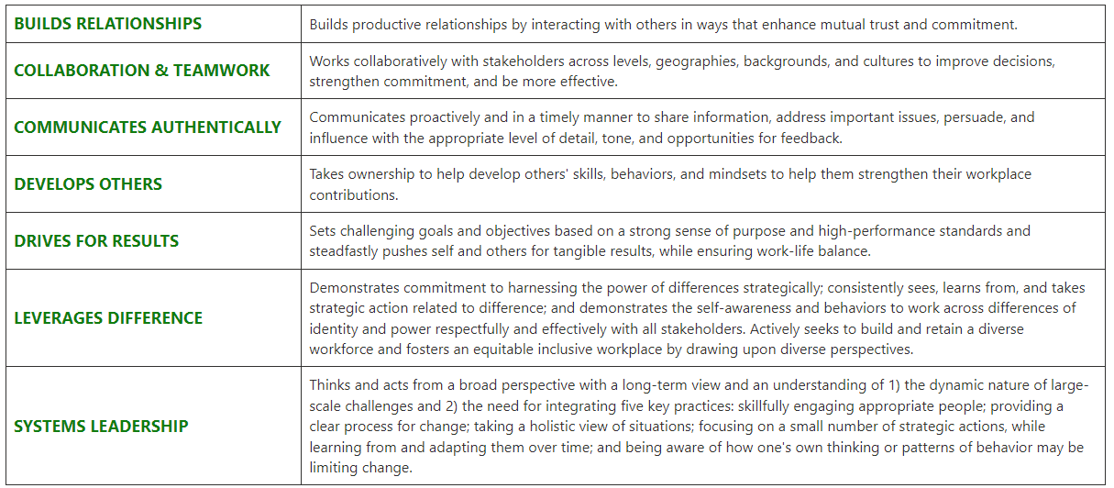

The Nature Conservancy is an Equal Opportunity Employer. Our commitment to diversity includes the recognition that our conservation mission is best advanced by the leadership and contributions of people of diverse backgrounds, beliefs, and cultures. Recruiting and mentoring staff to create an inclusive organization that reflects our global character is a priority and we encourage applicants from all cultures, races, colors, religions, sexes, national or regional origins, ages, disability status, sexual orientations, gender identities, military, protected veteran status or other status protected by law.
TNC is committed to offering accommodations for qualified individuals with disabilities and disabled veterans in our job application process. If you need assistance or an accommodation due to a disability, please send a note to applyhelp@tnc.org with Request for Accommodation in the subject line.

