Biological Science Technician Positions
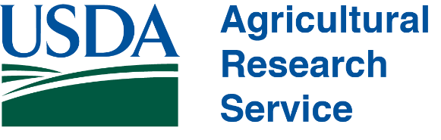
Are you looking for an opportunity to gain field experience regarding research, ecology and management in rangeland ecosystems? The Rangeland Resources and Systems Research Unit with USDA-ARS will be hiring field research technicians for the summer of 2022. The positions will be based in Fort Collins, CO, and involve daily travel to the Central Plains Experimental Range to collect vegetation and other ecological data from several experiments examining effects of cattle grazing management and native herbivores on rangeland dynamics. Work will involve measurements requiring the ability to rapidly learn plant species identification in the shortgrass steppe, and ability to work long hours under highly variable weather conditions in a treeless landscape. Additional qualifications include careful attention to detail when collecting repetitive measurements, positive attitude, sense of humor, coursework and field experience in ecological sciences, ability to work effectively as a member of a 4-7 person field team, and flexibility in work hours related to weather and experiment requirements.
Dates and Pay: May 16th to mid-August (start and end dates flexible depending on school calendar; May 16th start date preferred). Position is 40 hrs/week starting at $15.22/hr.
Applications: Please submit resume, unofficial transcripts, and 3 references by March 1st, 2022 to Nick Dufek, Nickolas.Dufek@usda.gov.
Please include in resume:
-Major/Minor -Relevant Experience -Relevant Coursework -Technical Skills
-Plant ID experience -Rangeland Experience
Submissions will be reviewed as received until positions are filled. US citizenship is required. USDA/ARS is an equal opportunity employer and provider.
