Community Stewardship Program Manager

Who We Are:
The Nature Conservancy’s mission is to protect the lands and waters upon which all life depends. As a science-based organization, we create innovative, on-the-ground solutions to our world’s toughest challenges so that we can create a world in which people and nature thrive. We’re rooted in our Mission and guided by our Values, which includes a Commitment to Diversity and Respect for People, Communities, and Cultures. Whether it’s career development, flexible schedules, or a rewarding mission, there’s lots of reasons to love life #insideTNC. Want a better insight to TNC? Check out our TNC Talent playlist on YouTube or on Glassdoor.
Our goal is to cultivate an inclusive work environment so that all our colleagues around the globe feel a sense of belonging, and that their unique contributions to our mission are valued. We know we’ll only achieve our Mission by hiring and engaging a diverse workforce that reflects the communities in which we work. In addition to the requirements in our postings, we recognize that people come with talent and experiences outside of a job. Diversity of experience and skills combined with passion is a key to innovation and a culture of inclusion! Please apply – we’d love to hear from you. To quote myriad TNC staff members, “you’ll join for our mission, and you’ll stay for our people.”

What We Can Achieve Together:
The Chicago Urban Conservation Program builds on the Conservancy’s science-based, collaborative, results-oriented approach, and its record of contributing creative and effective solutions to conservation challenges. We work to achieve benefits for people and nature in Chicago and neighbouring communities by increasing access to and engagement with urban nature, increasing urban biodiversity and improving community resilience and public health by implementing natural solutions as essential components of a healthy, just, climate-resilient city. All our work is done collaboratively in partnership with other leading agencies and organizations across Chicago and neighbouring communities and aligned with environmental and social justice priorities.
The Community Stewardship Program Manager will manage the Chicago Park District’s Natural Areas community stewardship program and supervise volunteers who perform restoration, conservation, monitoring, and engagement work. This position will be under the joint direction of the Director of Community Engagement (The Nature Conservancy) and the Natural Areas Project Manager (Chicago Park District).

We’re Looking for You:
The Community Stewardship Program Manager will be responsible for assisting Chicago Park District (CPD) staff to empower and engage community members to care for and activate CPD natural areas. The Manager will be responsible for education, recruitment, training, and coordination of a wide diversity of volunteers for stewardship activities such as assisting with ecological restoration and monitoring of species in natural areas, thus building upon the district’s capacity to accomplish such activities.

RESPONSIBILITIES & SCOPE
- Work with CPD staff, volunteer stewards, and partners to determine and coordinate volunteer activities in CPD natural areas
- Coordinate, advertise, and supervise stewardship workdays and special events.
- Recruit a diversity of individual and group volunteers through various methods such as relationship building, developing partnerships (e.g., with community organizations, community members, environmental organizations, businesses, park advisory councils, faith groups, and local schools), tabling at conferences and other events, and developing outreach and educational materials.
- Develop retention, recognition, and training opportunities for volunteers, including updating the community stewardship handbook.
- Recruit and supervise volunteer ecological monitors, coordinate training workshops, and maintain records of ecological monitoring activities.
- Maintain stewardship volunteer database, keep records of workday activities and attendance.
- Create an annual report, submit budgets, and contribute information for grants, press releases, and other materials to increase awareness of stewardship program.
- Work with CPD staff to develop work orders, workday management plans, and schedules.
- Assist CPD staff with projects such as interpretive signage, website updates, press releases, fact sheets, etc.
- Collaborate with the Chicago Area Program and other TNC networks as needed to contribute to program development and share best practices.
- Principal work location is the CPD office in Chicago, Illinois, with supplemental space at the TNC Chicago office. Due to the flexibility required in this position other work locations may be utilized from time to time. Work on weekends and some evenings will be expected.
- The employee will need to pass a CPD background check prior to employment.

What You’ll Bring:
- BA/BS/AS/Technical or vocational degree and 1-year related experience in community engagement and/or custodial and ecological land management or similar field; or equivalent combination of education and experience.
- Experience supervising staff and/or volunteers.
- Possession of a valid driver's license or obtain within 6 months of employment.
- Possession of Illinois Herbicide license or obtain within 6 months of employment.
- Ability to complete tasks independently under deadlines while delivering quality results.
- Working knowledge of common software applications (e.g., Word, Excel, Zoom, web browsers)
- Excellent communication skills via written, spoken, and graphical means. Ability to explain conservation practices to non-technical audiences.

DESIRED QUALIFICATIONS
- Combination of 5 years’ experience in natural resource management and/or community engagement, or equivalent combination of education and lived experience in a similar field.
- Experience working with or knowledge of natural systems in the Chicago region. Ability to recognize plant and animal species to implement management activities.
- Extensive experience working across differences such as race, culture, disabilities, socio-economic class, and language group. Multilingual or bilingual skills appreciated, particularly Spanish.
- Knowledge of current trends and practices in conservation, land management and natural resource preservation.
- Experience in volunteer management including recruiting, training and supervising volunteers.
- Experience working with multiple organizations and complex organizational structures.
- Experience with database management, promotional materials development, and social media.

What We Bring:
Since 1951, The Nature Conservancy has been doing work you can believe in protecting the lands and waters that all life depends on. Through grassroots action, TNC has grown to become one of the most effective and wide-reaching environmental organizations in the world. Thanks to more than 1 million members, over 400 scientists, and the dedicated efforts of our diverse staff, we impact conservation throughout the world!

The Nature Conservancy offers a competitive, comprehensive benefits package including health care benefits, flexible spending accounts, 401(k) plan including employer match, parental leave, accrued paid time off, life insurance, disability coverage, employee assistance program, other life and work wellbeing benefits. Learn more about our benefits at in the Culture Tab on nature.org/careers.

We’re proud to offer a work-environment that is supportive of the health, wellbeing, and flexibility needs of the people we employ!

This description is not designed to be a complete list of all duties and responsibilities required for this job.

Our Competencies:
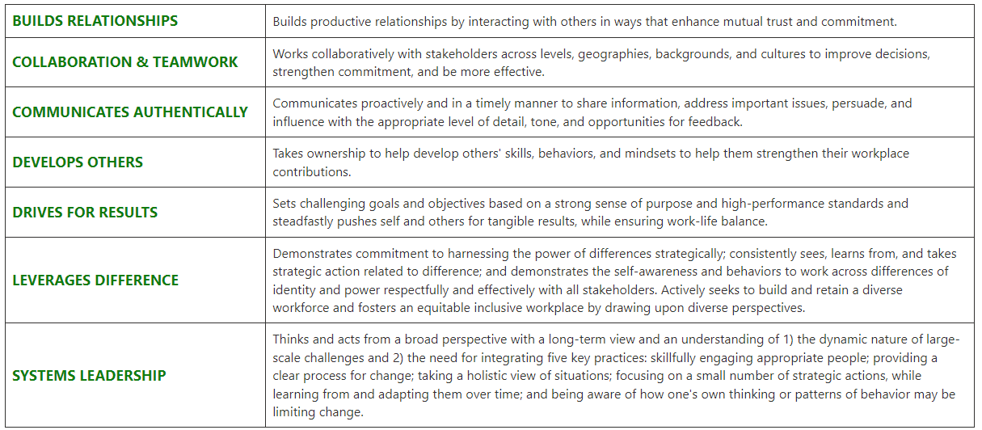
The Nature Conservancy is an Equal Opportunity Employer. Our commitment to diversity includes the recognition that our conservation mission is best advanced by the leadership and contributions of people of diverse backgrounds, beliefs, and cultures. Recruiting and mentoring staff to create an inclusive organization that reflects our global character is a priority and we encourage applicants from all cultures, races, colors, religions, sexes, national or regional origins, ages, disability status, sexual orientations, gender identities, military, protected veteran status or other status protected by law.
TNC is committed to offering accommodations for qualified individuals with disabilities and disabled veterans in our job application process. If you need assistance or an accommodation due to a disability, please send a note to applyhelp@tnc.org with Request for Accommodation in the subject line.

