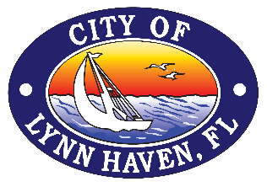
FOR IMMEDIATE RELEASE
September 4, 2024

LYNN HAVEN HONORING THE HEROES OF 9/11

LYNN HAVEN, FL -- The City of Lynn Haven will host its annual 9/11 Remembrance Ceremony on Wednesday, September 11th, beginning at 9:00 a.m. at Sharon Sheffield Park, located at 901 Ohio Avenue, Lynn Haven, FL.

The ceremony will include remarks from city officials and guest speakers followed by a First Responder’s Remembrance Drive conducted by the Lynn Haven Fire and Police Department. The city will provide a limited number of chairs on the lawn; however, attendees are encouraged to bring their chairs and blankets.

City Manager Vickie Gainer invites everyone to join us as we honor the fallen heroes and first responders of 9/11. “We invite the community to join us for the 9/11 ceremony as we honor the brave men and women who made the ultimate sacrifice. This gathering is a time to remember our fallen heroes and show our collective commitment to never forget.”

For more information on the ceremony, please contact the Marketing & Communications Department at 850-248-0483 or communications@cityoflynnhaven.com.

