  - Media Toolkit

Wisconsin Promise is pleased to present…

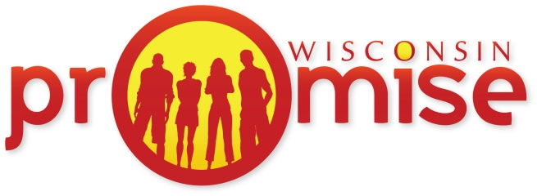
Cody’s Story

We invite you to help us share some of the experiences of Wisconsin Promise teens and families. Use this toolkit to help us get the word out through your website, social media, newsletters, email listservs, or just share with a friend!

Social Media Graphics
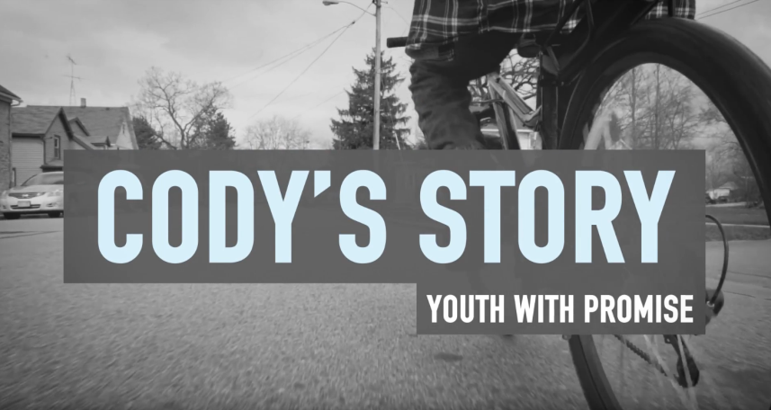
Feel free to use these in your social media posts!

Social Media Content: #PromiseWIStories

Post for Facebook
Meet Cody – a teen with promise…
Cody is excelling as a student at #Burlington High School and employee at #McDonalds. He plays video games, rides bike, and is learning to drive and weld. His goal is to be a welder after college. Cody was born with a brain tumor, but that’s not stopping him. He’s a youth with @wipromise, on a journey to achieve his personal, educational, and career goals. https://promisewi.com/ #PromiseWIStories #Wisconsin #McDonalds

Post for Twitter
Meet Cody – he dreams of driving his own car and becoming a welder. His story @WI_Promise http://bit.ly/2nnievN #PromiseWIStories

Post for LinkedIn
Meet Cody – excelling as a student from #Burlington and employee at #McDonalds. He plays video games, rides bike, and is learning to drive and weld. His goal is to be a welder after college. Cody was born with a brain tumor, but that’s not stopping him. He’s a youth with @wipromise, on a journey to achieve his personal, educational, and career goals. https://promisewi.com/

Sample Content for Blogs, Emails, and Newsletters

Meet Cody – a teen with promise…
Cody is excelling as a student at #Burlington High School and employee at #McDonalds. He plays video games, rides bike, and is learning to drive and weld. His goal is to be a welder after college. Cody was born with a brain tumor, but that’s not stopping him.

He’s a youth with @wipromise, on a journey to achieve his personal, educational, and career goals. Watch Cody’s story: https://promisewi.com/ #PromiseWIStories #McDonalds

