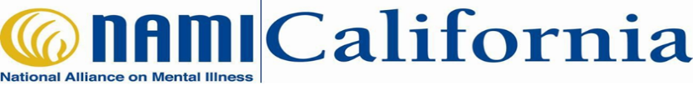
Cultural and Linguistic Responsiveness Toolkit Webinar Training

This webinar trains participants how to effectively engage diverse racial and ethnic communities. Affiliates, partners, and city and county staff are invited to attend this free webinar training on NAMI CA’s Cultural and Linguistic Responsiveness Toolkit. All webinar training sessions are guided by trained presenters and provide opportunities for live participant interaction.

Information in the Toolkit Webinar Training includes:
- National Cultural and Linguistically Appropriate Service (CLAS) Standards
- Principles of Community Engagement
- NAMI Affiliate Common Challenges and Suggested Strategies
- Listening Session Recommendations
- And much more!

Training times and dates:
- May 18, 2018 from 5:30PM-7:30PM
- June 14, 2018 from 2:00PM-4:00PM

Sign up today!

To register for the webinar, please contact:
Catherine Chivers
Community Engagement Coordinator
catherine@namica.org

