Best Field Trip EVER!
On a beautiful fall morning in October, about twenty of us, mainly from the St. Paul Area Synod’s Care of Creation Team, descended on Walker Farms in Princeton, MN in an effort to learn more about Regenerative Farming. Brothers George and Andy Walker are second generation farmers who have chosen to focus on implementing regenerative agricultural practices in order to “build soil organic matter, microbial population density and diversity, and sequester carbon.” https://walkerfarmsmn.com
George and his wife, Anneliese, took all the time we wanted to answer all of our questions, share a wealth of information with us, and show us around their operation. He explained that soil is a DEgenerated resource; hence the need for REgenerative Ag as opposed to Sustainable Ag. A couple of key ingredients in Regenerative Agriculture are no till – to maintain the carbon in the soil and leave mycorrhizal networks intact, and using cover crops to reduce erosion and pull more carbon into the soil. “It’s all about bio-mimicry,” George said, and “re-engaging the livestock with the landscape.” When local landowners found out what they were up to, they sought out the Walkers to lease land and revitalize their soils too; the Walkers are regenerating soil they don’t even own!
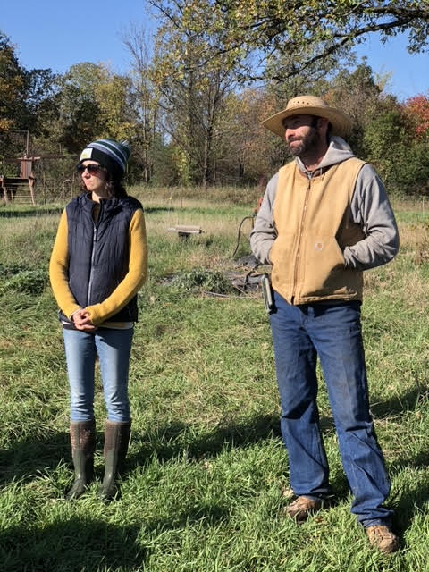
Anneliese and George Walker of Walker Farms
When farmed successfully, the microorganisms in the soil return to health along with bugs, worms, and butterflies. Imagine someone being excited about dung beetles and weeds! “The weeds tell you something about your soil.” George explained that a seed could lie dormant for centuries until the soil had what it needed to thrive. When certain weeds show up, George knows he’s regenerating healthy soil. These healthy weeds also have deep roots and can withstand droughts as well as help the rain get down into the soil. As George learned from Gabe Brown, a pioneer in the soil-health movement, “It’s not about how much rain you get, it’s about how much you keep.”
The land upon which the Walkers’ animals are grazing had been row-cropped for 40 years, including all the tillage and chemicals that traditionally go along with that practice. Now, there are cattle, pigs, sheep, turkeys, and chickens living on these lands, doing what they would do in nature: grazing, rooting, scratching and depositing manure in turn. As they are moved around the farm, they leave their “fertilizer” behind, which eliminates the need for fossil fuel-based fertilizers.
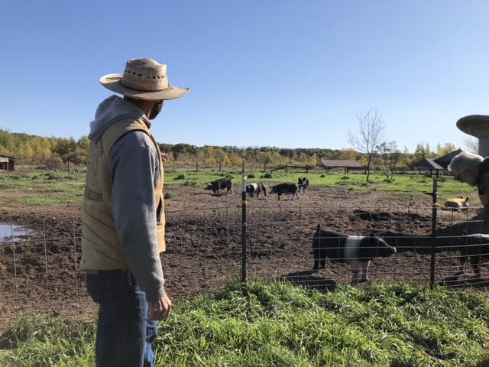
Our first stop was a visit to the pigs. Now I know where the term, “happy as a pig in mud” comes from, as they seemed to be having a heck of a good time. George says the animals on their farm “live their best life, then have one bad day, and let’s face it, we will all have one bad day eventually.” The pigs will take the land down to bare dirt and mud, but at the end of our tour, we were shown the place where the pigs had been located five weeks prior, and the weeds were 2’ tall!
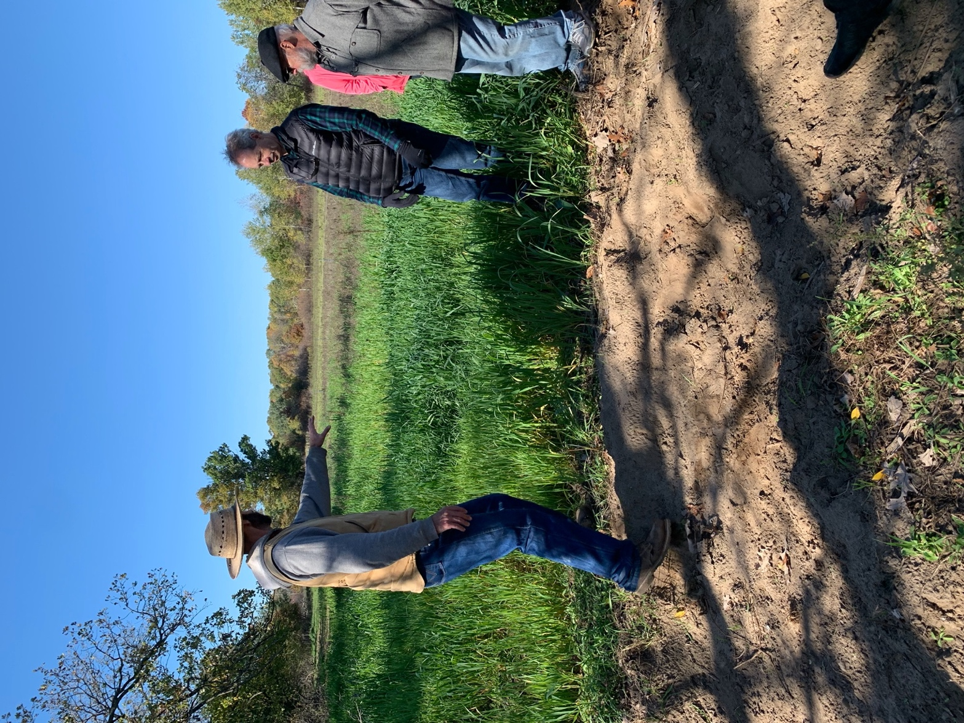
George shows us the land where the pigs had been five weeks ago (background) vs. more recently (foreground).
We followed George into the pasture where the fowl were and witnessed him perform one of his daily chores: climb onto the tractor connected to the turkey coop, start it up, drive about 25 feet, pulling the shelter (and the turkeys walking along inside) the length of the coop, and shut it back down. Just like that, they had fresh land to graze. The chickens moved right in behind to see what the turkeys had left them. While most of the stock was confined to their various pens, the chickens were the only ones that were truly free-range, staying nearby only for shelter and feed. Just a footnote, George said he could run his whole operation with a pickup truck and a 4-wheeler! The tractor is just something they have from the past, and it’s handy to leave in place for the daily turkey pull.
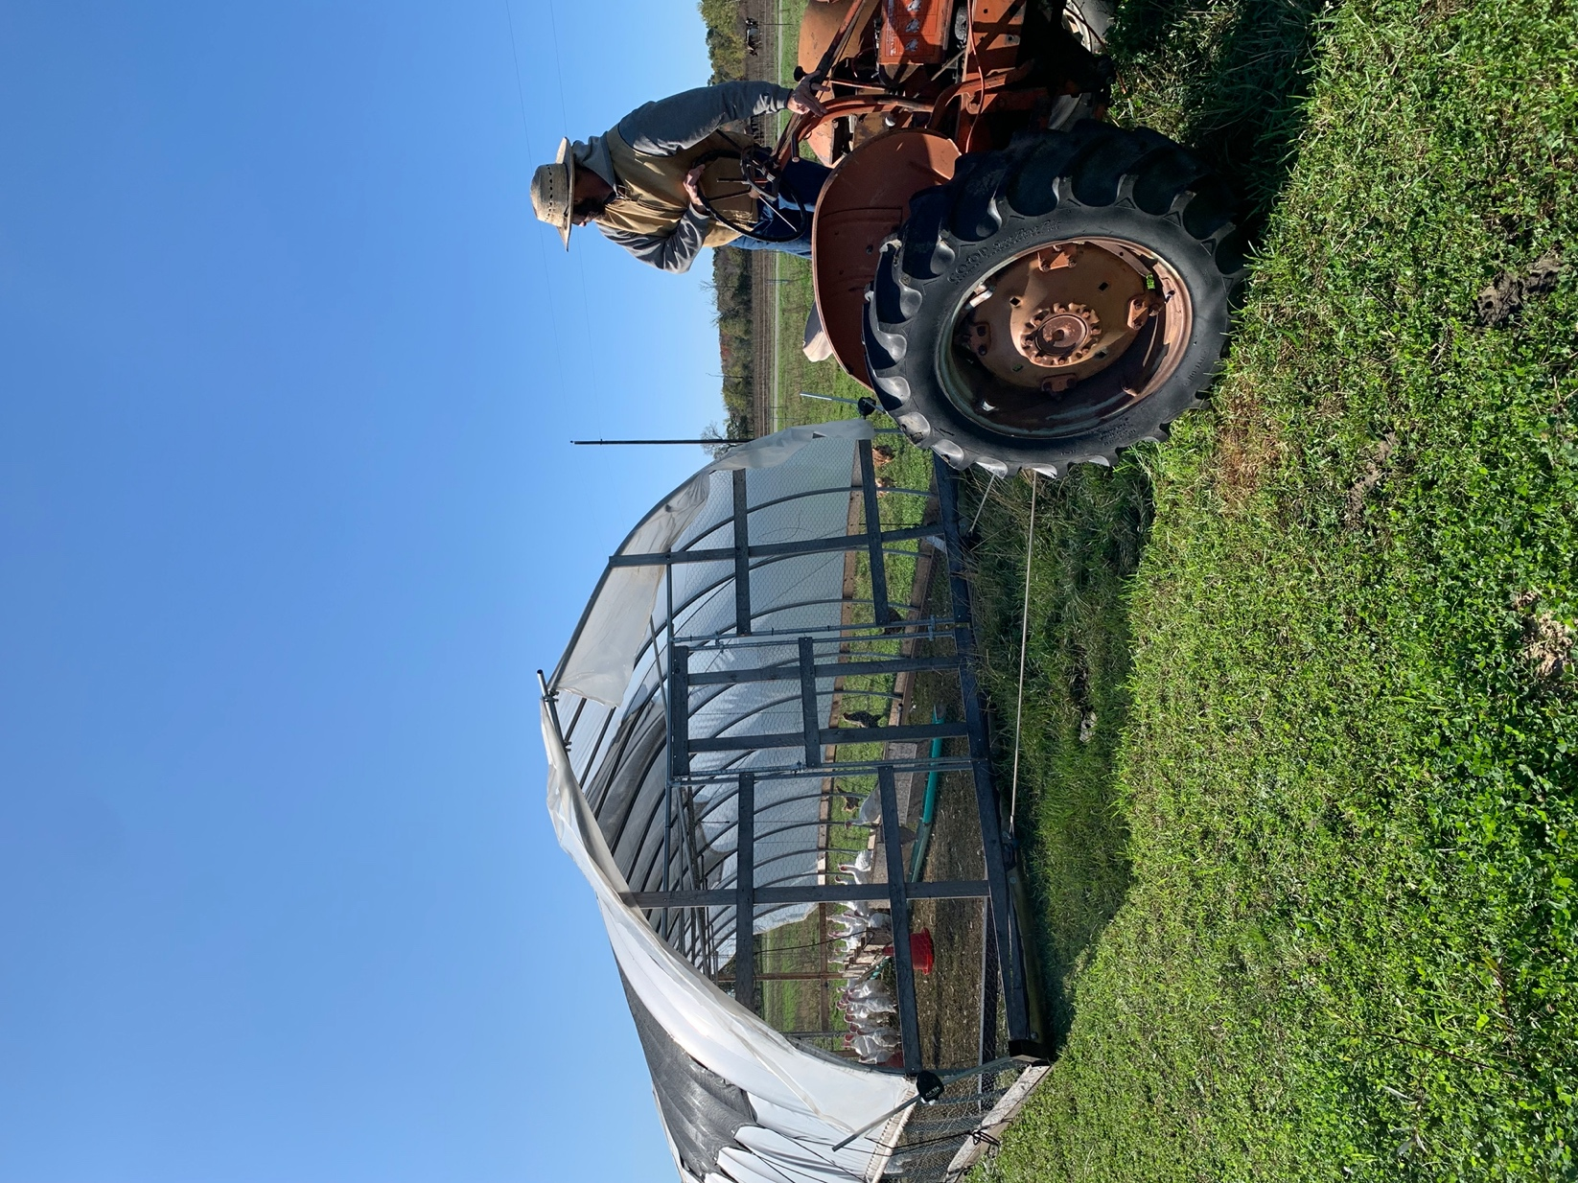
George moving turkeys to fresh pasture.
We then crossed the driveway, entered into the cattle pen, and watched as the joyful cattle RAN into the fresh pasture as George opened the way. When people hear about moving cattle on a daily basis, they think it sounds like a lot of work. Other than poking a line of stakes into the dirt and running wire for the new boundary, the cattle do the rest with no encouragement. When the animals are eating natural plants and bugs, they are getting nutrition not found in the diets of confined animals that are stressed and living in their own filth. This nutrition is passed along as humans eat the meat.
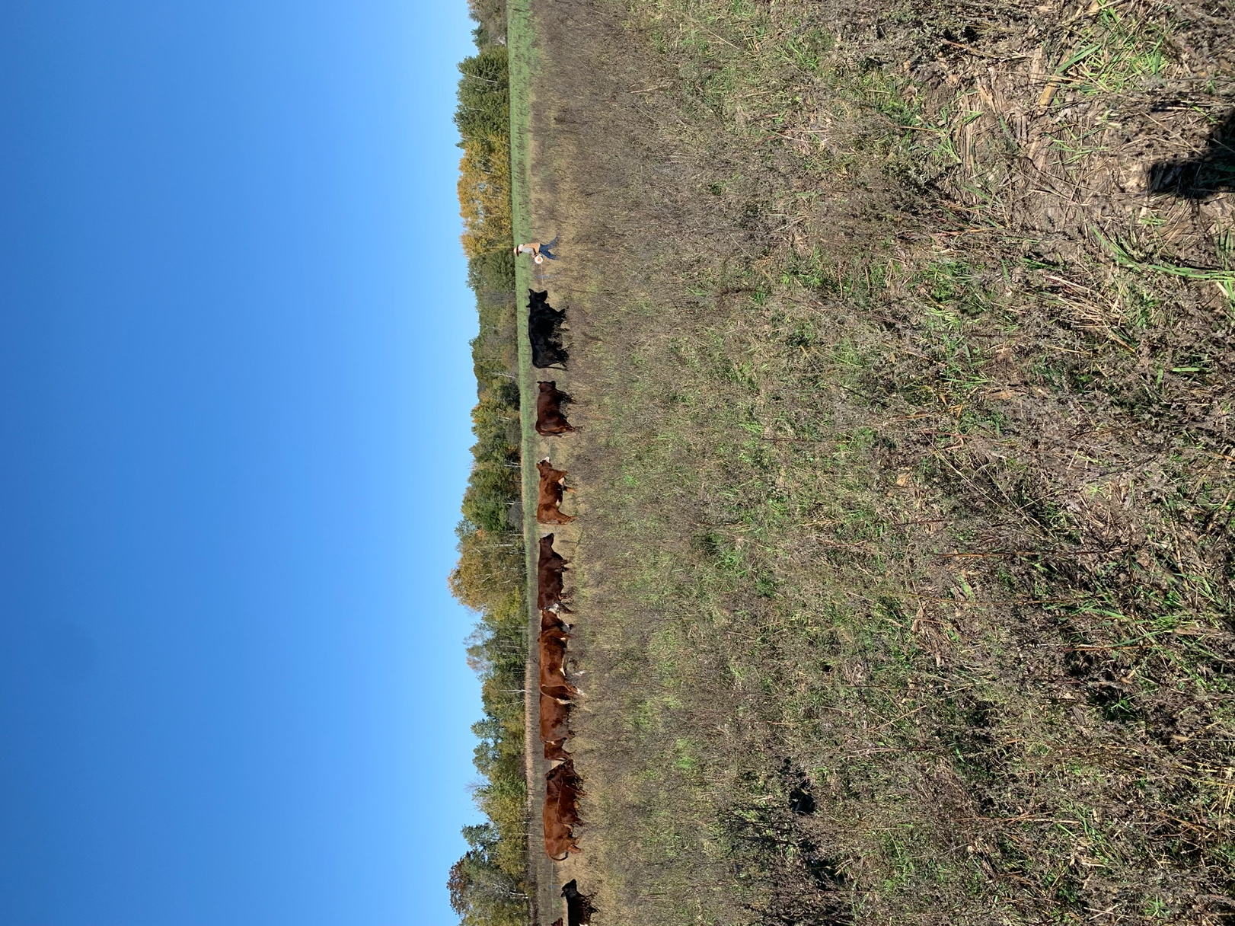
George reeling in the line to allow the cows to move to new pasture.
Now, I have studied the top contenders in the book, “Drawdown,” a ranking of the most impactful ways we can reverse global warming, and I know that right up there at #4 is eating a Plant-rich Diet. I also know that thinking the world will go vegan or vegetarian overnight is a pipe dream, just like eliminating fossil fuels from our lives overnight. It always comes down to our choices. If you choose to include animal products in your diet, the best way to do that is to find a farmer that cares about how the animals are raised and how it affects the earth.
You will find higher prices for Walker farm products, but as George points out, “There are no hidden costs; no cheap labor.” The workers are paid fair wages and benefits. As Anneliese pointed out, “The U.S. is addicted to cheap food.” Raising yields by planting fencerow to fencerow has resulted in a surplus of food grown in the U.S. We currently waste 40-50% of our food in this country, another large source of carbon emissions, coming in at #3 in “Drawdown” as an opportunity to reduce emissions.
One shocking revelation George shared was that the USDA’s sticker claiming “Product of U.S.” on meat is not what we think. Over 80% of our beef is NOT grown in the U.S. Much of it comes from Argentina and Brazil, receiving the “Product of U.S.” claim after being processed into various cuts in U.S. facilities. No wonder they are cutting down Amazon rain forests! Check out COOL – Country of Origin Labeling laws.
https://www.ams.usda.gov/rules-regulations/cool
There is legislation that would help the regenerative movement, but in the meantime, the most important thing we can do is to seek out local farmers, encourage regenerative practices if they’re not already using them, buy locally produced food, and talk about it with your friends and neighbors. We’d all like to know where our food is coming from and that it is produced in a healthy manner. Co-ops are a great source for vetting farmers. Vote with your wallet. Shake the hand that feeds you. In the case of George and Anneliese Walker, I’m glad I did, and I can’t wait to try their happy pig bacon!
Laurie Windisch

