 Green Blades Preaching Roundtable

Revised Common Lectionary Gospels, Year B
Rev. Kristin Foster

- October 10 ~ Mark 10:17-31
- October 17 ~ Mark 10:35-45
- October 24 ~ Mark 10:46-52
- October 31 ~ Mark 12:28-21
- October 31 ~ Reformation ~ Psalm 46; Jeremiah 31:31-34; John 8:31-38

The first four Sundays in October move us slowly through the pivotal 10th chapter of Mark.
Jesus is heading toward crucifixion in Jerusalem, that minor colonial outpost of the Roman Empire and the center of Temple religion. Roman military and political leaders are always on the ready to use violence to quell resistance to the Empire. The Temple leaders, knowing their powerlessness in the Empire’s grand scheme of things, try to protect their own place within Empire by guarding status quo.
Someday that Empire will implode. It is not sustainable. But caught within it, in the immediacy of its tentacled power, its ultimate unsustainability may seem irrelevant to survival in the present.
Moreover, the Empire was really good at doling out crumbs of rewards for those who accept its terms.
Why does this matter for us, as we preach amidst so many needs close at hand? How do we preach truthfully with the near horizon of accelerating ecological unraveling brought on by our own ‘empire’ or civilization?
Up here in northern Minnesota (even down close to the State Capitol), we live in a minor outpost of an ‘empire’ of industrial, petroleum-fueled, consumption-based civilization.
In this situation, will we take the role of Temple leaders, knowing the danger of challenging this ‘Empire’, simply trying to protect our place as church, help people when we can, and keep our worship traditions alive?
Or does Jesus call us to something else? What does it mean to follow Jesus in the context of the existential threat of climate disruption and ecological destruction?
In the Gospel readings for all the Sundays in October, we can learn, sometimes uncomfortably so, where our own following begins.
Pastor Lisa Buchanen beautifully reflected on the gospel for Sunday, October 3 (September Green Blades Rising), referring to the celebration of St. Francis. So let’s begin with the following Sunday.
In the passage for Sunday, October 10, a man comes to Jesus asking what seems to be a purely spiritual question. “What must I do to inherit eternal life?” says the rich man. (Mark 10:17-31). Jesus tells him to sell everything he owns and then come, follow Jesus. In order to inherit eternal life, he must let go of his wealth. He cannot do it.
We too are in the position of the rich man, clearly at and beyond the time when we as a world need to STOP our own fossil fuel consumption. It is indeed consuming us, consuming our forests and oceans. It is poisoning us and our fellow creatures. No rationalizations will change that fact. We are killing the Earth’s near-infinite capacities to generate and sustain life, and killing ourselves in the process. But around the world we keep building pipelines and digging through tar sands, and guzzling precious water in order to do that. We turn rainforests into plantations for mangos and cattle and other delicacies. We choke marine life with our plastic refuse. The call to ‘sell everything’ and follow Jesus has never been clearer. Or more seemingly impossible. Moreover, do we really want to give it up? Even when the ultimate, the eternal cost, will be the termination of most life itself on this planet, God’s Beloved?
“Go, sell what you have, and give it to the poor. Then come, follow me.” Yes, we can make some changes in our own consumption. But we cannot let our important individual actions distract us from the scale of collective, systemic, international and corporate change needed. Harder than a camel walking through the eye of a needle. Redistribution of wealth? Reparations and restoration of land to Native American siblings and the descendants of enslaved people? Disinvestment from the fuel which has given us the highest standard of living in history? It’s a camel standing at the eye of a needle.
But with God, nothing is impossible.
On Sunday, October 17, Jesus’ lead three disciples (Peter, James, John) ask him to guarantee them important positions in his administration when he begins his reign as anointed ruler (Mark 10:35-45). Like the rich man, they want something secure to hang onto. They want a guaranteed outcome for their current efforts. Jesus refuses to make any such promises. He won’t give any guarantees, even to his very sincere disciples.
In this ecologically, politically, economically precarious time, Jesus refuses to give us any guarantees of the outcome of our efforts. In fact, if we are to be faithful, we need to give up guarantees, even a guarantee that it’s not too late to reverse the terrible course we’re on. We don’t know.
Notice, too, that Peter, James, and John want to define their future with Jesus in charge along the same terms as the present system - security, hierarchy, power and status to rule over others. Same top-down system, but their favorite Guy in charge.
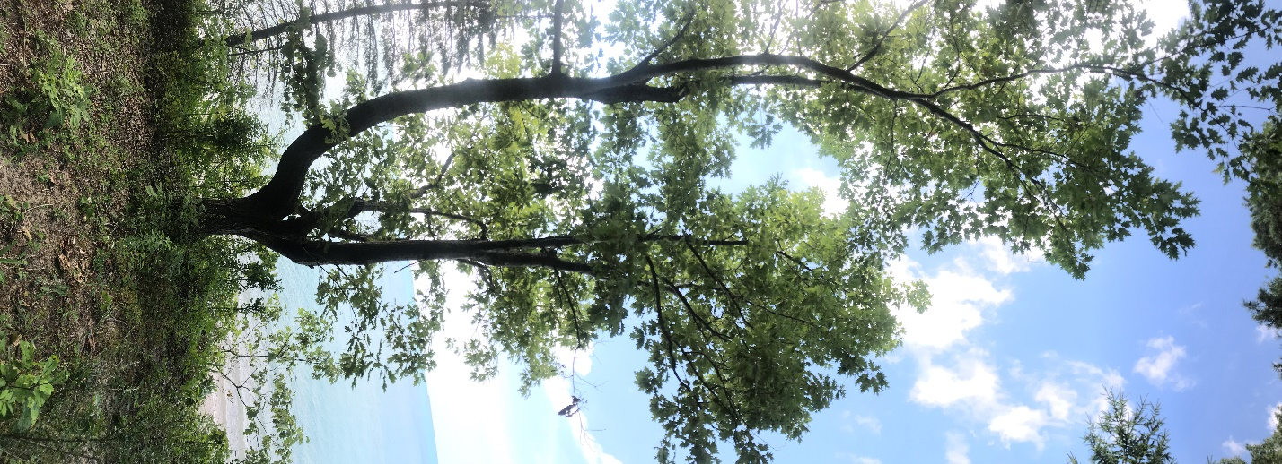
Jesus is creating an utterly different future. And their participation in that future comes not from dominating but from serving, without knowing the outcome.
Don’t we also need to free our imaginations from the system of domination, consumption, and disconnection which is eating away at Life? “The greatest among you will be those who serve. I give my life as a ransom for many. That’s my guarantee.”
So, what are the world’s deep and crying needs that we are to serve? How can we see them?
On Sunday, October 24, Bartimaeus the beggar sits at the side of the road that Jesus, his disciples, and crowds are walking (Mark 10:46-52). The disciples hear the cry of the blind beggar and bring it to Jesus. They serve Bartimaeus not by rushing to help him but by hearing him and bringing to Jesus his cry. He receives his sight.

Jesus tells Bartimaeus to go on his way, his eyes opened by his faith. With his new ability to see, instead of going his own way, Bartimaeus goes on Jesus’ way, the first person in Mark 10 to do so. Might Bartimaeus remind us of those desperate ones, who are more able to see and follow in faith? What about our Indigenous siblings, survivors of centuries of land theft, attempted genocide, and treaty violation, even in the present? Who are now protecting water and forests here in northern Minnesota and around the world?
How can we open our ears to listen to them, open our eyes, to see? To follow?
For a narrative poetic interpolation of blind Bartimaeus as a, read Oak Tree Saviors.
On Sunday, October 31, if we follow the path of Mark, we come to the gospel of the two great commandments (Mark 12:28-34). Everything comes down to love. Love of God. Love of neighbor. Neither loves has an exclusion clause. The whole earth, God’s Beloved, is our neighborhood. As Indigenous traditions teach, the plant beings and the rock beings and the water beings and the animal beings and the airborne beings in our neighborhood are our relatives. For the sake of the braided love of God and our earth neighbors, we find ways to let go of the need to possess and consume and dominate. For love, we commit to ending our dependency on fossil fuel. For love, we let our hearts hear the cries of our neighbors.
And if we celebrate the Reformation with its readings on October 31, we come to a new covenant (Jeremiah 31:31-34) for the sake of the whole earth creation, written on our hearts. Is this not another form of the love commandment as a promise? In Psalm 46 come to the assurance of God’s presence “though the earth shakes, the mountains tremble, waters roar and foam, though the nations are in uproar”. Held fully accountable for our damaging impact on creation and each other (Romans 3:19-28), we are freed from self-justification by the faithfulness of Jesus to live by faith. In a society rife with deception, denial, and distortion, Jesus assures his followers that the truth will make you free (John 8:31-38). Whether that truth is from science or art, from journalists or scripture or direct experience, even when the truth is unbearable, in Jesus, Truth-bearer, it will make us free.

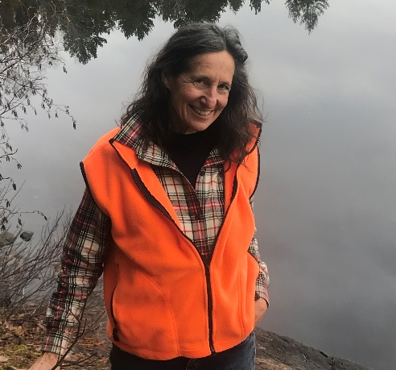
Pastor Kristin Foster serves as co-chairperson of the EcoFaith Network NE MN Synod Leadership Team and content editor for Green Blades Rising. She was the founding chairperson of the Iron Range Partnership for Sustainability, where she still serves on the board. Retired in 2018 after almost three decades of ministry with the people of Messiah Lutheran Church in Mountain Iron, she lives with her husband the Rev. Frank Davis, Ph.D. on an old Swede-Finn farmstead outside Cook. They have two adult daughters and three grandchildren, for whom she sees whenever she has the opportunity!
She is a member of Trinity Lutheran in Cook.

