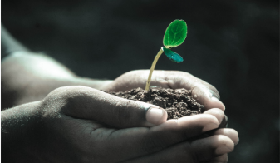
Green Blades Preaching Roundtable
Third Sunday of Easter
April 14, 2024
Year B.
Acts 3:12-19; Psalm 4; 1 John 3:1-7; Luke 24:36b-48 (NRSV)

Pastor Amanda Kossow
Cass Lake, Minnesota
Pine City, Minnesota

While at times, questions can be and have been an annoyance, which has more to do with my own reluctance or fear to probe further, they have always drawn me closer. To friends. To family. To creation. To people who sit on the opposite side of an issue. And of course, to God. That, though, is one of those lessons typically learned in hindsight. And while it would make more logical sense, at least to me, for answers to be those magnetizing forces, questions disturb more of the seedbed of our consciousness and conscience, and thereby expand the space for new kernels. As I read through each of the texts for this Sunday, it wasn’t answers per se, but questions, that spontaneously sprouted.
I’ve always secretly criticized Peter for his partly true censure in Acts 3, verses 13-15. It seems he conveniently forgot to include himself in that list of those who rejected Jesus. I, of course, am following not too far from his footsteps. It’s easy for me to condemn others for denying Jesus and his way by their exploitative lifestyle habits, while neglecting my own part in the overall extractive system. Then, I’m confronted again when I come to the end of Peter’s statement. “To this we are witnesses.” How am I a witness to the God of resurrection still at work among us today, raising life from death? How are we, as a body of Christ planted in (name town here), witnesses? How are our other-than-human neighbors witnesses to this God?
Turning to the psalm, I am caught by the author’s potentially emotionally charged, remark: “You gave me room when I was in distress.” Perhaps by being given that room, the psalmist was eventually able to occupy the changed state found at the end. “I will both lie down and sleep in peace; for you alone, O Lord, make me lie down in safety.” The psalmist starts out demanding God’s attention, and ends acknowledging God’s activity. So often, society pressures us to suffocate our distress. What a gift to be given, instead, space. To allow our distress, and thus ourselves, the chance to breathe. There is healing in such an approach. So, how are we, or how are we not, giving creation room when it is in distress?
In the gospel, I am drawn to a very earthy action. “Touch me and see.” Quite an intimate invitation. Well, actually more than an invitation. Jesus doesn’t just appear, scars and all, as visible proof of his resurrection. He bids them to touch. To awaken the nerve receptors within their own flesh, and thereby not only feel the truth of both crucifixion and resurrection, but to connect with him, on multiple levels. Luke doesn’t tell us whether or not the terrified disciples actually did so, but it got me to questioning: would I have reached out my fingertips? Or would I have been averse to experiencing the unspoken truths? How often, if at all, are we willing, when given permission, to touch the scars, or wounds, of another life? It is, after all, a very vulnerable act, for both parties. Whenever I come across a burned tree while hiking, I gently place my hand upon the scarred bark. Though I will never know my kin’s story, turning away from whatever happened seems, to me, to be a turning away from, a rejection of the very God whose own wounded body came from the same earth. Jesus’ words also lead me to ask, how are we touching Earth? That very essence from which he himself was born. That readily received his blood and tears. That swaddled him in burial. And that gave him back in resurrected form. The query acknowledges the sad truth that some lives only learn touch to be a very painful experience rather than gift as God intends. To these precious lives our Wounded Healer says, “Peace be with you.”
“What we will be has not yet been revealed,” the author of 1 John asserts. This screams seed imagery, as they too go through a process of becoming. (Reading further beyond our assigned pericope, the writer uses a seed metaphor). Though, perhaps, they are more patient, or less resistant to the Creator’s active labor, than many of us humans when it comes to being on the way. In any case, this first letter of John asserts that, as God’s children, we are becoming like Christ, and that “…we will be like him, for we will see him as he is.” See him as he is. I get that there is an eschatological tone to these words. However, I couldn’t help but wonder, do we see the unfolding Christ in the here and now? Dissecting the festering fistula of our either/or mindset? For instance, either the economy or the environment. Do we see the unfolding Christ in the fragile bloom, signaling new life rising from death’s bitter clutch? If so, how are we witnessing to those unfoldings?

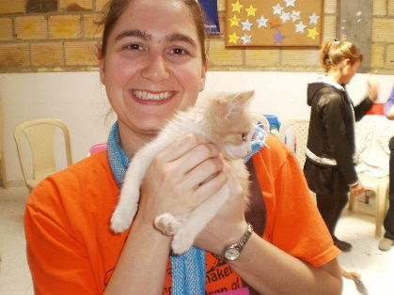 (This photo is taken from the building of Luz Y Vida, the companion church in Colombia to the congregation I previously served) My name is Amanda and I currently serve as pastor at Trinity Lutheran Church in Cass Lake, MN. There is a t-shirt from Grand Island, MI which describes me to a “T.” It states, “Into the woods I go to lose my mind and find my soul.” I am an avid animal and nature lover who hikes, kayaks, and snowshoes as often as possible. Having spent much of my life in the Upper Peninsula of Michigan, I feel a strong kinship with creation, particularly trees. During my time in seminary and in both my first and now second calls, I’ve also been gaining a deeper appreciation for and learning from my bond with human neighbors whose culture differs from mine.

