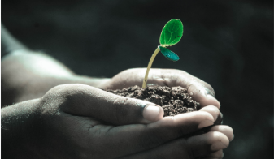
Green Blades Preaching Roundtable
September 15, 2024
Isaiah 50: 4-9a or Proverbs 1: 20-33; Psalm 116: 1-9; James 3: 1-12; Mark 8: 27-38 (esp. 31-38)
Pastor Daphne Urban, Bemidji, Minnesota

In the presence of the Holy Spirit, Grace and peace from God our Creator, And the Lord Jesus the Christ.
This Sunday’s scriptures are full of promises that shatter expectations. In verse after verse, story after story, God procmises impossible things.
And the miracles keep coming. There is a miracle of a child born to Abraham and Sarah, who were just about to lay their retirement chair out on their porch. Instead, their long time prayer of having their very own child came true. They instead got to put arocking chair in the house, Next to a crib, for their very own baby. A God miracle if there ever was one.
We also hear about the miracle of how suffering, death, and resurrection bring us into God’s kingdom and transform our lives! We hear about the miracle of faith that allows us to believe the unbelievable. And one of the best miracles to me is how God makes us, all of us, God’s own church, the very living body of Christ. Computer programmers, homemakers, teachers, waitstaff, plumbers, pastors, nurses, engineers, retirees, volunteers, students, preschoolers, gardeners, scientists, climate advocates, and so many more that I could go on all day. We all come together around God’s word, united by the common faith that we have been given. It’s a God miracle, and a promise by God himself.
So today’s scriptures make us aware that faith is more than an idea. Faith takes shape in a living God who names us, claims us, and invites us to follow Jesus more faithfully, and BE Church together.
By being God’s church together, we come to learn that God’s ways are different than the ways of the world. We have to decide, are we all in, or not?
This is the beginning of Fall, Autumn, and a time of year when the weather is changing from hot to warm to colder, preparing for the upcoming winter. Therefore it’s a time to refocus our attention on Jesus, and in turn, on God.
In the book of Isaiah, in chapter 55 it says, “For my thoughts are not your thoughts, nor are your ways my ways, says the Lord. For as the heavens are higher than the earth, so are my ways higher than your ways, And my thoughts than your thoughts.”
I think we tend to forget that God is in charge, not us. I try to remember every morning to ask God, What are you up to today? And, what are your plans for me today? I always have my own list, But God has God’s own list too, And our lists don’t always align. And I have to be reminded daily, that God’s in charge, not me.
The disciples in our gospel story in Mark also had to learn and re-learn that God is in charge. They were following Jesus. They thought they knew him, thought they were in alignment with him. But they forgot at times what Jesus was really all about. And then Jesus shared something with them one day that they didn’t expect. It reminded them again that Jesus’ way is not their way. Jesus’ way is God’s way. And God’s way is the divine way, which is very different than the human way of the disciples.
Now we have heard the story of Jesus’ crucifixion SO many times that it’s easy for us to overlook how shocking it would have been for the disciples, hearing it for the first time, from Jesus himself.
One of these disciples is Peter. He is both a man of great faith and a man of crumbling faith. Peter has decided that Jesus is the Messiah, and Jesus has staked everything on this. Peter has decided that Jesus is the fulfillment of the long-awaited prophesy. Peter has decided that Jesus is restoring Israel’s fortunes and ushering in a new era of peace. And Peter believes that Jesus is going to be the one to kick out the Roman overlords. Peter and other disciples truly believed that because they saw Jesus perform miracles, saw crowds follow him. They saw Jesus heal people, indeed, so many amazing t things that they thought for sure Jesus would kick the Roman overlords out too. But Jesus surprised all the disciples this day, including Peter. Jesus had news that didn’t make sense, News that was shocking and sounded so unlike the Jesus they had come to know. Jesus shared that he would soon undergo suffering, Be rejected by the religious leaders, and would be killed.
I’m sure it was hard to hear. It was the worst possible thing that Jesus could have said. He insults the religious and governmental leaders. He seems to invite disdain and death. It gets so bad that Peter, pulls him aside and demands that he stop speaking this way. He wants Jesus to stop. Jesus is speaking of things Peter doesn’t want to happen. He rebukes Jesus.
Well, Jesus turns right around and rejects Peter’s words. The words of Jesus are hard, but they are the way to salvation. Even though Peter is his close friend, anything that is not part of God’s plan must be rejected. Jesus goes so far as to name the source of this rejection of God as Satan. Because only Satan would reject the word of God, even if it is hard. So Jesus rebukes Peter.
There is a book titled, “Unmasking the Powers”, written in 1986 by biblical scholar Walter Wink. In the book, the author reflects on the original function of the Satan. People such as Job and Jesus, whom Satan tempted, were given the opportunity to remain faithful to God’s word, and promise or to concede to the world’s ways of doing things. When Jesus calls Peter “Satan” in our gospel story today, He is not labeling Peter has the embodiment of ultimate evil. As the term so often is applied in contemporary culture. Instead, he’s naming Peter’s action as “Setting your mind not on divine things but on human things”, as a temptation to choose the world’s path.
So when Jesus rebukes Peter he’s sharing a teaching moment. To be the Messiah means not to be served, but to serve. Not to command, but to obey. Not to kill, but to be crucified for our sake. Not to stay dead, but to be raised so that all might have life. Peter wants Jesus to follow the ways of the world, But Jesus follows the ways of the divine, The ways of God.
He must go through the suffering, the pain, and death in order to bring salvation to the world. It’s kind of like how we have to go through the effects of climate change.
We don’t like that the world is warming, the ice caps at the poles are melting, the sea levels are rising, the fish are dying, the animals and insects at the highest peaks of earth are disappearing. We don’t like that the storms are intensifying, the droughts are increasing, the fires are burning, and that most of the people on this earth are doing nothing about it. We don’t like any of this. But we are not in charge. We have changed some of the things happening on our planet, but we don’t want to admit it. We don’t want to try to change our ways to help be the fix of these crazy climatic events that keep happening.
However we have to go through the suffering, the pain, and death of the climate changes and BELIEVE that God has our backs. God is in control. We have to believe and hope that we have to be like Jesus, we have to go though all of this stuff. It’s the way of God and the way of our world.
Jesus, must go through the suffering, the pain and the death in order to bring salvation to the world and must share this now because it’s coming soon. And he must share this and rebuke Peter’s response to it because he needed to help the disciples understand that, ‘My thoughts are not your thoughts, Nor are your ways my ways.” The disciples didn’t want to hear it, and they didn’t understand it.
It’s still hard for us to understand sometimes too. Following Jesus is hard. It’s not an easy path. But as I once heard a pastor say, “We follow Jesus not just to be saved or to go to heaven, We follow Jesus because it’s worth it.”
Our readings show us how God calls us to a life reoriented not around worldly priorities, but around faith in Christ. Though scary, unknown, and uncertain, this path leads to life for us and for the world. It’s a miracle. It does not conform to logic or reason, It goes against expectation. The God of promise is always beyond expectation, And beyond evidence.
We come with empty hands.
And we leave with an everlasting promise.
Pastor Daphne Urban
Zion Lutheran Church/Blackduck, MN and Our Savior’s Lutheran Church/Kelliher, MN

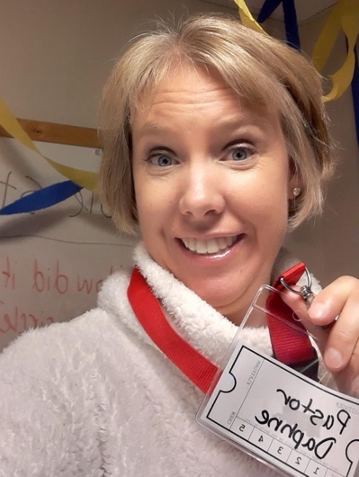
I serve these two congregations as my second call. My first call was in Red Lake Falls, MN a couple of years ago. I have an MDIV from Luther Seminary and consider myself an EcoPastor, not only because I love the study of God’s Creation and our care of it in this world, but also because I have a BS in Meteorology. Climate change is constantly on my mind and preaching about how it affects us is important to me. It’s my social justice focus in ministry and I’m on the NWMN Synod Creation Care team. I live in Bemidji, MN with my husband and 3 children, but was born and lived in California, Colorado and Maine, before making Minnesota my home about 15 years ago. It is a JOY to be a part of the EcoFaith network in NEMN!

