
Green Blades Preaching Roundtable
October 20, 2024. Lectionary 29, 22nd Sunday after Pentecost
Mark 10:35-45, Hebrews 5:1-10, Psalm 91:9-16, Isaiah 53:4-12

Luke Pederson
SAM Trinity of Norden and Good Shepherd
Northwest Synod of Wisconsin
TEEM Journey Together Wartburg Seminary

The Gospel text from Mark is one of my favorites. When James and John, the “sons of thunder” ask Jesus to give them positions of power, glory and honor at his right and left hand in his kingdom only to be told that, like Peter when he confessed Jesus as Messiah, they do not understand what they are saying. They too are thinking of human things and not divine things. Again, Jesus takes our human notions of power, honor, and glory and flips them upside down. This text comes after Jesus has for the third time foretold that he will be handed over to suffer and be sentenced to death, and three days later rise again. Fear, I think, motivates these two disciples to ask Jesus for positions of honor and glory, just as they had earlier argued among themselves who is the greatest. Fear of what they will face, fear of losing Jesus, fear of change. Indeed, I think it is the fear of change that underlies their request.

For about the first half of the Gospel of Mark they have been witnesses to many astounding miracles by Jesus. From healing everyone that comes to him, casting out unclean spirits, walking on water, feeding 5,000 people with just seven loaves and two fish, and along with Peter, they are inside witnesses to Jesus raising Jairus’s daughter from the dead and Jesus transfigured on the mountain with Moses and Elijah alongside him. With Peter’s confession, though, comes the Passion predictions by Jesus as he foretells what is to come. The Messiah has come not to be a ruler but a servant, upending human notions of authority and power. Everything is about to change, and they must change, too. In asking for positions of power, are they hoping that this will prevent them from facing what Jesus is soon to face? In seeking power, do they hope to control the situation or even to deny it?

As we continue to bear witness to the growing effects of a warming global climate, we are confronted with the need to change—to reexamine our relationship with the Earth, with each other, and all life upon it, to see with new eyes that we are not rulers over and above but interconnected with everything from Blue Whales and Redwoods to Monarch Butterflies, Bees, and the microbiome in our soils and waters. The loss of even one is a loss to all, with consequences we may not yet foresee or understand. What could it mean for us to be servants of the Earth? What do we need to let go of; what changes need to be made for us to be good shepherds of creation? Jesus’s words about greatness in service and not in rule over others may remind us of the story of creation in Genesis, that God has given the breath of life to all inhabitants of the Earth, the same breath of life given to human beings. We are all made from the same substance, from the Adamah, the very Earth itself.

To follow Jesus is to follow his call to metanoia, to repentance, to change. The climate crisis is an urgent call for repentance, for change; An urgent call for us to see how choices made today can have long-lasting impacts on our children’s future and for generations yet to come, on their air they will have to breath, the water they need to drink, the soil they will need to grow crops. May we remember our baptismal promises to care for others and the world God made, that joined together through the waters of baptism, our hands are his hands in the world.

In closing, I share the Affirmation of Christian Vocation found on page 84 of the Evangelical Lutheran Worship (ELW) that I use as part of the blessing in worship:

Almighty God, by the power of the Spirit you have knit these your servants into the one body of your Son, Jesus Christ. Look with favor upon them in their commitment to serve in Christ’s name. Give them courage, patience, and vision and strengthen us in all our Christian vocation of witness to the world and service to others; through Jesus Christ our Lord. Amen.

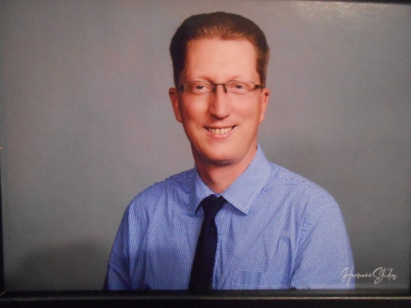
Luke Pederson is a Synodically Authorized Minister serving the congregations of Trinity of Norden and Good Shepherd in Mondovi, WI, located on the ancestral homelands of the Dakota people. He is a student at Wartburg Seminary in the TEEM Journey Together program and is the chair for the Northwest Synod of Wisconsin’s Creation Care Team.

