Silverware Library
Bethlehem Evangelical Lutheran Church Brainerd, MN.
By Russ Schultz, Team Leader
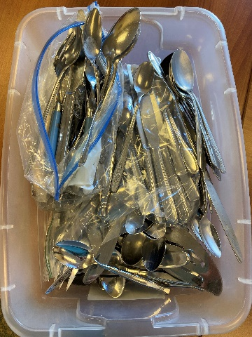
A novel idea. A low-cost eco-friendly initiative was presented to the Creation Care team by our youth pastor, Sarah Marshall. It was the idea of having a Silverware Library at our church. The concept was to have Church members donate their old silverware to the church so that other members can check out the silverware, like a library book, when they have a special event at their home such as a grad party, birthday party or other special event thereby using silverware rather than purchasing plastic. We all end up saving in the long run.
This initiative has been well received. In fact, we learned that a member from another church has checked out the silverware for an event. It was through word of mouth.
We are now at a point of asking the congregation for more silverware donations so we may have a larger inventory on hand.
Silverware in Pastor Sarah’s office
At this point, Pastor Sarah keeps and maintains the silverware library in her church office.
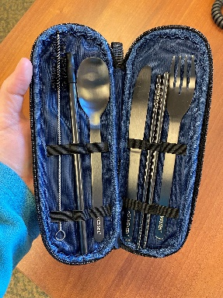
Setting a good example. Pastor Sarah’s commitment to reduce the use of plastic is demonstrated in her personal life. At a Creation Care meeting she showed us the silverware set she keeps in her work handbag and then talked about other silverware sets she stores in their vehicles for her and her family to use at restaurants. A big thank you, Pastor Sarah.
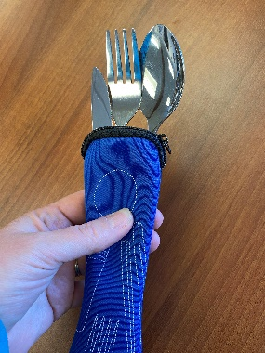

One of the silverware sets kept in the Sarah’s vehicles
Pastor Sarah’s silverware set kept in her work handbag.

A final note about our Creation Care team; we has been meeting monthly even through Covid. We found that The Silverware Library is just one example of the many small and easy things churches can do to help save our resources and be good stewards of the earth.

