

Green Blades Preaching Roundtable
September 29, 2024
Numbers 11:4-6, 10-16, 24-29; Psalm 19:7-14; James 5:13-20; Mark 9:38-50
HYMN: “Holy Spirit, Ever Dwelling” - ELW 582

Pastor Paul Brown, Immanuel, Princeton, Minnesota

The readings for today all reflect on the need for all of God’s people to work together to accomplish God’s purposes in the world. In the first reading, Moses is in a quandary, listening to the complaints of the people who are sick and tired of the monotonous diet of manna, while craving meat. Moses, in turn, complains to God that he has been unfairly put in the place of leadership listening to the cries of the people, and questions how he is supposed to be the one to supply their demands. God realizes Moses predicament and calls upon him to gather seventy elders of Israel to work with him. The Lord takes some of the spirit that was on Moses and spread it out among the seventy elders who were able to prophesy only once. The spirit then rested upon two within the camp, Eldad and Medad, who prophesied among the people. Joshua bids Moses to stop them, but Moses refuses him, saying, “Would that all the Lord’s people were prophets and that the Lord would but his spirit on them!”

In James we hear about the marks of the Christian community working together by praying for the sick, and others in need and hearing confession of sins while offering forgiveness. James asks the question, “Are any of you suffering or cheerful, or sick?” They should call upon the elders of the church to pray over them and anoint them with oil.

In Mark, we hear about how the disciples on their way to Jerusalem, as Jesus is teaching them about ministry, complain to Jesus about someone who was casting out demons in his name. Apparently, they’re concerned that they haven’t been certified or acknowledged to perform such a deed as this. Jesus tells them not to stop them from doing such deeds of power in his name. Jesus tells them, “Whoever is not against us is for us.”

We are all part of a holy priesthood, having access to God, to perform the works of God in the world. Some would preclude others from such access, but the Spirit that was unleashed at Pentecost is at work, apart from any attempts to hinder it. The same Spirit that hovered over the face of the waters of creation continues to hover over the community of believers. The Spirit binds us together for the common purpose of ministering to others in need and as stewards of the gift of creation itself.

The urgency of the current environmental crisis insists that the world community address the problem. In the face of our individual efforts of recycling, growing pollinator gardens, and being emission free, we can easily become overwhelmed and wonder how I can even make a difference to help the environment. However, the lessons this week reveal that we aren’t supposed to go it alone. They all point to the need to work together as communities of faith as well as supporting other organizations “outside the camp” toward the same goal of protecting our environment.

HYMN: “Holy Spirit, Ever Dwelling” - ELW 582

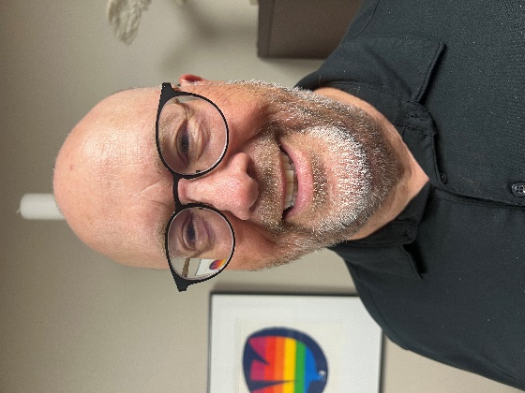
Paul Brown is an ELCA pastor, having served for 38 years in churches in Iowa, Minnesota, and North Dakota. He is currently pastor at Immanuel Lutheran Church, Princeton, MN. Paul lives with his wife, Brenda, in St. Francis, Minnesota. They have three adult children and one grandson. Immanuel Lutheran, currently an EcoFaith partner, was awarded the 2023 EcoFaith microgrant which went toward creating a pollinator and community garden.

