Green Blades Preaching Roundtable
Year A: Advent IV
Isaiah 7:10-16 ~ Psalm 80:1-7, 17-19 ~ Romans 1:1-8 ~ Matthew 1:18-25

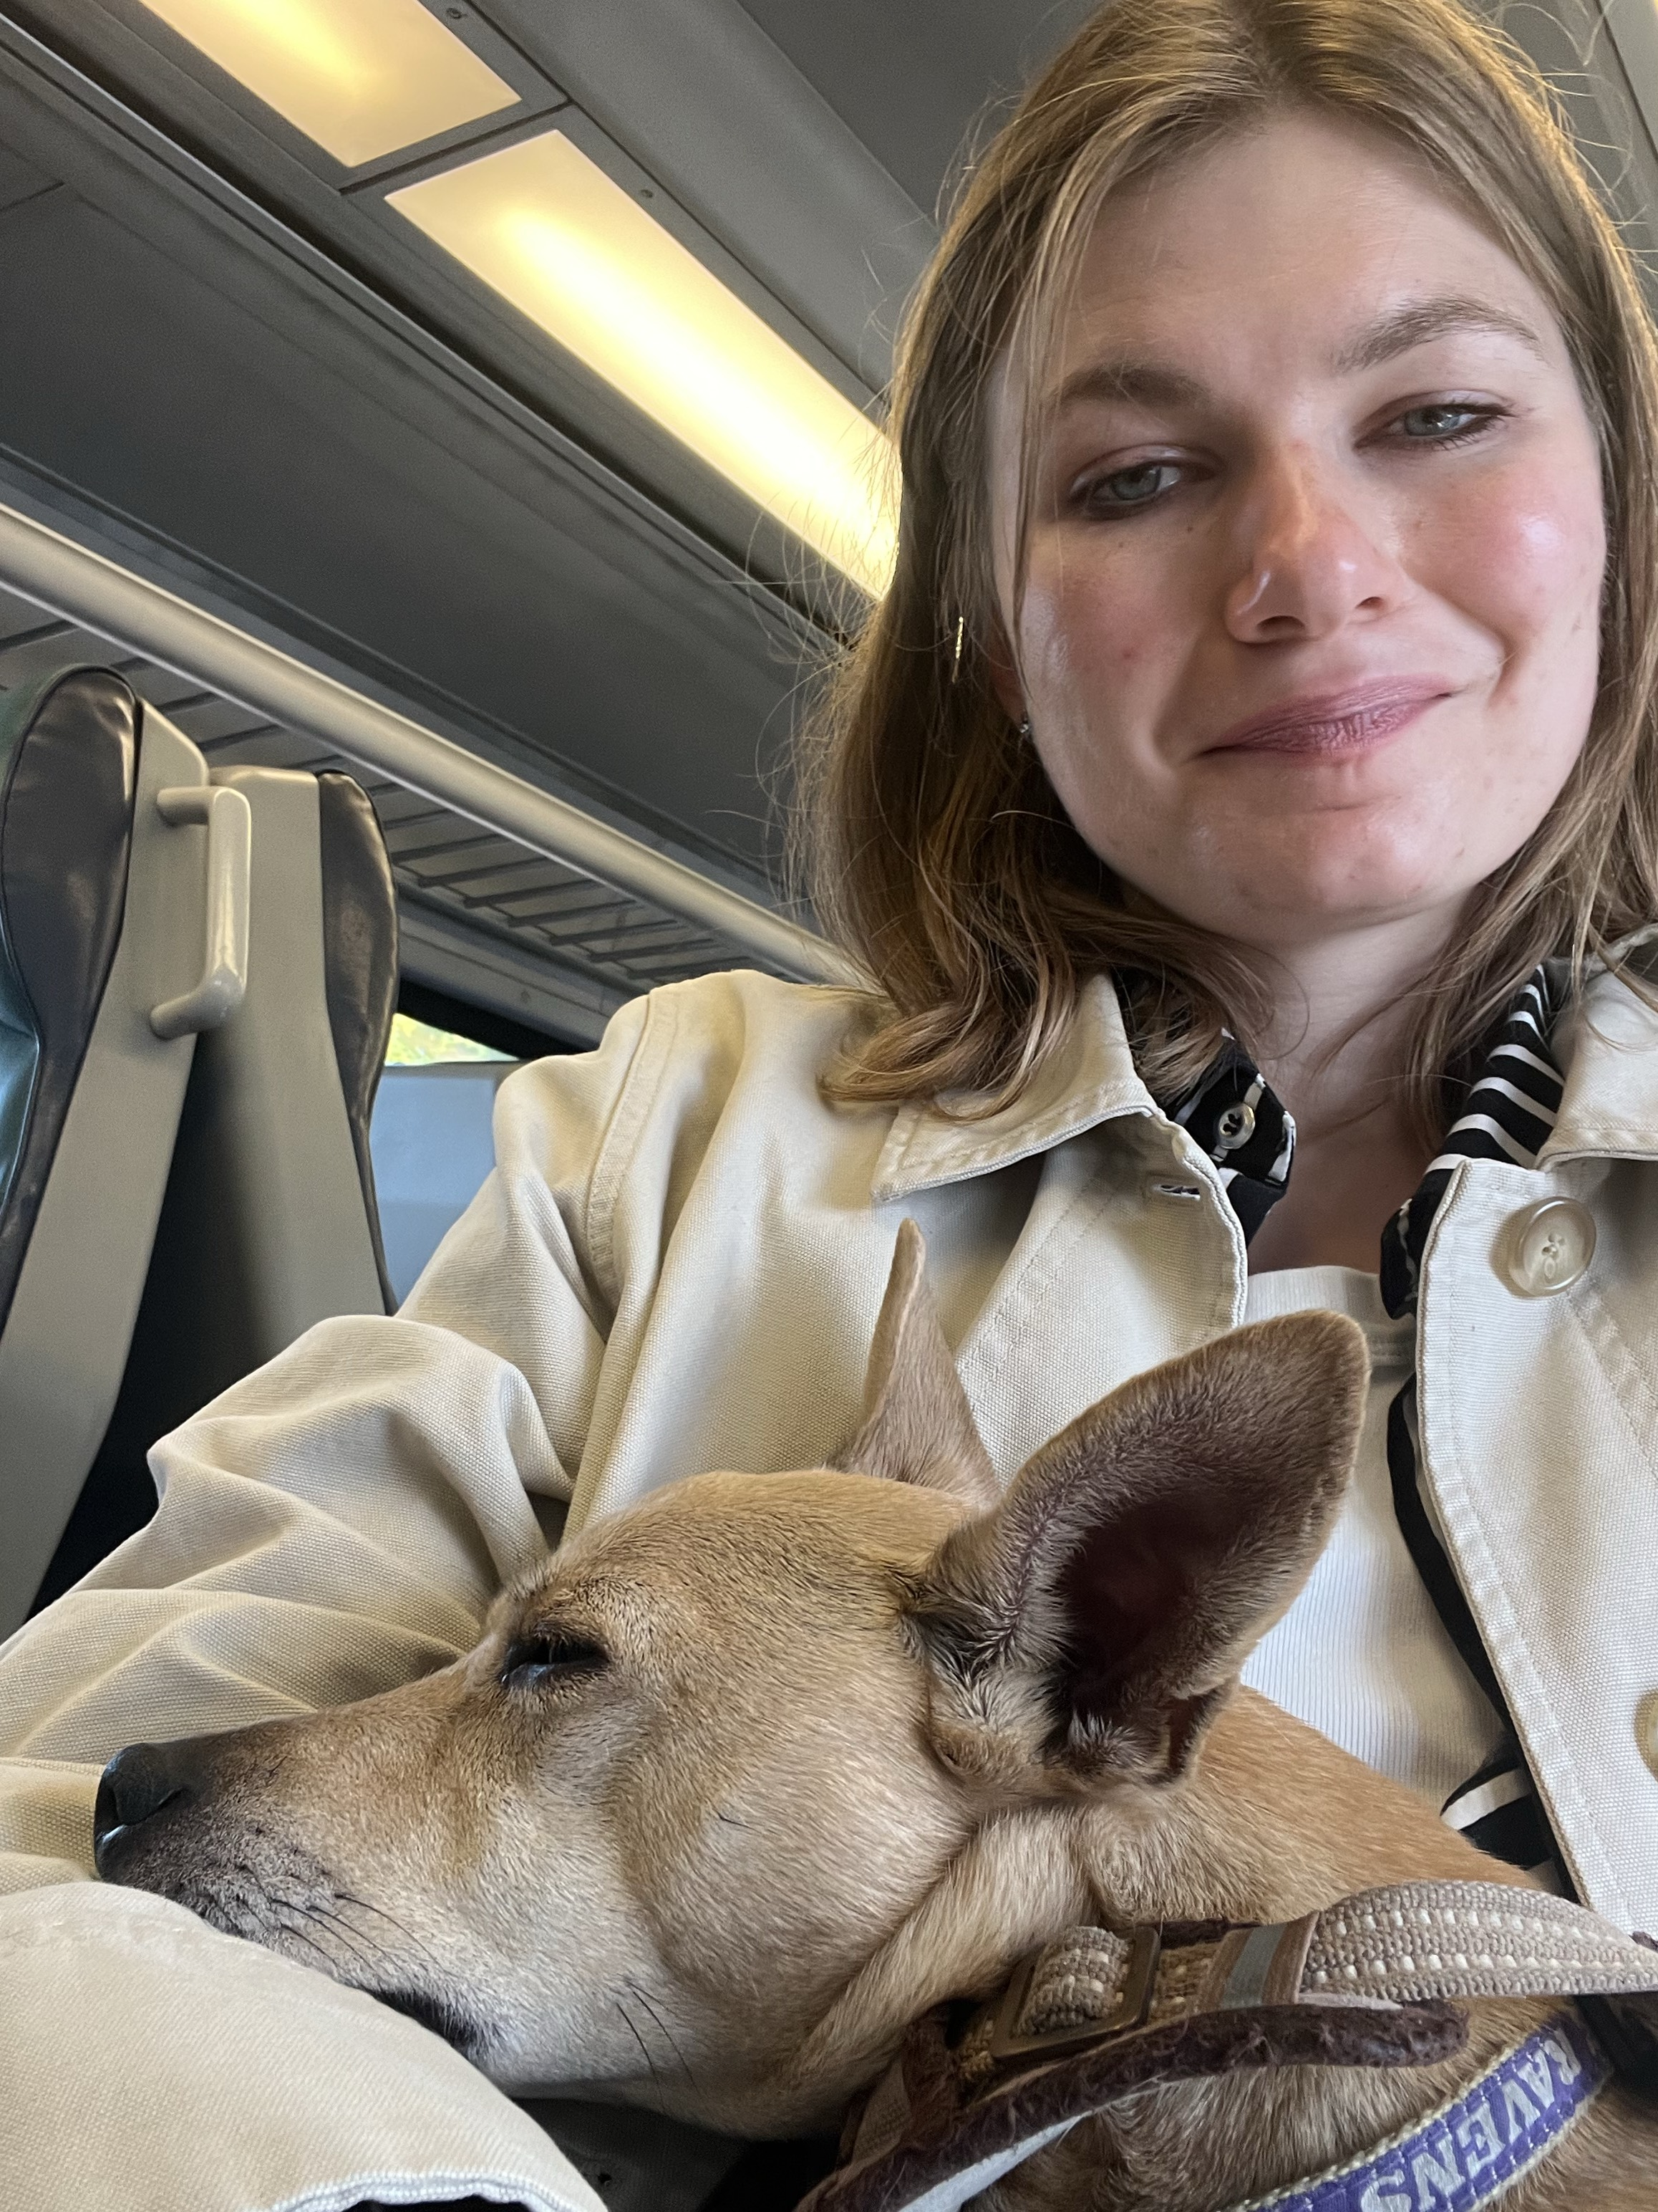
December 18, 2022

Born and raised a Lutheran in Chicagoland, Pastor Claire Repsholdt is currently serving in her first call in a small town suburban church lovingly known as the Lutheran Church of Our Savior in Patchogue, NY on Long Island. She is looking forward to being ordained in January 2023! Outside of work, she enjoys knitting, reading, making frequent train trips in to New York City, and taking her little dog Penelope on grand adventures.

"Look, the virgin shall conceive and bear a son, and they shall name him Emmanuel," which means, "God is with us."

Dearest preachers—

Here we reach the end of the season of Advent, the culmination of all of our anticipation for the birth of our beloved Christ. Even now, as we enter into the mad rush to Christmas that our society loves so much to practice. Even as we explode into a bustle of gift giving in our families and friendships this holiday season, perhaps there is still time to experience the hush of awe that falls on a group—when everyone realizes at the same time that, yes, “God is with us.”

Can you think of the moments of quiet like this in your life? When you’ve stood in front of a sunrise? When you’ve looked at the glistening sea floor that hid beneath the tide?

In the last few weeks, I am sure we have all embraced the traditions of Advent in full festivity. As we have prepared for the coming of Christ, it may have been a little bit like we are kids in the back seat of a car on a long road trip, hating the world as it passes by the window. Struggling to settle down as we are waiting and waiting and waiting for the big arrival. And for a few precious weeks, we have rightly embraced the task of enchanting each other to make the waiting less difficult. We baked cookies, wore colorful clothes, lit candles, and sang some of our most familiar hymns.

In these last few days, though, perhaps, after all of this amazing enchantment has been done, we have enough courage to look out the window at the world around us. Perhaps we have enough time to let what is unadorned in this season speak. To look out at the world and let the cold wind, the black skies, the bare trees whisper to us that something new is about to arrive.

I know that sometimes, as adults, it can seem impossible to let the wild joy of Christmas sweep us off our feet. And yet, I know it is always there in the quiet fields around us, waiting for us to slow down and let it.

On Christmas Day, 2020, I was working as the only chaplain on-call at Yale New Haven Hospital. I decided it was the least I could do, since I could not travel home to Chicago to be with my family, and all of my colleagues had families near by to see. Plus, I admit, I was excited to hear that the chaplain on call that day got to plan a Christmas service for the entire hospital.

I put on my favorite Christmas cardigan for the occasion—blue with white beaded snowflakes. I strung together a simple liturgy, featuring Christmas prayers, poems, and, most importantly, a boom box that would play the best hymns imaginable. And as I sat in the chapel, filled with beautiful poinsettias and lit candles, checking my watch…no one came.

But as I stood there after I had done so much set up and looked out at the empty room, the unadorned message of Christmas began to speak. I realized that I believed in the healing love of Christ so much that it was worth it to do the whole service alone, just in case someone showed up who needed to hear some good news.

So I proclaimed to the empty chapel that Christ is born to save us all and hold us close as we make our way to glorious eternity. That’s that funny way God has about God… of filling untouched wombs—creating life exactly wherever everyone has heartily agreed lies a bare landscape. As I preached to that empty chapel, I did not feel alone at all. I cried, as I read the story of Christmas and sang, Christ is born today. I knew without a doubt that God was with me there. The Christmas story promises that God is with us always! I knew that one day I would celebrate Christmas again in a full church.

This year, I did, indeed, make it to a full church. I am celebrating in an amazingly full church as I approach my first Christmas in my first call. And yet, I am doing so with the wisdom that in the most barren landscapes of our lives—the deep breaths we take at dawn, the tacit prayers we utter when we face an empty road home, the thoughts that fill our minds as we bend to shovel another heap of snow. God is with us even in these moments—preparing us to rejoice when we see each other again.

I hope you find ways in these last days before Christmas to look out the window at the world around you—to drink in the emptiness of nature, the huge room of your heart, the biggest silence of your day. Let yourself hear in those bare landscapes that God is with us. Let yourself live into the softness of these final days of Advent. Let them be a huge womb where you can nurture your sweet love of Jesus Christ.

See how this will prepare you to stand in the crowd, if that’s your thing, on Christmas Eve. See, then, who you can wink at with the sweetness of how good it is to have traversed so much cold and quiet ground to be together. See how lucky we are to be able to celebrate Christ’s birth unabashedly in a full church.

Your friend—
Claire

