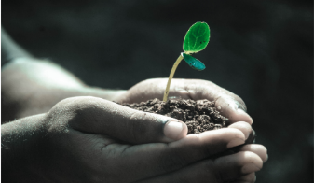
Green Blades Preaching Roundtable

Reflections on the texts
September 17th, 2023 sixteenth Sunday after Pentecost, Year A

Texts: Matthew 20:1-16, Philippians 1:21-30, Psalm 145:1-8, Jonah 3:1—4:11

Lisa Buchanen, Grand Rapids, Minnesota
Bethany Lutheran, Deer River

Genesis 50:15-21; Psalm 103: [1-7] 8-13; Romans 14:1-12; Matthew 18:21-35

What continues to hold my interest as I consider these passages is the connection between forgiveness and freedom. Joseph’s brothers are trapped (so to speak) in their fear and projections of how Joseph would punish them or continue to trap them in unforgiveness. The brothers confess, “we are here as your slaves” (Gen. 50:18b), suggesting they will do whatever Joseph wants them to do, without thought of their own desires, personhood or dreams, since that is what slavery kills in a person. Joseph, who knows a thing or two about dreams (wink) does not keep them bound as slaves but forgives them and restored them to the status of brothers, citing his faith in God (50:19) as the means by which he can forgive.
I know that I need to watch myself when forgiveness becomes a piece of performance art rather than a means of restoring a relationship. I can feel the performance beginning to happen when I consider how generous I am that I could forgive my husband for how loudly he snored last night. Very gracious of me and my forgiveness.
The readings presented today suggest that we can practice forgiveness freely because we have been given God’s expansive mercy. It is not a commodity we give out when we feel like it or when someone deserves it, although I’ll still take it. The readings give us a vision for living so closely with God that forgiveness is an expected part of our everyday, like breathing or digesting.
Despite Jesus speaking in parables to begin his teaching on forgiveness, Matthew’s Jesus pulls no punches by the end of the passage – torture for all who do not forgive! This is a problematic section to consider since Jesus says the heavenly Father would be responsible for such recompense. I can appreciate how Jesus wants to teach about compassionate forgiveness, but the methods are certainly challenging for me, and I would guess for many others.
The parable does make me consider my debts to others, to the world and how much I cannot pay back. I cannot give the sun back all the warmth and energy it has provided me, nor can I give the air back the oxygen I’ve used to breathe and survive. I am in debt to the environment just by existing. But that seems to be the agreed upon deal with living on earth. The debt only starts to get troublesome or unforgiveable when we take too much or destroy too much; when we forget how much has already been given to us, and out of boredom or greed, we want more…just like the slave who squanders the king’s mercy.
My kids went to “farm camp” for a week this summer and had an amazing time learning how flowers grow and what chia seeds taste like. They also came home with Mr. Barley Head, which is a small plastic cup filled with dirt and barley seeds. There are two googly eyeballs on the side of the cup so that as the barley grows, it looks like Mr. Barley Head is growing hair! The kids can give him haircuts! As you can imagine, my littles forget to water Mr. Barley Head on several occasions. But a little sip of water often brings Mr. B.H. right back from the brink of death and it also reminds me how forgiving nature can be. A little time, a little water, a little sunlight and many living things can repair themselves. I don’t want to minimize the debt we have accumulated with our planet, but I must remain hopeful that our planet can continue to forgive us until we can finally not squander such mercy.
I think the world is finally starting to collectively see the unfreedom of climate change through severe storms, unrelenting heat, and flooding. The question remains if we want to stay bound in such a system or if we want to turn toward a future of freedom?
Opening ourselves up to the One who is “full of compassion and mercy, slow to anger and abounding in steadfast love” (Psalm 103:8) provides the interior freedom to be in right relationship with others, with God and with our environment. Such is the fuel of forgiveness.

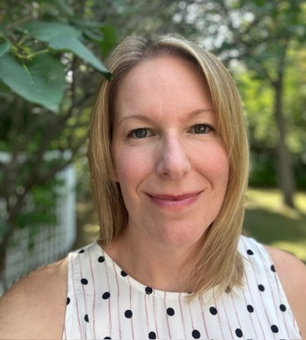
Lisa Buchanan is pastor at Bethany Lutheran Church in Deer River, Minnesota. She lives with her partner, Ben, in Grand Rapids and their two up-and-coming 2nd graders, Scarlett and Alexander.

