Green Blades Preaching Roundtable
Second Sunday of Advent
December 4, 2022
Isaiah 11:1-10 - Romans 15:4-13 - Matthew 3:1-12

Pastor Karen Behling (she/her)
Chippewa Falls, Wisconsin

Since its publication in 1992, my preaching and teaching has benefitted from Manna and Mercy by Daniel Erlander, and I am now appreciating the many related materials available through Augsburg Fortress.

https://www.augsburgfortress.org/store/category/287225/Daniel-Erlander

Erlander helps us to recognize the overarching themes of the biblical story which he describes as a “long story - a story of friendship, passion, promise, disappointment, hope, and self-giving love. It is a story of God mending the universe.”

When John the Baptist appears, calling people to mend their ways, we are called into this larger story of God who is acting to bring reconciliation and who is inviting us to join this effort to mend the universe. As one who has used needle and thread and sewing machine to mend many garments, I know that the best mending considers both utility and aesthetics. I recall many times when one of my children came with a torn article of clothing, often one of their favorites. Occasionally, the tear happened at the seam, and so the repair was as simple as re-stitching that seam, and the garment looked as it did before the tear. More often, however, the mending required some sort of patch which meant that the garment would look different after the repair. With some creative use of color and a bit of imaginative flair, however, I learned to mend garments that brought delight to my children with their whimsy and beauty. In many cases, the mended garment became more cherished than the original. And no two patches ever looked the same.

Repentance is all about assessing where relationships have become torn and then creatively imagining how to mend that tear so that joy can flourish. Or as John the Baptist urges us, “Bear fruit.” Fruit is pleasant to behold, it nourishes, and from its seeds, it produces more fruit which promotes more life which brings greater blessings.

As we look around at our world today and consider the state of our relationships with each other and with the waterways and with the land and with all the creatures of this planet, it is so very obvious that the fabric of our life together has ripped and torn apart. So much is out of balance. And as unsettling as things may be for us, in many parts of this world, the situation is truly alarming. To do nothing is to consent to this scary downward slope. To repent is to name the tears in the fabric of our life together and then to find ways to work together to mend these many tears. It will not be easy. There is no quick fix, nor can we go back to what once was. But with some imagination and some innovation, we can find ways to mend these tears and discover the life that could be, the life that God envisions for all of us together.

All three of today’s readings invite us to look to the future, to embrace God’s vision for harmonious life together, to recognize that change is necessary if we are to thrive and flourish, and ultimately, to acknowledge that change is necessary for the survival of so much life on this planet.

John the Baptist’s call for repentance is a call for change. Our lives need mending. Our relationships need mending. Our planet needs mending. The tone of urgency that we hear in John’s message is similar to the tone that we hear from many climate scientists. We simply cannot continue to live like we have all the time in the world to get our act together, because we do not have much time at all. The fabric of our life together is tearing apart. We see gaping holes where forests have been cleared and where machines have dug deep to extract resources and where there are dead zones in bodies of water and where toxic spills have wiped out plant and animal life.

We can act before it is too late. We can mend our ways by acting to change our habits and practices in our homes, in our church buildings, in our communities, in our policies for how we use this earth’s resources, and in our commitment to act in ways that benefit all of this earth’s creatures - plants and animals and yes, people in all of our wonderful diversity, living throughout the world.

Throughout scripture and in all three of our readings for this day, God persists in pursuing God’s vision for this planet. It is a vision of shalom where all can dwell in peace. It is a vision of relationships bridged beyond differences. It is a vision for action that brings life and bears fruit.

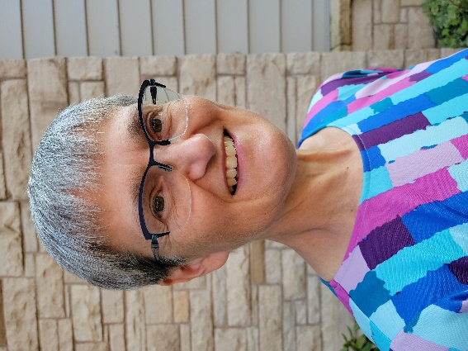
Pastor Karen Behling (she/her) lives within a mile of the congregation she serves - Our Saviour’s Lutheran Church in Chippewa Falls, WI - which means that most days, she enjoys walking as her primary mode of transportation. Previous calls have been in Minnesota, Iowa, and North Dakota in congregations small to large, with and without staff. Her primary creative outlet is quilting, and a perfect day includes time with family as well as time for yoga, gardening and a good book. Those children whose clothing she mended are now 26, 28 and 33.

