God’s Promise and Creation

Reflections by Margot Monson, Entomologist and Beekeeper
Written for Grace University Lutheran Church, St. Paul
For a Lenten devotional series

Margot Monson was the Keynote Speaker for the EcoFaith Summit 2023,
The Pollinator Plot: Cross Pollination in a Time of Ecological Crisis

Scripture: Genesis 9:8-17

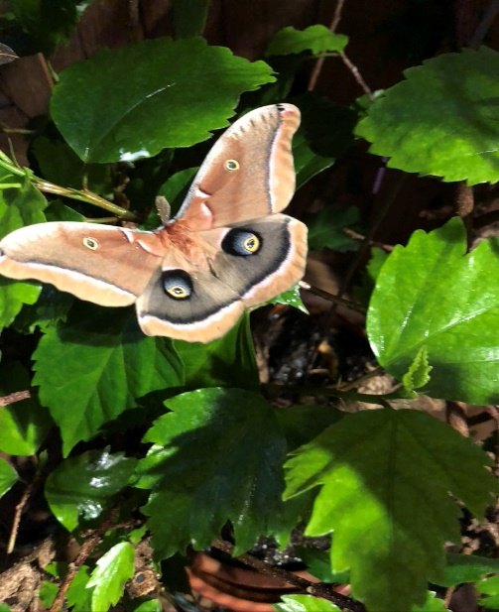

I see God’s promise as the gifts entrusted to us in the many marvelous life forms of Creation.

Plants and animals evolved together, need each other, and we need them.
Bats search for nectar for themselves and their young, hummingbirds take nectar for energy while they catch proteinaceous insects to feed to their young, and most plants need pollinating insects in order to produce viable seeds.

Bees are nature’s primary pollinators because in the process of collecting the protein rich pollen for their young, they transfer pollen from one flower to another of the same species, and so fertilize the plants.

In addition there are literally thousands of different species of beetles, flies, moths, butterflies, and even wasps that are also important pollinators. They accidentally transfer pollen while searching for their prey or foraging for nectar.
Some plants can only be pollinated by certain insects, because the shape of the flower makes collecting the pollen impossible – in spite of its tiny flower, bumble bees are the only insects that are able to pollinate tomatoes. Watching these amazing interactions taking place gives me comfort.

In MN giant silk moths begin life as tiny larvae emerging from minute eggs and spend weeks eating leaves and growing all summer into fat green caterpillars. Next they spin a silken cocoon and live in it until it eventually falls from the tree and becomes part of the leaf litter. If it avoids being prey for birds, squirrels, parasites, or taken away by fastidious home owners, it will survive all winter, no matter the temperature. Metabolism is suspended until metamorphosis completes the development into adult moths, which begin emerging from cocoons in May and June. These large moths are nocturnal, have evolved to fly only at night, do not take in any nourishment, and live only about one week in search of a mate. The females will only deposit their eggs on particular plant species, then they die. In about a week, the eggs hatch and the cycle begins again.

This Polyphemus moth is one of the many gifts of Creation that give me hope. Yet these beautiful forms so wonderfully made, and all the lives that have evolved together, will continue to sustain us only if we make our own promises to protect and nurture these amazing gifts. This is the challenge that I ask of myself.

Margot Monson

