God’s goats for Creation Care
Bethlehem Evangelical Lutheran Church
Brainerd, MN.
By Russ Schultz, Team Leader

The goats are coming!
Made possible through a N.E. Synod EcoFaith network micro-grant, Bethlehem’s Creation Care team is undertaking a project to clean up about one acre of undeveloped church property overrun with the invasive vegetation- buckthorn.

The church would like to clean up the area so it can be used as a prayer and educational area to promote stewardship of our environment and more.

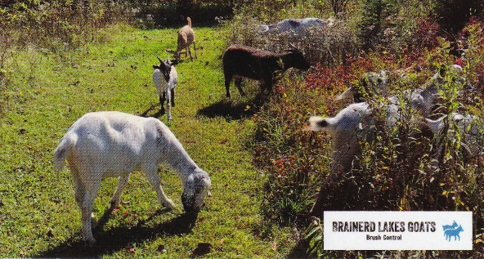
After property cleanup and site preparation with natural plantings, it is envisioned the property would provide a nature sanctuary for learning and education, opening other options such as a pollinator gardens, holding Sunday and Bible school learning events, creating nature paths benefitting the local area including schools.

A side benefit would be building a Congregational awareness on the need to care for our creation.

Project description and background:
Our creation care team invited a Master Naturalist from the Minnesota Extension Service to our meetings and toured the property. She identified the invasive species buckthorn that is overtaking the area and crowding out the good natural vegetation. She also emphasized the need to control the buckthorn. One of our creation care team members suggested that goats could be used to control the buckthorn.

We learned that the city of Brainerd used goats for buckthorn removal on two separate occasions. The Minnesota Department of Natural Resources also used goats for invasive vegetation control at two separate locations around the state.

Afterwards we contacted a local company “Brainerd Lakes Goats” and invited the owner to attend one of our meetings. We walked the property and the owner, Joe Ambrosia, explained in detail the process his company and his goats would go through on the brush removal of buckthorn. He answered questions about timelines, liabilities, and the things we needed to do to protect the good vegetation. He estimated the cost to be $800 and recommended the best time to conduct the project would be mid-summer.

Existing Property:
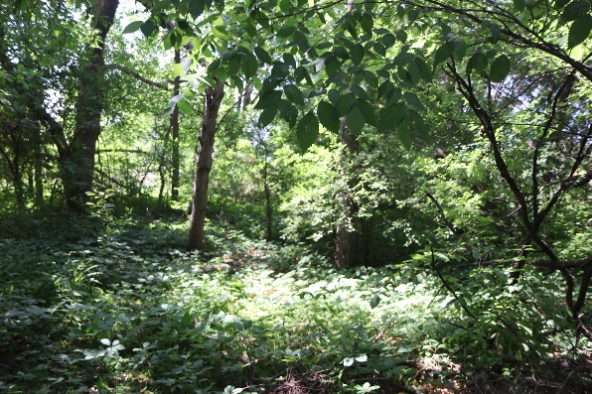

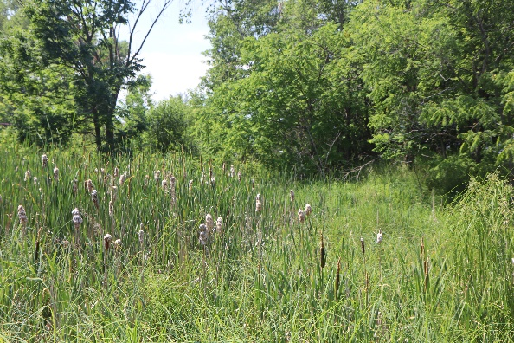

Implementation and timeline of project:
Mid-summer. The goats would be on the property site for 2 to 3 weeks to accomplish the buckthorn brush removal. It is noted that the larger buckthorn trees would have to be removed by hand later and the team thought the congregation could be involved through “God’s Work Our Hands Projects.” Also, our Sunday school classes and adults could help in the site preparation, plantings, and planning process.

More to come on our progress.

