A River Runs through It
Meditation on a Trip Westward and Nature’s Resilience
The Rev. Jeff Holter, Duluth
My wife (Joan) and I were invited to our nephews wedding this fall. It was a destination wedding to Glacier National Park. Our nephew and his wife met at work but had spent their vacations traveling to national parks throughout the country. It was right at the end of the park season and we actually anticipated traveling through some snow. Already early on we had determined not to fly out to Montana but to enjoy the drive through North Dakota and all the way to Glacier. I suppose that for some that sounds boring, but we wanted to just take in all that scenery of the central plains.
The route we chose was the northern rout, going through Fargo and then taking highway 2 pretty much all the way to Glacier. There is another rout, going south and taking the freeway through Bismarck ND, however then all one sees is traffic and endless pavement. What both Joan and I appreciated was that HWY 2 follows the terrain of the rolling plains. You can not travel at the speed of “not seeing anything” but you do see the creatures and native topography of these rolling hills. As you got closer to Glacier you began to see the Rockies and the mounds of rocks jutting out of the plains.
As I recall our trip, what matters the most is the realization that what made the trip memorable was both the joy of the wedding and the nature and natural world we encountered. Let me elaborate! Sometimes no matter observant one tried to be, you just can’t guarantee that the weather or wildlife are going to cooperate. So, the first day we drive up Glacier to Logan’s Pass. The rode is very narrow and the air is so very thin. Still when we arrived, we decided to climb to a mountain lake that is about a three mile hike up this steep hill. About one and a half miles into the climb the thin air was getting the best of us. Darn aging! So, we determined that one and a half miles was absolutely OK with us and we started down the path again. We had just stopped to rest when someone yelled “BEAR”! We turned around and sauntering up behind us was a grizzly bear. We froze, until Joan realized our bear spray was in my backpack. Joan quickly dug into the backpack while I took my cell phone out and started taking pictures of the bear. Who wasn’t hungry for Lutheran that day, and just kept on crossing the path and on toward other more edible food. I have the pics, and I won’t forget that experience. I keep thinking of all the beauty we saw on this trip: buffalo, antelope, moose, wild mustangs, so… many prairie dogs and one lone coyote who was also keeping an eye on the prairie dog village. This is a great country and our world can be a place of beauty and wonder and can still boggle the mind.
Our trip back home was also very meaningful. We kept taking the roads less taken, which brought us to a roadside parking lot for a needed stretch of the legs and some time to move around. Joan and I parked the car and walked down to the river which the road seemed to be following. The river was very low and water only slowly moving along. The shore line exposed the river bottom where rocks with dried up moss and mud caked stones once shined when the water had covered them. We walked closer to the running water and realized we were not alone. A gentleman came following behind us taking a rest from what we came to find out was a long trip from Bismarck. We talked for a bit sharing our mutual appreciation for the river and a beauty of the nature unfolding in front of us. That lead to other disclosures about where we were from and the joy of having been at a wedding for our nephew. In turn he shared why he was there. He and his wife were coming home from a doctor’s appointment. He shared that his wife has cancer and things did not look good, but they always stopped at the river on their way home to celebrate the goodness of God and beauty of God’s good creation. He then told me that this river was actually very special because it was the river and location of the movie; “A River Runs Through It”. The movie stars Brad Pitt, and was directed by Robert Redford. What I think of however is how nature in all of its glory can bring peace and wholeness when life gets crazy and when we are tested beyond our human endurance. Nature is our healing. Nature is God’s way of putting things into perspective and keeps us from losing hope. Nature’s resilience gives God’s grace a means to visibly show us how God is disposed to us. Holding us and giving us a place to renew our spirits. I believe this is God’s true testament to us, and I believe how we treat nature is our true testament that we can trust God to be there for us no matter what. Enjoy your day, enjoy life and give thanks to God for God’s goodness endures forever.
Peace, Jeff

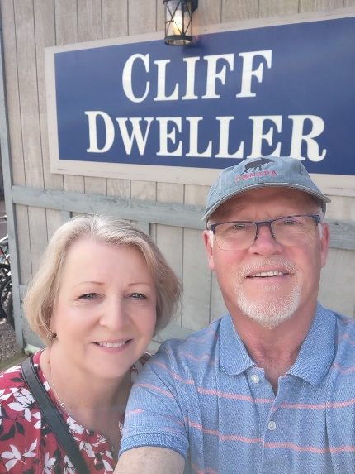 Pastor Jeff Holter is presently serving Kenwood Lutheran and Family of God Lutheran churches in Duluth, Minnesota. He writes: “We just became a parish in June of 2024 meaning we are in a honeymoon relationship at the present. I am a Concordia College and Luther Seminary grad, but more significantly I am married to Joan, my wife of 46 years and the father to four sons and six grandbabies who are growing up so very quickly. I am also coming to the close of my active ministry years and am still trying to figure out what that means . In short, I am in a lifelong learning relationship with humanity including myself and by the grace of God I am still looking forward to whatever lies ahead because God is good and God’s love endures forever.”

