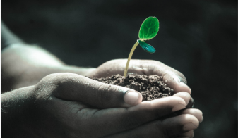
Green Blades Preaching Roundtable

DIAMOND-BRIGHT SWADDLING CLOTHES

Rev. Emily Meyer envisions God wrapping us in snowy robes of healing and right relationships.
….
Reflections on the texts/ Care for Creation Commentary
First Sunday after Christmas, Year B
December 31, 2023

on the Revised Common Lectionary
Isaiah 61:10-62:3
Psalm 148
Galatians 4:4-7
Luke 2:22-40

Rev. Emily Meyer, Minneapolis, Minnesota

Hymn suggestions: In the Bleak Midwinter, ELW #294
Cold December Flies Away, ELW #299
Song: Those Who Dream - The Many

What a beautiful and delightful set of texts - that virtually no one will encounter - on this First Sunday after Christmas (a.k.a. New Year’s Eve Day).
You might focus on the turning of the year. A quick investigation of the institution of the Roman Calendar - the solar calendar that measures our days, weeks, and months - reveals that,
‘By the 1st century BC, the Roman calendar had become hopelessly confused. The year, based on cycles and phases of the moon, totaled 355 days, about 10 1/4 days shorter than the solar year. The occasional intercalation of an extra month of 27 or 28 days, called Mercedonius, kept the calendar in step with the seasons. The confusion was compounded by political maneuvers. The Pontifex Maximus and the College of Pontiffs had the authority to alter the calendar, and they sometimes did so to reduce or extend the term of a particular magistrate or other public official. Finally, in 46 BC, Julius Caesar initiated a thorough reform that resulted in the establishment of a new dating system, the Julian calendar (q.v.). [Britannica; learn more about the Julian Calendar here.]

A reflection on time - and its manipulation - and our measuring of days and seasons may be appropriate on this Sunday.

One final note on the term ‘calendar’ from Thomas Hewitt Key, University College, London (here)

CALENDA′RIUM, or rather KALENDA′RIUM, is the account-book, in which creditors entered the names of their debtors and the sums which they owed. As the interest on borrowed money was due on the Calendae of each month, the name of Calendarium was given to such a book (Senec. De Benef. I.2, VII.10). The word was subsequently used to indicate a register of the days, weeks, and months, thus corresponding to a modern almanac or calendar.

This understanding of the term, ‘calendar’- as debt ledger - corresponds in interesting ways with Paul’s understanding of Christ’s arrival on earth, ‘born of a woman, born under the law, in order to redeem those who were under the law and so we might receive adoption as children.’ The birth of Christ is both sign and promise that we/God’s beloved are no longer debtors or ‘enslaved’ people, but free, redeemed (‘bought back’, ‘bought out of servitude’) children of God.

~~~

If the dogmatic approach of language and history isn’t your thing, the rich imagery of Psalm 148 lends itself beautifully to a video or photo montage - a visual sermon. Invite the congregation to share their own photos and create a local gem. Or borrow the one I created combining photos from around the state of Minnesota. [See more below.]

~~~

The Gospel reading from Luke is a beautiful narrative of a highly intergenerational consecration. It makes me wonder: what if all children’s blessings/baptisms were conducted with at least one elder from the congregation actively and specifically blessing the child? We do this symbolically, with the whole congregation voicing God’s promises and blessings, but the image of both Simeon and Anna laying hands on, lifting up, and embracing this infant - a child they have never met and with whom they have no biological connection: this is what ‘church family’ is intended to do: bless each generation with both predecessors and successors.

~~~

Finally, Isaiah. This is a powerful text of promise and hope that many - if not all - of us need to hear. Tragically, our desperation for it may make it difficult to accept: with climate crises galore, wars raging and threatening to escalate at any moment, with division and depression on the rise locally and globally, God’s words of promise may feel out of touch or even useless.

Where can prophetic promises bring hope to the hopeless and joy to those who grieve losses - personal, communal, and global - time and time again?

61:10 I will greatly rejoice in YHWH, my whole being shall exult in my God; who has clothed me with the garments of salvation, who has covered me with the robe of righteousness, as a bridegroom decks himself with a garland, and as a bride adorns herself with her jewels.

Trauma-informed approaches to ministry encourage us to create safe spaces for those who cannot rejoice in this season. Blue Christmas/The Longest Night provides such a space. This First Sunday after Christmas may also be a time to acknowledge that not everyone is rejoicing; our ‘whole being’ - whether that ‘being’ is each individual, the community as a whole, and/or the whole ‘being’ of creation - may not be capable of exulting. Those of us - or those parts of our individual and collective selves - that are not able to rejoice are likely attuned to the pain of the world.

In the Northwoods the chances are good that by December 31, there is a blanket of snow on the ground. This image may be helpful. As the snow covers the ground, so does God’s healing come to us: sometimes feeling like cold, harsh realities that are weighty and overwhelming - realities we can’t shovel away…

61:11 For as the earth brings forth its shoots, and as a garden causes what is sown in it to spring up, so YAHWEH will cause righteousness and praise to spring up before all the nations.

..Yet somehow, mysteriously, beneath that blanket of snow, the miracles of new life are already germinating: spring’s floral garlands are gathering nutrients; the gems of adornment are hardening and taking on a deeper luster. Somehow, when we lean into the promise that healing is possible, we discover new paths toward reconciliation, reparations, healing of broken relationships. There are seeds beneath the snow that await only our dreaming to take root and grow.

62:1 For Zion's sake I will not keep silent, and for Jerusalem's sake I will not rest, until her vindication shines out like the dawn, and her salvation like a burning torch.

If only God would speak loudly, boldly, prophetically, definitively for the sake of Jerusalem - and everywhere war is actively destroying lives and threatening the planet. Christmas is meant to be a time of peace. Might it be that amidst our celebrations we who follow the Promise of Peace are called to ‘not keep silent’? To actively strive for the Beloved Community’s healing - like a burning torch? The antidote to our despair may very well be to give voice to our fears and take action.

62:2 The nations shall see your vindication, and all the kings your glory; and you shall be called by a new name that the mouth of YAHWEH will give.

It’s easy to read this word ‘vindication’ and equate it with ‘vengeance’. They feel similar. But ‘vindication’ means, ‘absolving someone of blame or suspicion’. God has been angry because Israel has not been living into their covenant with God and so God has dispersed them from the Promised Land into the wild spaces of Babylon.

But God wants to restore the relationship. God is at work to bring about healing. Like Simeon and Anna, God lifts us up and calls us by a new name: beloved.

Will God’s beloved people find the courage to live into God’s will?

62:3 You shall be a crown of beauty in the hand of YAHWEH, and a royal diadem in the hand of your God.

Reconciled relationships - between individuals, between communities, between countries and cultures and religions, between humans and creation - reconciled relationships are the ‘crown of beauty’ and ‘royal diadem’ in the Divine hand. Those jewels forming beneath the blanket of snow are shaped in relationship, re-shaped often to become more clear, more luminous, more beautiful.

The snow is heavy, wet, cold - and beautiful; a blanket of diamonds in its own right. The earth wears it as a garment of joy knowing that without it, spring cannot and will not arrive. Moshieich, the Savior identified in Isaiah 61:1, the Messiah Christians find in the Babe of Bethlehem, has come to heal and restore, renew and reshape God’s beloved people. Even in the midst of pain and suffering - out there in the world and within our troubled hearts and souls - the Christ is being born again, wrapping us in diamond-bright swaddling clothes, inviting us to rest if and when our hearts are weary, but urging us, too, to let that sparkling robe of healing and beloved relationship be a beacon of hope - to ourselves and to the world.

~~~

Recognizing that attendance may be low on this First Sunday after Christmas, and/or that you, dear pastor, will be taking a Sunday out of the pulpit, I humbly offer two resources that may make your life - and celebrations - a bit easier:
I’m creating a Readings and Carols service using Christmas hymn favorites that our congregation won’t yet have sung. It’ll be ready - including at least a few of these texts - somewhere before December 31. If you’d like to borrow it, email me at eplmeyer@gmail.com.
See also the Psalm 148 video mentioned above: Ministry Lab members have free access; non-members can inquire and we’ll figure out something equitable.

Originally written by Rev. Emily P.L. Meyer for Green Blades Rising Preacher’s Roundtable.
ministrylab@unitedseminary.edu
Find more from Emily Meyer at www.theministrylab.org.

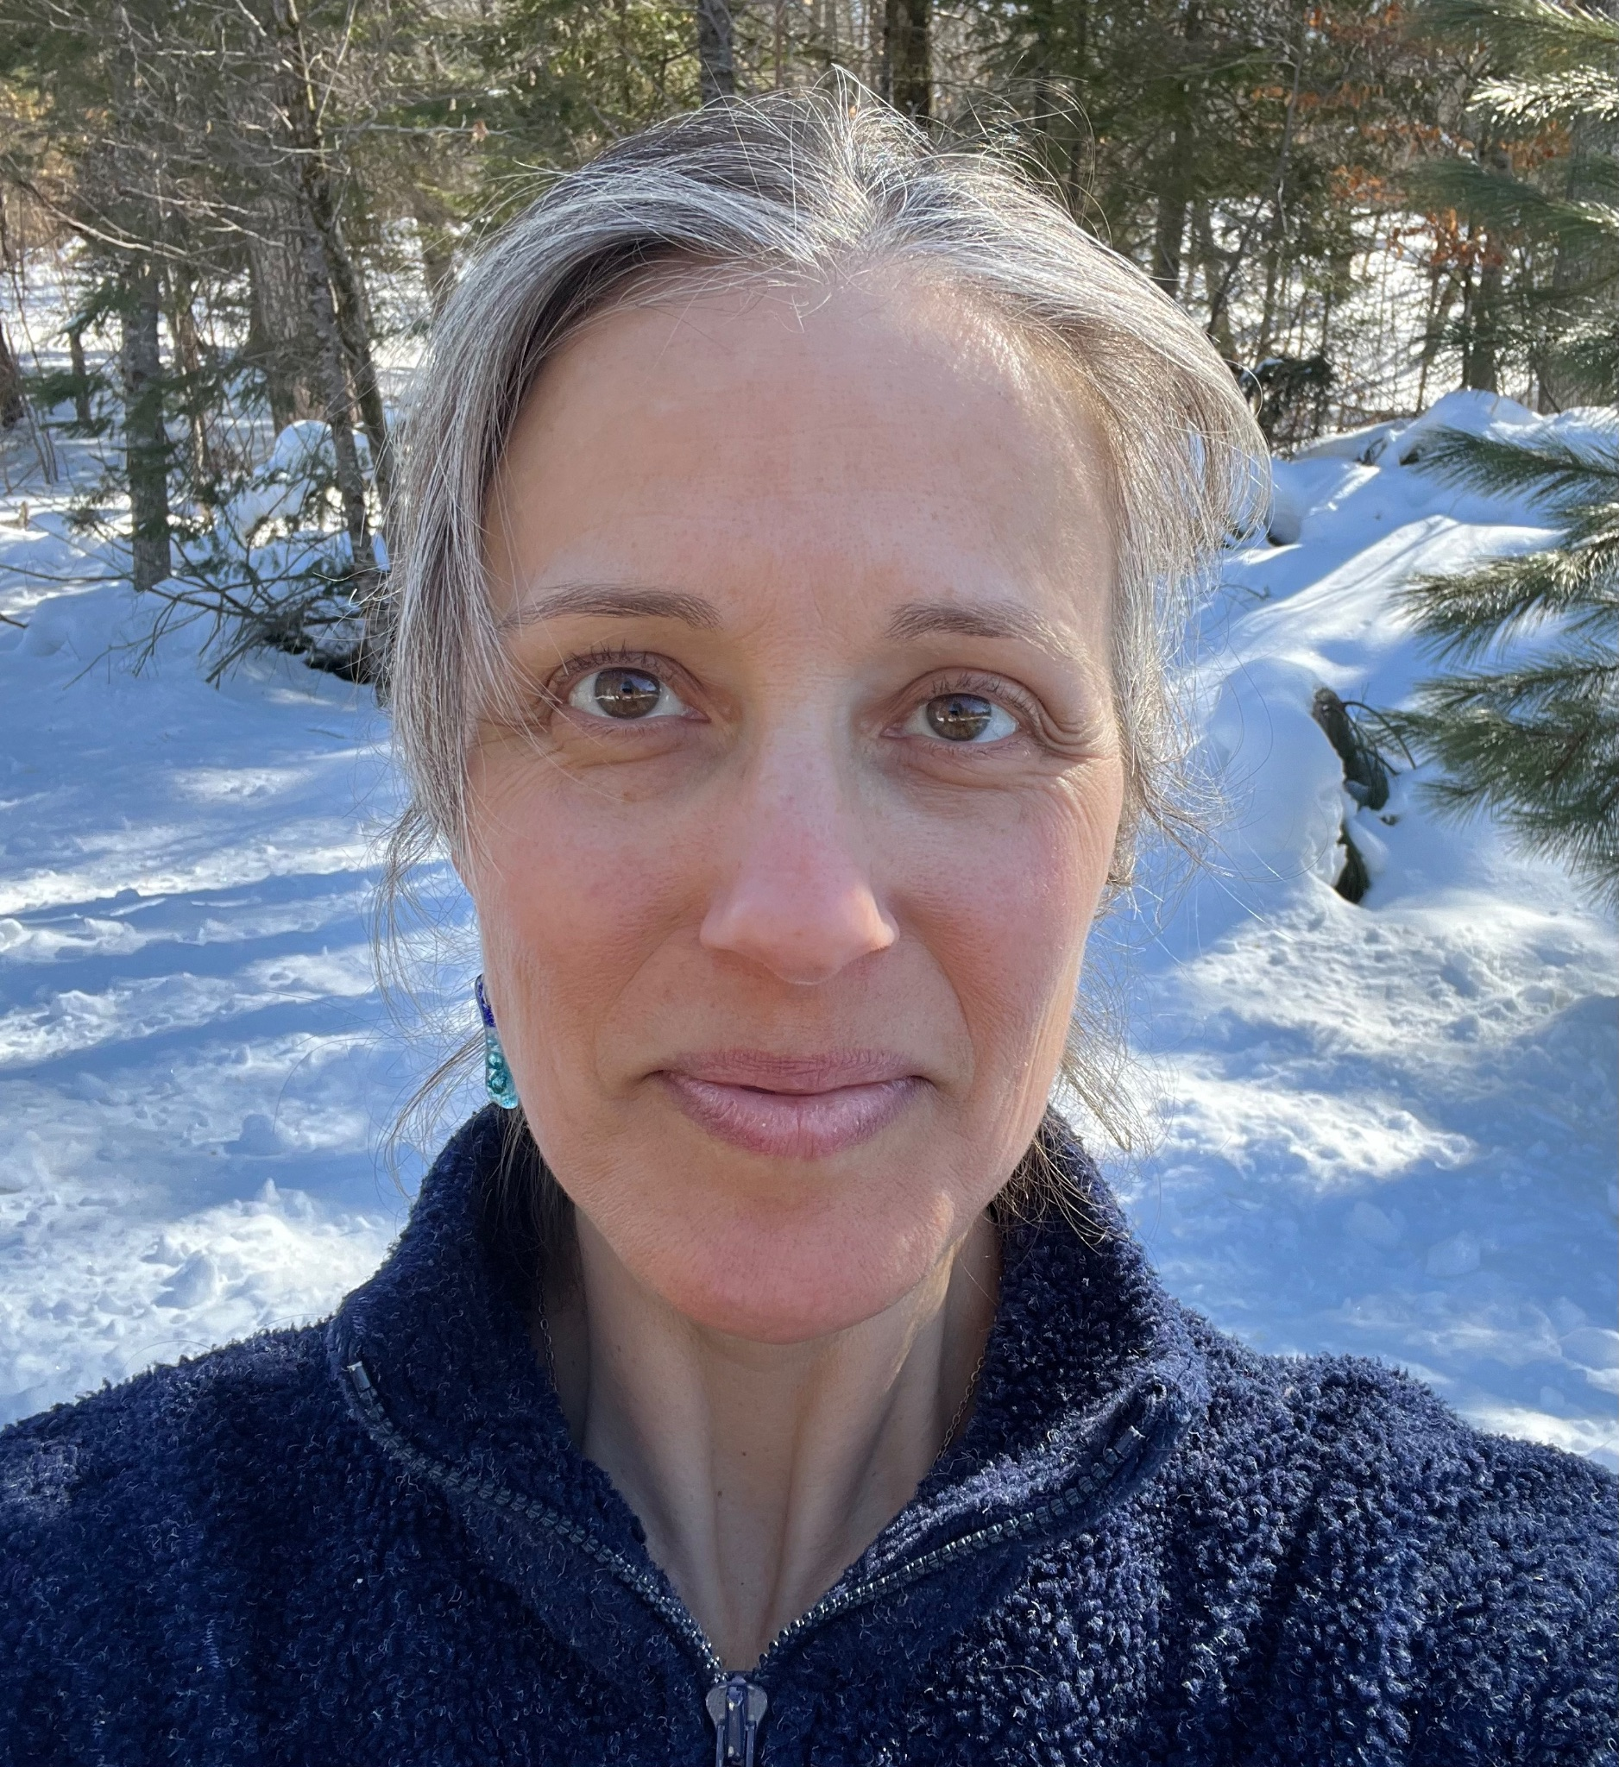

Rev. Emily Meyer creates contemplative retreats, liturgical arts, sermons, costumes, choreography, and performances. Along with contributing to Green Blades Rising and Lutherans Restoring Creation, Emily serves on the St Paul Area Synod’s Care of Creation Team, the ELCA’s Truth-Seeking and Truth-Telling Initiative, and as director of The Ministry Lab.

