
Green Blades Preaching Roundtable
September 1, 2024
15th Sunday after Pentecost
Year B.
Kristin M. Peterson, SAM
Bethlehem, Twig, Minnesota

Deuteronomy 4:1-2, 6-9; Psalm 15 ; James 1:17-27 ; Mark 7:1-8, 14-15, 21-23

Sunday, September 1st is part of our Labor Day weekend. It is a time where one can look back over the events of the summer or look forward to the preparations for fall including the start of school, a time to harvest, and a focus on stewardship.
As a preacher who is becoming accustomed to the rhythm of preaching every Sunday, I have often found Sundays and Seasons a helpful resource. This is particularly true as I prepare for preaching on September 1. There are several themes from which the preacher can choose (250).
- What things may be lawful but not moral?
- The importance of passing knowledge down through the generations.
- What is the role of hospitality? How do we share with other cultures and traditions, adding to our knowledge base rather than assimilating others into our culture?
- The danger of elevating human tradition above divine law.
- The importance of remembering that the Torah also gives rights to nonhuman animals and to the land itself.
- What is more important, our lives or our tradition?
- Do we worship God or do we worship the dogma that religion has created for us?
- When we value tradition over the well-being of creation, what impacts do we have on human and nonhuman ecosystems?
The list makes it clear that there are several areas where the assigned lessons can be connected to creation care. There are also additional connections that I discovered as I dug into these lessons.
One of those sources was a commentary written by Douglas Moe on the James text in The Lectionary Commentary: Theological Exegesis for Sunday’s Texts, edited by Roger E. Van Harn (522-525). For Moe, the focus of this reading is on how the gifts received from God are to be put into God’s service in specific and practical ways. We are reminded to be doers and not hearers. That God’s word, law, covenant is now written not on stones but in our hearts. God’s word brings new life when it is planted in our hearts. God’s word brings blessings, but it also brings demands: We are to bridle our tongues and care for ‘orphans and widows’ (James 26-27). “James ends with a reminder that faithfulness to the word is fundamentally a matter of one’s world view. ‘Keeping ourselves unstained by the world’ means allowing God’s word to reprogram our thinking so that our thought processes naturally emulate the values of Scripture rather than the values of the surrounding culture (524).” This section provides the preacher with an opportunity to discuss the ways in which our values are related to caring for all of God’s creation.
If you decide to focus on James in your preaching, consider incorporating the Alleluia verse for the Gospel Acclamation into your service “God gave us birth by the word of truth so that we would become a kind of first fruits of creation.” (Sundays and Seasons, 249) How might we act if we see ourselves as ‘the first fruits of creation’?
Both the First Lesson from Deuteronomy and the Gospel reading from Mark address the importance of following God’s laws. God’s laws are to be taught to all future generations. This reminds me that all of the actions that we take today have an impact on future generations. There are many examples of how our past actions have impacted the current state of creation. When human laws take precedence over God’s laws, we are asking for trouble. Just look at the current impacts of human created climate change.
In our Gospel reading Jesus takes the Pharisees and scribes to task for equating oral tradition with God’s laws. Here Jesus cites the prophecy of Isaiah concerning hypocrites, when he says, “in vain do they worship me, teaching human precepts as doctrines.” According to Bonnie Bowman Thurston in Preaching Mark, the version of Isaiah 29:13 used here comes from the LXX (84). (I only include this because if you look up Isaiah 29:13 in the NRSV, the words are not a perfect match.)
This reading provides just one of the examples of Jesus being in conflict with the Pharisees and scribes because humans have reinterpreted God’s laws in ways that benefit them rather than as God intended them to be interpreted. Here is another way to connect the lessons to caring for creation. When humans put themselves first, creating laws that can be used in ways that are not equitable, that do not promote justice, whose intentions are not pure, all of creation suffers.
Possible hymns:
Gathering hymn: #561 “Joyous Light of Heavenly Glory”
(A Hymn usually used for Vespers it fits with the James text v 17)
Hymn of the Day: #772 “Oh, That the Lord Would Guide My Way”
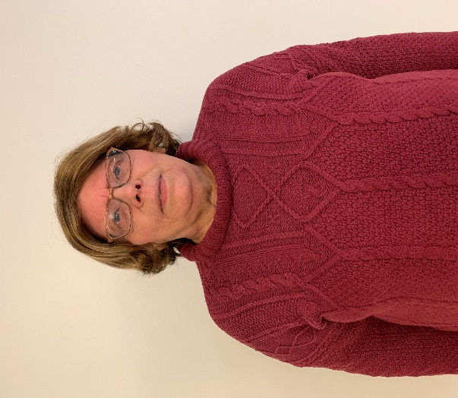

Kristin M. Peterson and her husband Tracy Close live in rural Hermantown outside of Duluth, MN. Kristin currently serves as the Synod Authorized Minister for Bethlehem Lutheran Church in Twig. She has a B.A. in Church Music as well as an M.A. in Religion and an M.M. in Music Education. For 27 years she taught courses in music and philosophy at Fond du Lac Tribal and Community College in Cloquet, MN. She has also served a variety of churches as organist and/or choir director. Living in the Northland provides her with daily reminders of how important it is to care for this wonderful creation that God has entrusted to us.

