Our Daily Bread: Regeneratively Grown & Offered for Sale

by Fredric L. Quivik

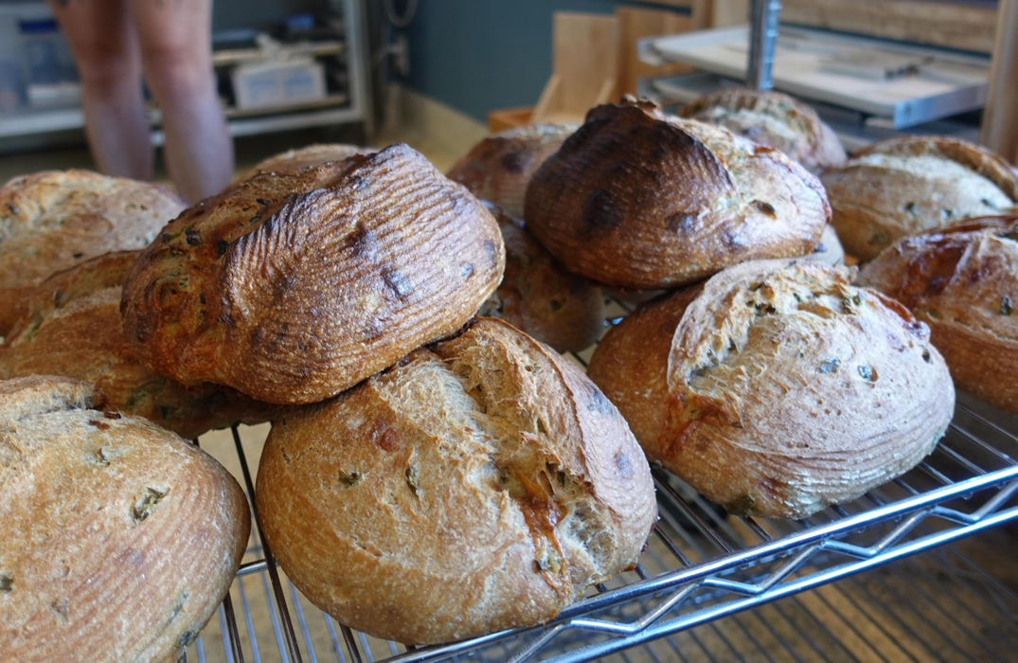

As someone who grew up on a dairy farm near Northfield, and whose father practiced crop rotation because of his Christian faith that inspired him to strive to leave the soil on his farm better when he left the farm that it was when he inherited the farm from his father, I have long followed conservation issues in agricultural practice, even though neither I nor my siblings went into farming.

As we now stare directly into the face of our looming climate crisis, my background interest in farming has helped me to understand that one of our biggest challenges as a species is figuring out how to feed the 8 billion people on our planet in ways that not only nourish people but also foster soil health while reducing our dependence on fossil fuels for mechanical power, fertilizers, and pesticides and herbicides. I’ve been especially interested, as a member of the ELCA’s Saint Paul Area Synod’s Care of Creation work group, to have learned about the movement for regenerative agriculture. I’m inspired by the work of Walker Farms, which we visited in 2021.

The thought that has concerned me, however, is that I live in Saint Paul, in a city. I’m not a farmer, so deciding to switch to regenerative practices is not a direct option for me. Although we have a backyard garden, we depend on retail outlets for most of our food. This means that, if I want to promote agricultural practices that are consistent with my sense of call to care for God’s creation, I need to look for ways to do that as a thoughtful consumer. One surprising way I’ve found to do that is through the bread we buy from a Saint Paul bakery on West 7th called Brake Bread.

Owned by Nate Houge, Brake Bread got started some years back as a neighborhood enterprise predicated on the idea that the business would deliver the staff of life to its subscribing neighbors using bicycles. (The “Brake” in the name refers to bicycle brakes.) My wife and I live in a different part of Saint Paul, so we learned about Brake Bread when friends who were visiting for supper brought a loaf from Brake Bread as a hostess gift. Then we noticed that our food coop, Mississippi Market, carries loaves from Brake Bread, which in turn led us to check out the storefront on West 7th. It’s great bread, and we quickly became enamored not only with the quality of the bread but also with the wonderful names: Batard du Nord, This is Nacho Bread, Ryed On, Seeds the Day, Olive You, Walnut Listen to Raisin, etc. We got on Brake Bread’s email list, and have enjoyed getting messages that end with, “We loaf you.”

It was only after learning about regenerative farming through our visit to Walker Farms that I noticed in the small print on Brake Bread’s website that most of the flour they use comes from wheat grown regeneratively. That led me to interview Nate about his business. I learned that, like the rest of us, his ideas evolved about how his business could mesh with a desire to care for creation. Starting with the basic model that he wanted his business to be serving his neighbors via bicycles, he then decided that he wanted his wheat to be grown organically and to be sourced locally. He then learned about wheat grown regeneratively when he started having his wheat ground into flour at Baker’s Field, a small flour mill and bakery in NE Minneapolis that specializes in such things.

Nate reflects deeply on the challenges of being in the food business and also being part of the US economy. He and his staff must make business decisions that allow the enterprise to stay open, and those decisions are often in tension with his objectives of serving his neighbors with healthy food that is sustainably produced. He observed during the interview that “capitalism is the survival of the strongest, and grace is the survival of the weakest.” That’s spoken like a true pastor’s spouse (Nate’s wife, Rev. Jodi Houge, is pastor of nearby Humble Walk Lutheran Church). Talking with Nate, I was reminded of what a bind we find ourselves in if we make our primary identity that of consumers, which means that our main objective is to find the cheapest purchase price. Searching for the cheapest food puts intense market pressures on farmers to use cost-cutting but unsustainable methods, like heavy reliance on mechanization, artificial fertilizers, and chemical pesticides and herbicides, and being moved to hire the cheapest labor possible, which exacerbates social problems, like unsafe working conditions and unresolved immigration issues. Searching for the cheapest food puts intense market pressure on feedlots and slaughterhouses to use methods that are unsafe for humans and inhumane to animals.

Brake Bread serves a neighborhood in which many residents do not have the luxury of opting for excellent bread like that sold at Nate’s bakery, and he struggles over that fact, knowing that many of his neighbors must travel a considerable distance to find a supermarket that sells food at cheaper prices.

Brake Bread is also sold in Saint Paul food coops, which label the produce, meats, and dairy that is locally produced and/or produced using organic methods. For example, Mississippi Market stocks chicken grown and slaughtered at Kadejan Inc., a family-owned farm at Glenwood, Minnesota, where the chickens live in free-range environments and where the meat is minimally processed. Those sorts of options are also increasingly available in supermarkets like Cub and Kowalski’s, where we now find significant organic selections in the produce section.

The challenge is this, since we city folk are not farmers: what sorts of market pressures can we as consumers bring for these stores to venture further into making available foods that are healthier and produced in environmentally responsible ways? Can we hope that someday soon, perhaps, we can also see food options in supermarkets that advertise being regeneratively grown, and that our purchasing actions can comport more fully with our values of caring for creation?

