Green Blades Preaching Roundtable
Ash Wednesday
February 22nd, 2023
Matthew 6:1-6, 16-21; Joel 2:1-2, 12-17; Psalm 51:1-17; 2 Corinthians 5:20b-6:10

Rev. Paul McLean Strike

I’m drawn to the ashes on this day. Isn’t everyone? These charred remains were once celebratory palm fronds, used to mark Jesus’ royal entry into Jerusalem with shouts of “Hosanna!” Now, with a little oil, the ashes are made into signs of the cross, naming and claiming us as sinful beloveds of God in Christ. These bits of earth tell me that I am but a part of the cosmos that needs the redemptive healing and care that Christ provides.
The gospel passage for today reminds me of God’s claim on us. Unlike the hypocrites, who seek the attention of others in what they do, the true follower pays attention only to God’s desire for them—for their eternal treasure is built up in their relationship with God. That relationship isn’t simply spiritual, but involves the whole being—physical body included. How we live in the world—in relationship with one another, in relationship with the dust around us (ie. all that God has made, touched, and loves)—is critical to our relationship with God. The ashes, for me, bring to the fore this physical/embodied facet of the relationship.
An Ash Wednesday blessing from Speak it Plain: Words for Worship and Life Together, by Meta Herrick Carlson, conveys this idea much better than I can:
Tonight we remember
that we come from the dust
both earthen and cosmic
thanks to bursts of atoms
billions of years old,
still chasing
the coattails of kairos.

We are the heavy elements:
carbon, nitrogen, oxygen,
pressed and held down
by the gravity of sin
trapped in the stillness,
waiting for nova until
wind, breath, spirit
fills the ordinary
and everywhere
with more.

Tonight we remember
that we come from the dust
by listening carefully
to the sound of our chests
rising and falling,
fragile with the wonder of dust
that lives.

On this day, may the “wonder of dust” bring us deeper into the love God has for us and for the fragile, yet precious, world God has made!

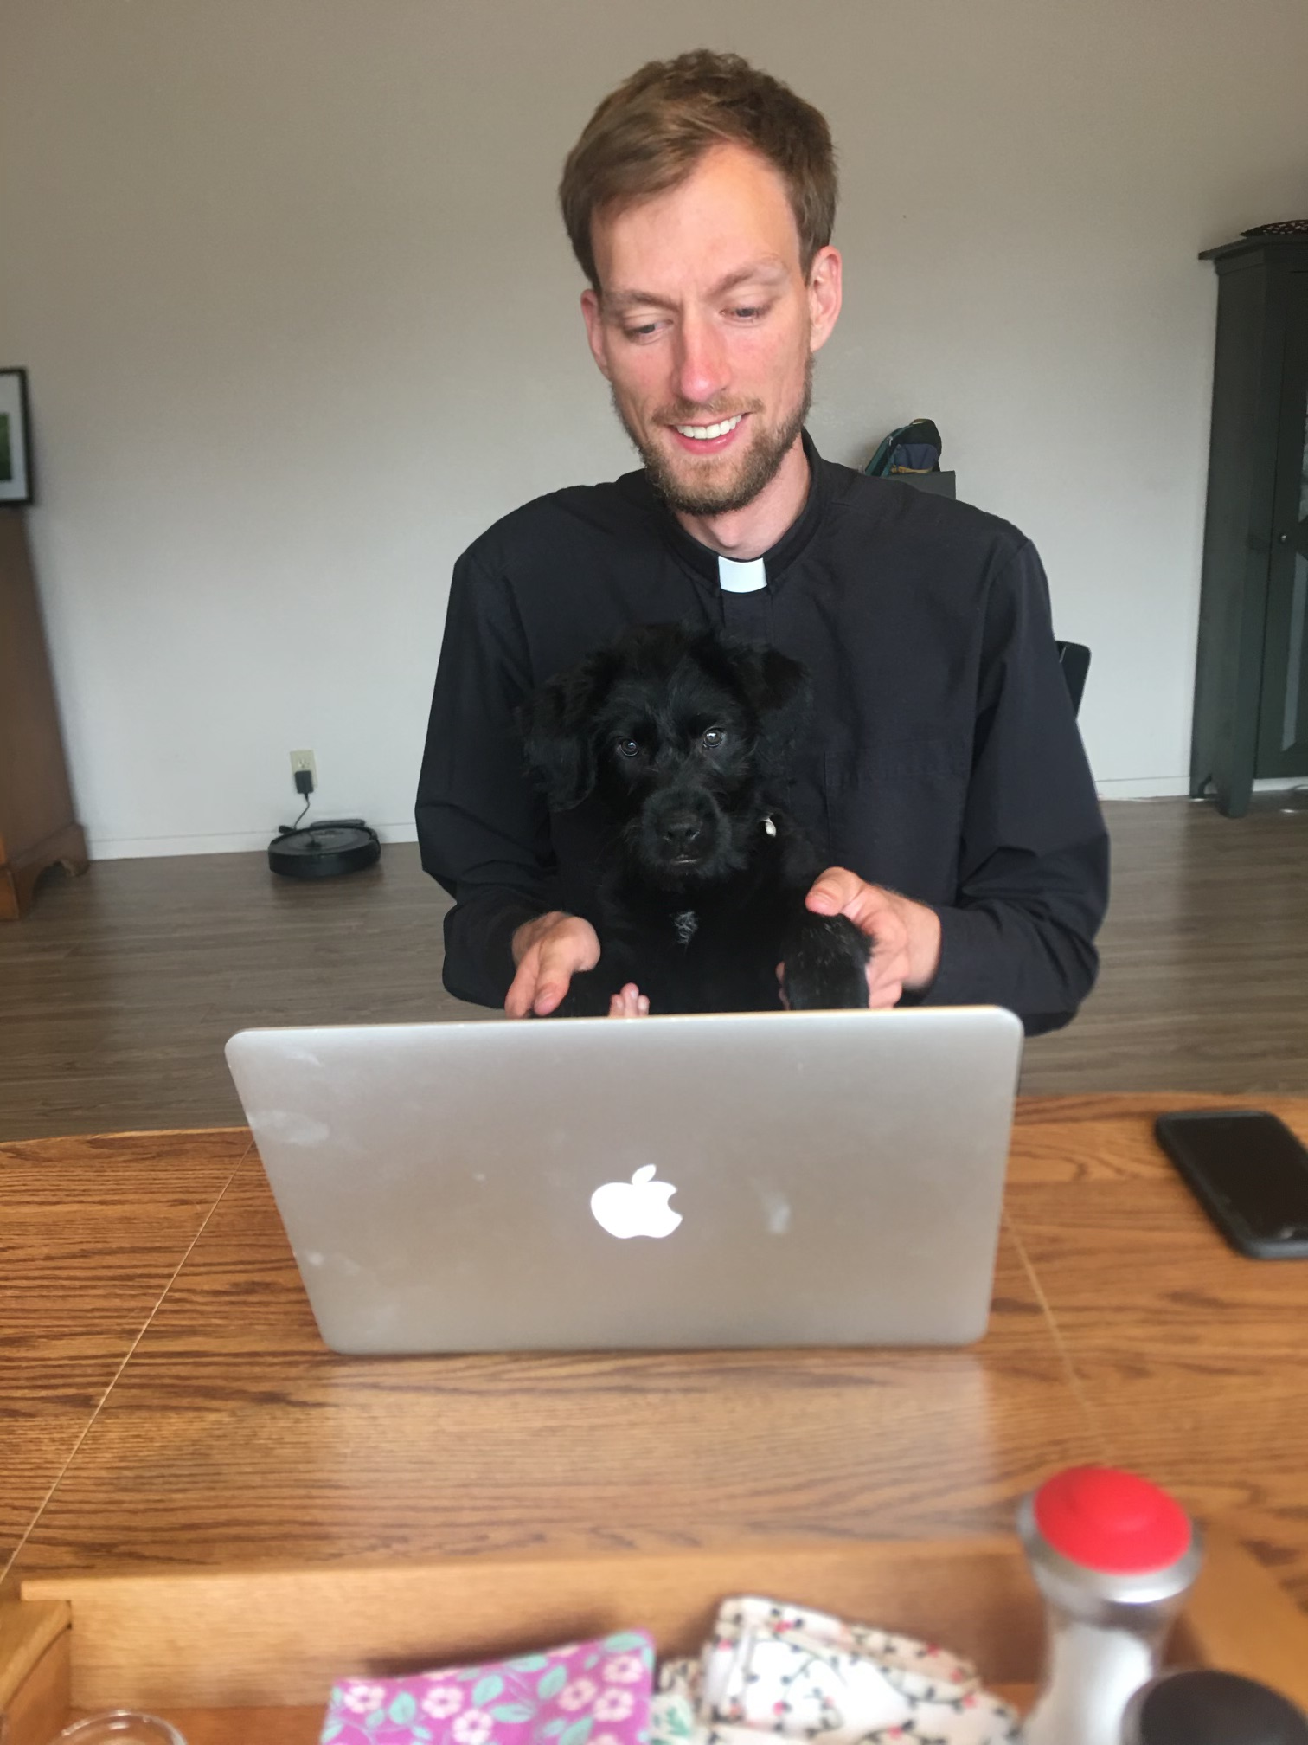
Paul McLean Strike is a first-call pastor at New Life Lutheran Church (ELCA) in Florence, Oregon. He lives with his wonderful spouse, Logan (also an ELCA pastor) and puppy dog named Beans. He enjoys running through the woods, on the beaches, and anywhere a trail can be sustainably made.

