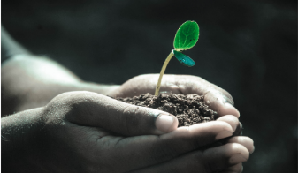
Green Blades Preaching Roundtable
AWE & WONDER, JOY & PRAISE
PAIN & STRENGTH, LOVE & CHANGE
Rev. Emily Meyer reflects on the reciprocal relationship between creation’s beauty and the strength of Love to change the world.
….
Care for Creation Commentary on the Revised Common Lectionary
Readings for ELW First Sunday after Christmas Day, Year C (2024-2025)
December 29, 2024
1 Samuel 2:18-20, 26; Psalm 148; Colossians 3:12-17; Luke 2:41-52

The Rev. Emily Meyer, Minneapolis, MN

Hymn suggestions:
Love Has Come - ELW #292
Canticle of the Turning - ELW #723
Joyful, Joyful We Adore Thee - ELW #836
Before the Ancient One, Christ Stands - All Creation Sings #953

Additional Liturgical Elements & Readings:
Ring the Bells that Still Can Ring - Rosemerry
Two Arrows - A Meditation by Rev. Cameron Trimble
Braiding Sweetgrass: Indigenous Wisdom, Scientific Knowledge and the Teachings of Plants - Robin Wall Kimmerer

Let’s take a quick gander at today’s Gospel reading: Mary and Joseph have lost their son, God’s son. He is missing (not coincidentally) for three days (think ‘tomb’). The tone of the story is almost hilarious in its gentility: Joseph and Mary are ‘astonished’; Mary confesses to being ‘anxious’.

I’m not sure this author appreciates what it is to love a child - and then have that child go missing.

The terror and trauma, the grief and fear, the physical heartache and debilitating anxiety would overwhelm most of us.

This kind of love and loss stops us in our tracks, turns our world upside-down, changes our lives.

My guess is our language would be a bit stronger than Mary’s, when the child was found.

As would the displays of affection: the hugging and weeping and full-body collapse - both from grief reversed and from the physical exertion of searching.

In this Sunday after Christmas, this story centers the gut-wrenching, heart-stopping pain and fear of loss God experiences as humanity loses its way and walks away from Love, too eager to return to the familiar comforts of what has been ‘home’ - and invites us to return to the Divine house, where rest and new learning prepare us for the road of healing, repair, and restoration.

I confess: I began thinking about this reflection before reading the texts.
I assumed we’d be reading the Slaughter of the Innocents.
I was prepared to gloat at how appropriate it was to read about the death of children in the midst of today’s milieu of fear, hate, and scapegoating.

I wanted to be able to self-righteously urge us into acting on behalf of families who will be torn apart through deportation; children (and people of all ages) who will be threatened and killed by emboldened fear and hatred; whole villages and cultures that will be decimated by climate disasters that are the result of ego-centric tyrants focussed on their own immediate gratification and self-preservation.

I wanted to read about Herod and his ego-maniacal slaughter of the innocents because it seemed so fitting.

But we are faced with a tale of one family’s willingness to loan their firstborn child to God - because of love; a song calling us to join ó kosmos in offering our whole selves in joyful praise; a letter urging us to clothe ourselves in Divine compassion, humility, and love; and a story inviting us to wonder about love’s power to turn us on our heels.

We are faced with a Child teaching us that we ought not rush back to the comfort and familiarity of the home we have known; it is more important to rest and learn in our Divine Parent’s house.

For some of us, rest and joy and Love are the more challenging call.

Fear, hate, and scapegoating are so much easier.
Action and gloating and self-righteousness, which are iterations of fear and hate and scapegoating, are so much more self-satisfying.

But to meet fear, hate, and scapegoating with more of the same is ruinous in the extreme. And self-satisfaction is burn-out inducing fuel.

Rather than retread that familiar road on this First Sunday after Christmas Day, we are invited to rejoice and be renewed, to revel in praise with the whole beautiful world!

Rejoicing feels like a guilty pleasure, or even false, these days, but the Psalmist calls us to revel in praise - along with the whole of God’s glorious creation.

Indigenous botanist and author Robin Wall Kimmerer (Citizen Potawatomi Nation) writes, “Even a wounded world is feeding us. Even a wounded world holds us, giving us moments of wonder and joy. I choose joy over despair. Not because I have my head in the sand, but because joy is what the earth gives me daily and I must return the gift.”

Our joyful praise is a gift to creation.
Joining in creation’s praise we practice interconnectedness.
Joining in creation’s praise, we experience awe and wonder.
Awe and wonder are the beginning of Love.

The kind of deep, real, powerful Love that turns us on our heels; that changes the world.

Wall Kimmerer also writes, ‘Knowing that you love the earth changes you, activates you to defend and protect and celebrate. But when you feel that the earth loves you in return, that feeling transforms the relationship from a one-way street into a sacred bond.’

Change in the human heart is what our world needs. God has been working on this for millennia: first through the Law, then in this Christ child we know as Jesus, and in these latter days through the Holy Spirit breathing Love like a wild-fire into human hearts.

Do we know this kind of life-changing, world-changing Love? What do we love so much that when we are separated from it we are brought to our knees; our heart becomes lead in our chest; our breath becomes shallow, our lives turn upside-down, our routines are forgotten?

Mary and Joseph turned around from the way they were going, abandoned all hope of ‘getting home on time’, forsook the safety of their traveling band, raced back - against traffic - to the squalor of the city, searched for three days (most likely alone), with bated breath and beating hearts. Mary and Joseph experienced the extraordinary grief and loss that accompanies Love.

When the object of our love goes missing, or is wounded or dying, our hearts break, our world is rearranged, our souls sink. Which is why some people choose not to love.

Author and activist John Green writes,

“At the end of his life, the great picture book author and illustrator Maurice Sendak said on the NPR show Fresh Air, 'I cry a lot because I miss people. I cry a lot because they die, and I can't stop them. They leave me, and I love them more.'
He said, 'I'm finding out as I'm aging that I'm in love with the world.'

Green continues:
It has taken me all my life up to now to fall in love with the world, but I've started to feel it the last couple of years. To fall in love with the world isn't to ignore or overlook suffering, both human and otherwise. For me anyway, to fall in love with the world is to look up at the night sky and feel your mind swim before the beauty and the distance of the stars. It is to hold your children while they cry, to watch as the sycamore trees leaf out in June. When my breastbone starts to hurt, and my throat tightens, and tears well in my eyes, I want to look away from the feeling. I want to deflect with irony, or anything else that will keep me from feeling directly. We all know how loving ends. But I want to fall in love with the world anyway, to let it crack me open. I want to feel what there is to feel while I am here.”

Joy and praise - reveled in and experienced in creation’s diverse abundance - lead to awe and wonder.
Awe and wonder lead to Love.
Love and pain, our Gospel reading reminds us, are inextricably linked.
Yet, through pain, Love changes us.
The pain - and the change - are gifts.

In a 2023 interview, Robin Wall Kimmerer, ‘encouraged a shift in worldview, toward humans treating every part of nature as family rather than as an “it,” and seeing the reciprocity between animals, plants, rivers, and humans. She ultimately answered her own question: “What does the earth ask of us? The earth asks us to change.”

The earth needs us to change.
Love changes us.
Can we fall in love with the world?
Do we dare Love this planet and our fellow human beings, with God’s knee-weakening, heart-wrenching kind of Love?
Do we dare allow ourselves to experience the terrible pain of knowing the treacherous road we walk?

Love changes us.
The pain - and the change - are gifts.

This is the celebration of Christmas: For God so loved the world…

When we deeply love, yes, our hearts may hurt and bruise and even break within us, but they also become full and strong and resilient in the extreme.

Love is the strength that gave birth to Jesus.
Love is the strength that found Jesus.
Love is the strength that fueled Jesus’ ministry.
Love is the strength that carried Jesus’ cross.
Love is the strength that brought Jesus from death to New Life.

In our interconnectedness with ó kosmos we are sustained and upheld through joy and praise, awe and wonder; through our interconnectedness with all that is we are strengthened by Love to turn around, to walk a different road, to change, and to be the change that will heal and repair this globe.

Originally written by Rev. Emily P.L. Meyer for Green Blades Rising Preacher’s Roundtable.
ministrylab@unitedseminary.edu
Find more from Emily Meyer at www.theministrylab.org.

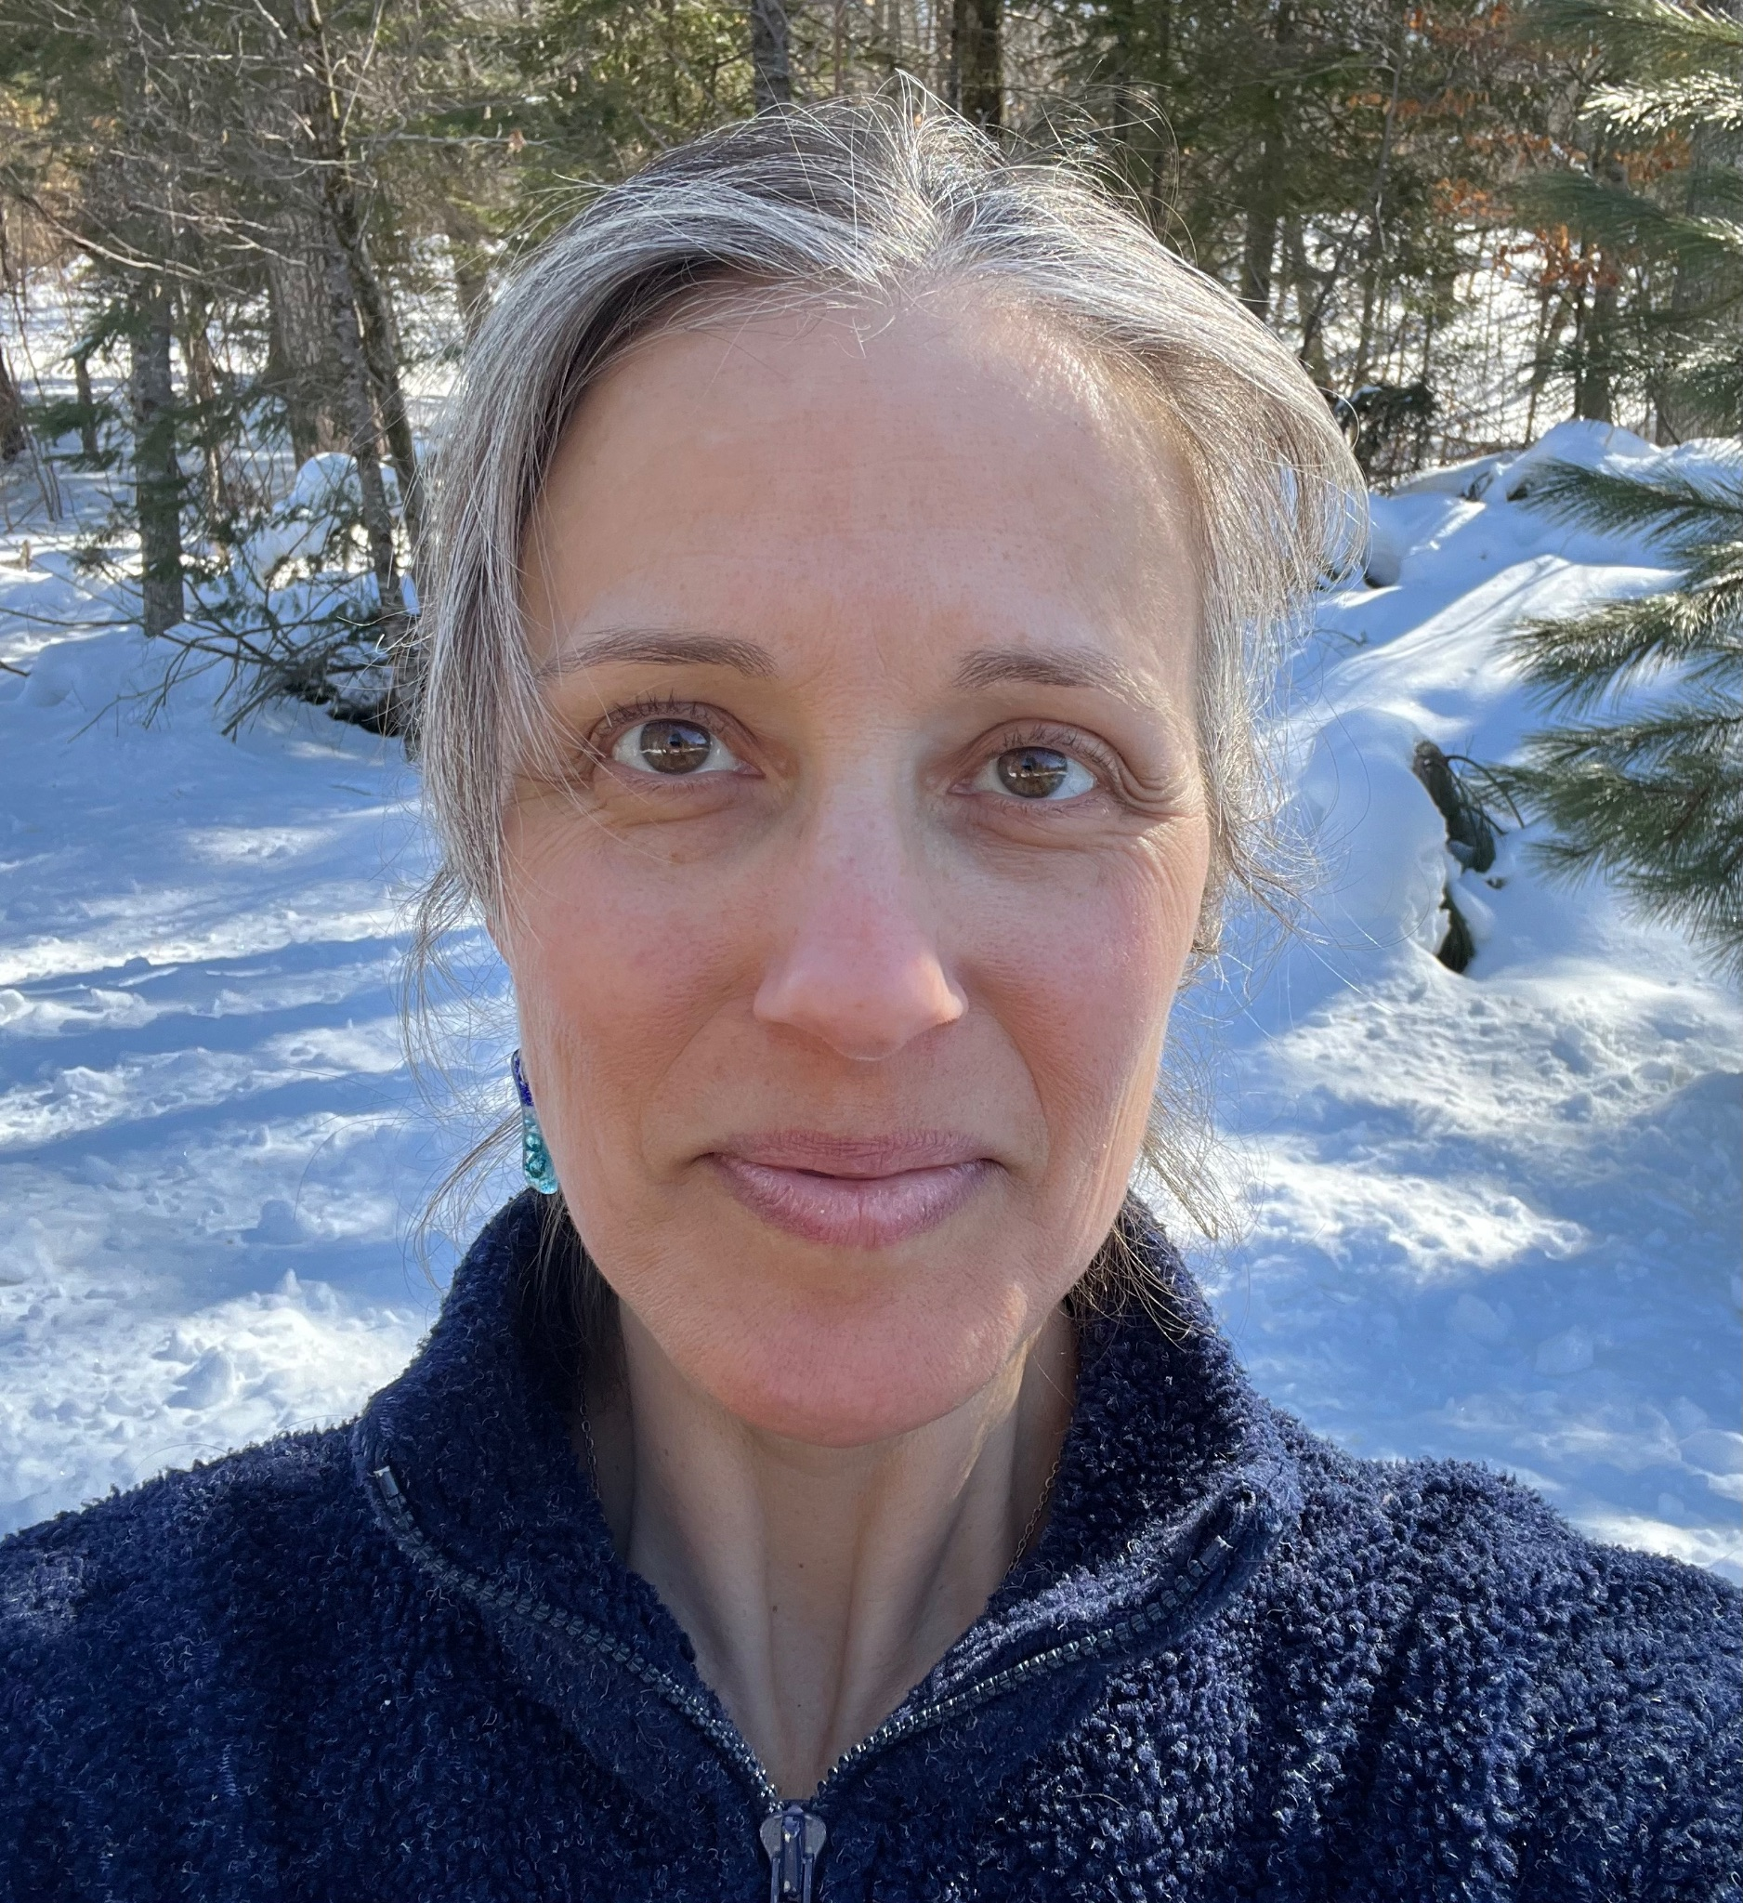

Rev. Emily Meyer creates contemplative retreats, liturgical arts, sermons, costumes, choreography, and performances. Along with contributing to Green Blades Rising and Lutherans Restoring Creation, Emily serves on the St Paul Area Synod’s Care of Creation Team, the ELCA’s Truth-Seeking and Truth-Telling Initiative, and as director of The Ministry Lab.

I wonder why Jesus didn’t reference this story of his parent’s search when telling the story of the Lost Coin and Lost Sheep…
Wall Kimmerer, Robin. Braiding Sweetgrass: Indigenous Wisdom, Scientific Knowledge, and the Teachings of Plants; accessed on GoodReads: https://www.goodreads.com/author/quotes/49921.Robin_Wall_Kimmerer; 11.21.24
Wall Kimmerer, Robin. Braiding Sweetgrass: Indigenous Wisdom, Scientific Knowledge, and the Teachings of Plants; accessed on GoodReads: https://www.goodreads.com/author/quotes/49921.Robin_Wall_Kimmerer; 11.21.24
Green, John. The Anthropocene Reviewed: Essays on a Human-Centered Planet: GoodReads; https://www.goodreads.com/quotes/10857726-at-the-end-of-his-life-the-great-picture-book#:~:text=Sign%20Up%20Now-,At%20the%20end%20of%20his%20life%2C%20the%20great%20picture%20book,feel%20while%20I%20am%20here; accessed 11.22.24.
Long, Julie. ‘Author Robin Wall Kimmerer asks, “What does the earth ask of us?”’: Nazareth University News; https://www2.naz.edu/news/archive/2023/March/749/author-robin-wall-kimmerer-asks-what-does-the-earth-ask-of-us; access 11.22.24.
Rosemerry. Ring the Bells that Still Can Ring: https://ahundredfallingveils.com/2024/11/03/ring-the-bells-that-still-can-ring/; accessed 11.21.24.

