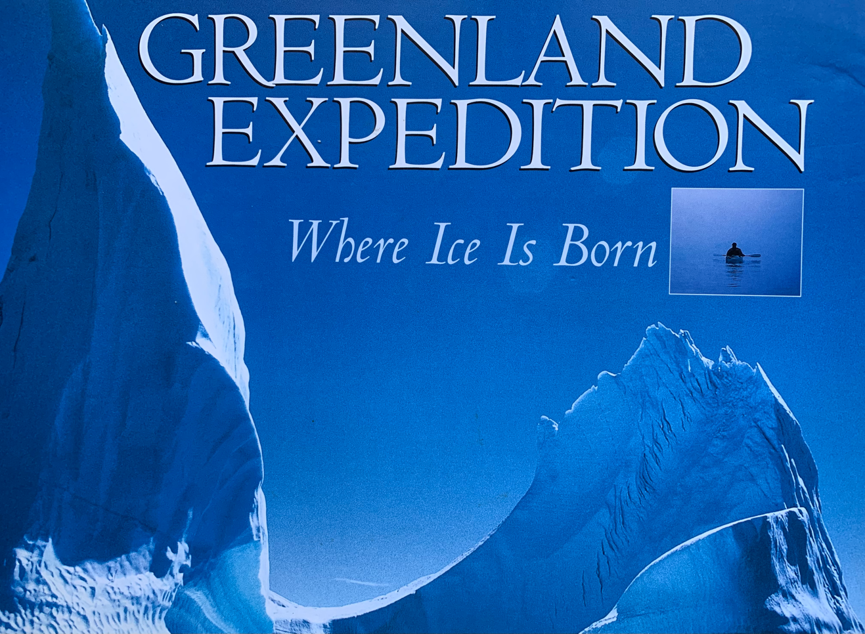
Cover photo from Lonnie Dupre’s book

What makes a person become an explorer? For Lonnie Dupre, it seems it was mainly curiosity. Growing up on a farm in Minnesota, he loved winter, perhaps partly because it was a break from working on his dad’s farm on hot summer days. He thought he lived in about the coldest place on Earth, so when he found out there were people who lived much farther north, he had to learn more about them. He started to study the Inuit and learn about their culture, then he took those learnings with him on his expeditions.

After a few expeditions in the Northwest Passage, Alaska, and the Nordic countries, he found a partner in John Hoelscher of Australia to undertake the 6500-mile circumnavigation of Greenland in segments from 1997 to 2001, using only traditional means of transportation - dog sledging on the north side and kayaking around the south side. The whole center of Greenland is covered by an ice cap averaging 1-1/2 miles thick. They are the only team to complete this human- and dog-powered feat, and according to Lonnie, as the shoreline is changes with the climate, they may be the only ones to ever be able to do it. There was one portion where they had to pull themselves over rock ice the size of footballs with gaffe hooks while sitting in the kayak. It wasn’t frozen enough to walk or sled on, but there was not enough water between the ice chunks to kayak through either. The routes between villages are becoming more dangerous and difficult as the fjords become impassable by dogsled. Lonnie noted a spot in the fjord which was 7 feet thick on his expedition and 20 years later, in a visit to see some of his old friends, the same spot was only 18” thick. Denmark is in the process of remapping the coast as it changes with the times.

Lonnie had to round up a team of dogs for his expedition, and he spent months training them and getting them in shape for the trip. As the dogs made their way across the ice in their traditional Inuit fan-hitch formation, they were the first line of defense against the polar bears and the Arctic wolves. The dogs stand watch around the tent as the men sleep at night. They all eat together as well. Everyone needs the high fat seal meat for energy – men and dogs alike, and they eat about 6000 calories/day. The fat in marine mammals is Omego-3 fat, so it is well absorbed by the body for energy. Lonnie clearly has a deep fondness for the dogs, so when he was done with the expedition, he wanted to find good homes for them. He searched around and settled on a few special young Inuit that really appreciated getting a few of their own dogs. You can just see the pride in all the Inuit faces in Lonnie’s photos and videos. They know they are carrying on the traditions of their ancestors and surviving in a challenging landscape.

The population of Greenland today is only around 57,000 even though it’s a much larger land mass than Alaska. Most are Inuit, but there are some Danish and some Inuit/Nordic people. Their life is spent hunting and fishing. They wear the traditional sealskin boots, polar bear pants, and blue fox coats. They eat mainly seal and fish as it is the most plentiful, but they also hunt polar bears, walrus, and narwhal. One of the first food descriptions Lonnie shared with us was the Inuit practice of hunting little sea birds during the summer by catching them in a net with a 12’ handle while they flutter overhead and gathering them at their feet in a pile. To preserve some food for winter, they put a pile of birds “feathers and all” into a sealskin hide, press all the air out of it, sew it shut, and pile rocks on top of it. The fermented bird meat will eventually help them get through the long winter. The sun goes below the horizon on Oct. 16 and comes back up on Feb. 17. It’s called Polar Night. (No, thank you!)

There are only two supply ship visits per year to Greenland for all their supplies –building materials, diesel fuel for electricity, food staples, medical supplies, etc. – and they come around July and September. With the loss of sea ice, it may be easier for the ships to get in, but it becomes more difficult to get to their traditional hunting grounds. Due to the challenges with transportation, more of the population is moving to the larger villages, and we know this is literally just the tip of the iceberg. As you get closer to the poles, the climate is seeing a greater increase in average temperature that is affecting the landscape.

The dog sled culture defines life in Greenland; it is their main mode of transportation for getting to their hunting grounds. It has defined their life together for their remembered history. At the current rate of change that culture will end with this generation, as dog sledging becomes impossible. For native Greenlanders, this leaves a future that is impossible to imagine.
