
Green Blades Preaching Roundtable
Second Sunday of Easter
April 7, 2024
Year B.
Acts 4:32-35; Psalm 133; 1 John 1:1-2:2; John 20:19-31

Gary Hedding, Chippewa Falls, Wisconsin

I am delighted by these Easter texts. What delights me and encourages me is their refusal to allow the resurrection of Jesus to be relegated to some kind of “spiritual” experience that took place in the hearts and minds of Jesus’ disciples. These texts emphasize the embodiment of the resurrection and what naturally follows from that embodiment. What follows, in these texts, is relationship with God through the embodied fellowship of the redeemed world and its people.

Immediately prior to verse 19 of John chapter 20, Mary Magdalene spots a man near the tomb who looks pretty ordinary. No halos, no heavenly appearance or soft glow about him. He addresses her with kind questions about why she might be crying and if she was looking for someone in particular. And she doesn’t recognize his voice. This is not a spiritual apparition but a man who looks like a gardener. The Gospel text continues this presentation of Jesus embodied in resurrection. OK, Jesus comes into a locked room without apparently opening the door, I will give you that, but immediately after saying, “Peace be with you”, shows them his pierced hand and side. He comes to them with a body that still bears its wounds, not a spiritual or heavenly body. Later Jesus will make breakfast for some of the disciples on a beach and eat with them.

Then, Jesus sends them, first breathing the Holy Spirit into these frightened followers. The Greek word here is the same word used in the Greek Septuagint translation of the Genesis text of the account of God creating Adam’s body and breathing life into him. It is the only time this word is used in the New Testament.

Jesus describes sending the apostles by saying, “If you forgive the sins of any they are forgiven them, if you retain [the sins of] any they are retained.” NRSV. Note the brackets. The words in the brackets do not appear in the Greek. You can make a case that they can be assumed by reason of the context, but I don’t buy that. The disciples are not called to forgive sins or pronounce that their sins will be retained, which would be truly terrifying, and, when practiced has crushed many a child of God. They are called to forgive sins and retain people in the fellowship of their gathering. The key evidence for this is that the first thing they do after Jesus’ visit is to retain Thomas. Thomas missed this first appearance of Jesus and says quite clearly that he will not believe in a resurrected Jesus unless he can, not only see but, put his hands in Jesus’ wounds. What do the disciples do with faithless Thomas? After all, in John’s Gospel the key sin is unbelief. They retain him, doubts and all. A week later Thomas has been invited into their fellowship, even with his unwillingness to trust in the proclaimed word of resurrection. There and then, Jesus comes to him, too. Thomas believes and Jesus emphasizes that there is a blessing for those who don’t actually see the embodied risen Jesus, but still believe his bodily resurrection. Retained fellowship with followers of Jesus is the doorway for faith along with the proclamation of the forgiveness of sins, which are then really forgiven. This faithful fellowship embodies the Word that creates belief.

The text from Acts 4 continues to describe the fellowship of believers in a way that embodies a life like Jesus. “With great power the apostles gave their testimony to the resurrection of the Lord Jesus, and great grace was upon them all.”(v.43) This resurrection grace is what makes the fellowship of the believers trusting enough to have no private ownership, but to rely on the apostles to give the combined wealth to those who need it. The Bible is honest enough to let us know that Ananias and Sapphira couldn’t live in that kind of trusting fellowship and that later there was a challenge to the fairness of the apostles which was addressed by the calling of deacons to manage the distribution to those in need. Nevertheless, the resurrection of Jesus is embodied in this kind of trusting fellowship.

The text from 1 John continues these themes. The embodied and resurrected Jesus is proclaimed not as a thoughtful example of something spiritual, but as “what we have seen with our eyes, what we have looked at and touched with our hands, concerning the word of life”. Then the text reveals the purpose of the embodied proclamation: “we declare to you what we have seen and heard so that you also may have fellowship with us; and truly our fellowship is with the Father and with his Son Jesus Christ.” This is not just for human fellowship. “He is the atoning sacrifice for our sins; and not for ours only but also for the sins of the whole world.” Jesus’ redeeming and embodied resurrection extends fellowship to the whole world. The world experiences the brokenness and alienation that sin has introduced into God’s creation. Jesus’ embodied resurrection redeems the whole world from this brokenness and alienated break in fellowship. Robin Wall Kimmerer, writing from her Potawatomi culture, describes this in her book Braiding Sweetgrass: Indigenous Wisdom, Scientific Knowledge and the Teachings of Plants. Her perspective declares that the Creator has established fellowship with all things in creation. She writes about how rocks are the eldest siblings of humans, plants are next eldest, animals are next and humans are the youngest of the Creator’s family. We need to look and learn from our elder siblings. Exchange among siblings is thought of as gifts given and gifts offered in return. Any mineral, living plant or animal which is harvested is a gift from them for our need and in return humans give a gift of active care for the earth and a respectful gift of tobacco or other symbol that recognizes creation’s gift. Private ownership, as in Acts 4, is not recognized as embodying the Creator or as healthy for our fellowship with humans for the rest of creation.

Lastly, Psalm 133 is an extravagant picture of unity in fellowship. A well-oiled beard that drains into a collar is a luxury that is like this kind of unity. The beauty of dew sparkling on Mount Hermon is like the beauty of siblings that live in unity. This is the Lord’s blessing - life forevermore.

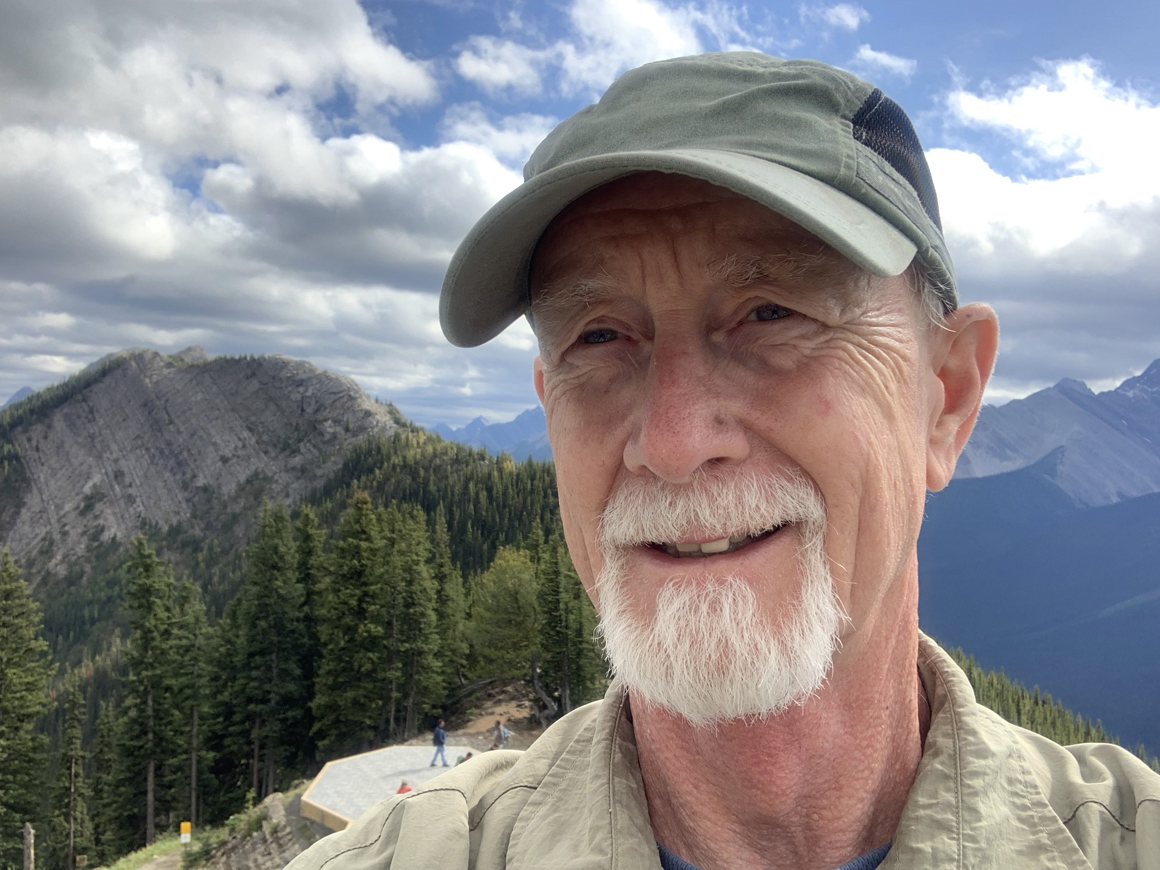
Gary Hedding is a retired pastor who graduated from Luther Seminary in 1978. He served his internship in Brooklyn, NY. His first call was Prince of Peace Lutheran Church in Coloma, WI; then as associate pastor and later lead pastor at Faith Lutheran Church in Marshfield, WI; followed by serving six years as assistant to the bishop in the Northwest Synod of WI; then as pastor of Bethlehem Lutheran Church in Cedar Falls, IA. Gary has been retired since 2018. Gary is married to Linda and they live in Chippewa Falls, WI with their dog, Strider
Their daughter, son-in-law and two grandsons live in the Fort Worth, TX and their son and daughter-in-law and one granddaughter live in Eau Claire, WI. Gary enjoys wilderness canoe tripping, sprint triathlons, fishing and hunting, reading science fiction and urban fantasy, and vegetable gardening.

