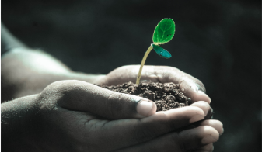
Green Blades Preaching Roundtable
The Epiphany of our Lord
January 6, 2025 (or transferred to 1/5 or 1/12)

Isaiah 60:1-6; Psalm 72:1-7, 10-14; Ephesians 3:1-2;
Matthew 2:1-12

Arise, shine, for your light has come!
Isaiah 60:1
Pastor Claire Repsholdt
Patchogue, NY

This Sunday, we celebrate Epiphany, which officially marked the last day of Christmas on Friday— the day when a sparkly star in the sky finally led three wisemen to Jesus.

As I write for Epiphany this year, even though in the lectionary from last week we already celebrated Jesus at 12 years old, I am reminded of the difference between God’s time and our time.

And I am reminded of the miracle of the cycle of life.

A few years ago, on the eve of Epiphany, I got a call that a beloved pastoral colleague of mine was at home just beginning to give birth to her new baby—and because of a few surprises, she and her husband were suddenly in need of babysitters— were my husband and I available?

Though my husband and I have never been part of a birth ourselves, it was obvious that the call was heaven sent. Of course we replied:

Nothing could make us happier.

We rushed over to pick up their older son, so his parents could safely have a home birth.

When we arrived, the labor pains were already gripping my friend so much that she could barely speak, or give us more than a flutter of an entirely focused hand.

So we whacked away their son, and he waited with us at the parsonage where we live, chasing our dog Penelope and building trains and eating dinner, reading many, many books, and finally falling asleep.

In the middle of the night, the first hours of Epiphany, we got a text with the news—

Our friends had a new baby boy

Their son would have a little brother.

//

In the early morning before church would begin, we drove over together to meet him.

Two sleepy adults and one older brother, not quite wise men, but there were three of us.

The first to see a little baby boy in his mother’s arms . . .

I had never seen a person so flushed with total delight and exuberance as my friend was. To see the entire being of her baby, still bearing the marks of birth, and the light of her joy. It was radiant. I felt as though I had stepped foot into the workshop of creation.

It was as though we had found our way to the bottom of a star.

//

Have you ever seen someone’s star at its rising?

Have you ever been part of the circle of life, a birth or a perhaps even death, and felt yourself emerge into glorious light?

It can be difficult to explain the glory of that journey, which unites us with so many creatures throughout the earth. I am reminded of the words Mark Strand gives to it in his poem, The Continuous Life:

Explain that you live between two great darks, the first
With an ending, the second without one, that the luckiest
Thing is having been born, that you live in a blur
Of hours and days, months and years, and believe
It has meaning.

(You may enjoy reading the whole poem for some bonus Epiphany inspiration:
https://writersalmanac.publicradio.org/index.php?date=2008%2F08%2F11.html)

We all have our ways of finding the meaning of life that slips elusively between the great darks.

Maybe, like the wiseman, you are a watcher of the night skies, peering carefully at them through the lens of a telescope, and you know how stars can teach us about times and places.

Maybe, like me, you have also been there, on the phone, in the room, as the babysitter, while a beloved baby was being born, and you felt as though you had found your way to the heart of all creation.

Whatever the case may be, I’m sure you’ve seen it.

We have all kinds of different words for this moment, when a star rises.

It happens all the time throughout our lives.

We might say, “Her face lit up.”
Or, “he was beaming,”
Or, “she had a twinkle in her eye.”
Or, “a star is born.”

We have so many ways to explain the ways that we can be connected to the glimmers of creation—

how we see someone’s soul stretch its rays to the surface of them, how we can’t help but notice, that the creative light of God is burning right there in front of us.

//

As Christians, we are called to follow the stars that glimmer around us,

to look for ways to share the light that shines within us,

that star that God placed in us on the day we were born,

that longs to rise to the surface of ourselves.

We are called to let our little lights shine,

so that others might see us and see more light for their own journey home.

It can be hard to see the light as it glimmers.
It can be hard to let our lights shine all the time, so that others can see.

But I learned in seminary a song that helps me remember to share that shining light on my darkest days.

You can listen to a lovely recording of a choir performing it here:

https://m.youtube.com/watch?v=0QFK-lsaVng

I find it’s a pretty easy song to teach to musicians of all levels.

Even simply reading the lyrics aloud is powerful for me, a ritual of sorts during this time of year. They explain in just a few words the power of the mutual aid that enslaved African Americans offered to each other as they journeyed to freedom, and to God’s eternity.

The words go like this:

Let your little light shine, shine, shine.
Let your little light shine, oh my Lord.
There might be someone down in the valley trying to get home.

So let your little light shine, shine, shine.
Let your little light shine, oh my Lord.
There might be someone down in the valley trying to get home.

Well, it may be me or it may be you.
It may be your brother or your sister, too.
There might be someone down in the valley trying to get home.

Traveling from near or from lands afar
By the morning sun or the evening star
There might be someone down in the valley trying to get home.

So let your little light shine, shine, shine.
Let your little light shine, oh my Lord.
There might be someone down in the valley trying to get home.

So let your little light shine, shine, shine.
Let your little light shine, oh my Lord.
There might be someone down in the valley trying to get home.

Well, it may be you or it may be me
Traveling by the air, by land, or sea
There might be someone down in the valley trying to get home.

In times of joy or in times of woe
Don’t you ever let your lamp burn low
‘Cause there might be someone down in the valley trying to get home.

So let your little light shine, shine, shine.
Let your little light shine, oh my Lord.
There might be someone down in the valley trying to get home.

So let your little light shine, shine, shine.
Let your little light shine, oh my Lord.
There might be someone down in the valley trying to get home.

Dear preachers, may the testimony of God’s glory flow from you this week. May God’s light glow in you anew this year. May your words radiate outward the inward glory of God’s creative work in your soul. And may you be re-born in your purpose to shine.

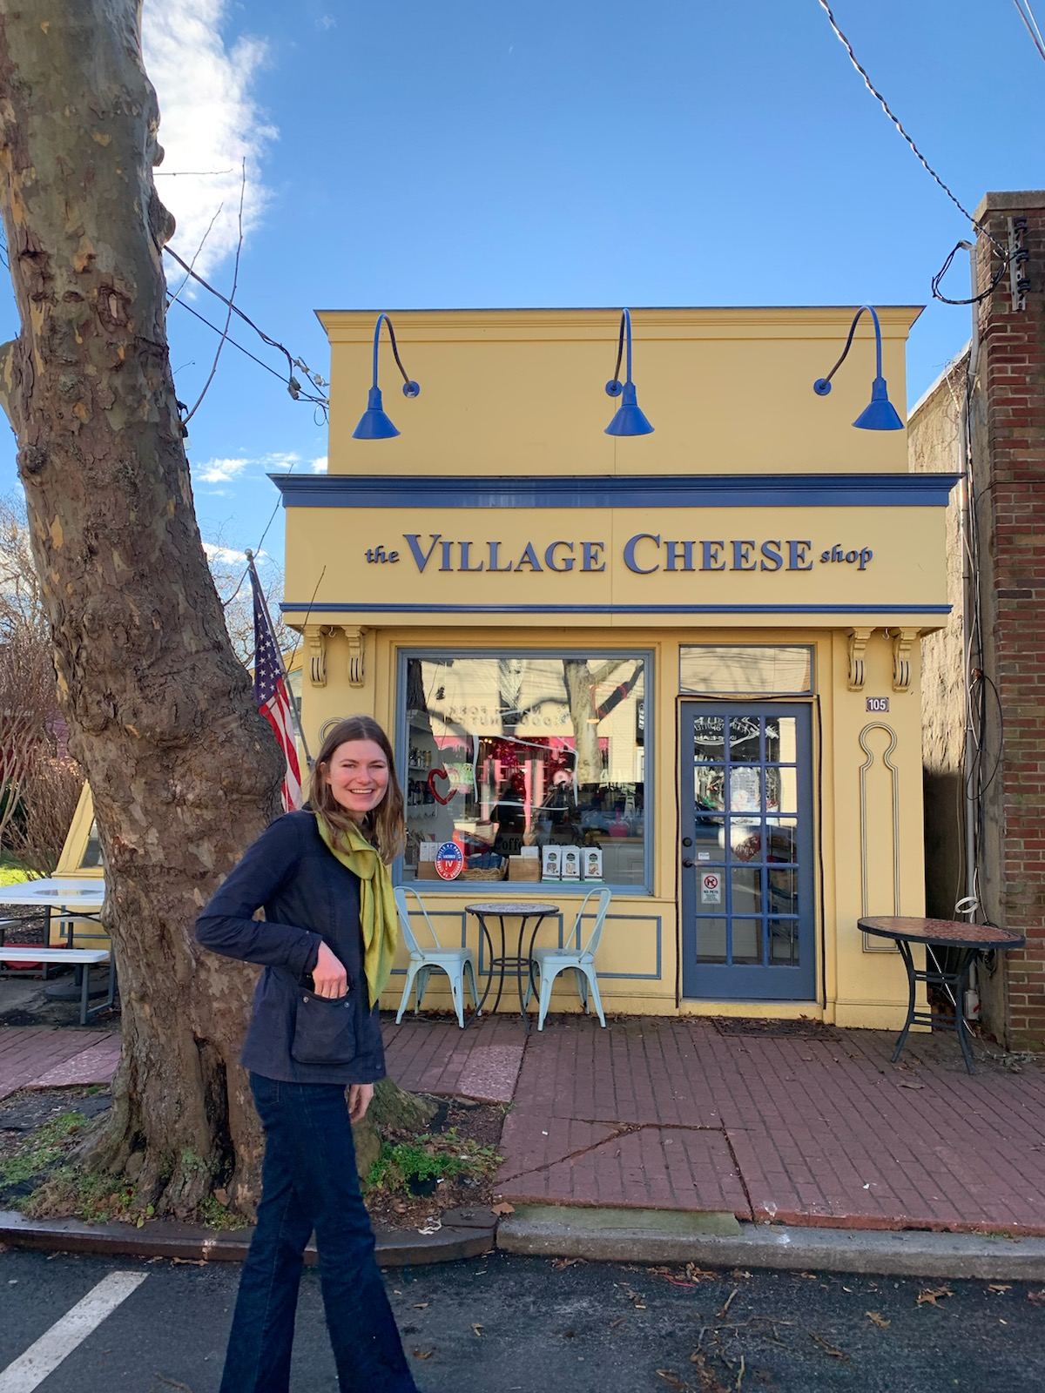
Claire (she/her/hers) was born and raised at a little family church in the Chicago suburbs, where both sides of her family lived. She discerned a call to ministry during her senior year at Indiana University, where her studies in English and History led her to theological questions, and her leadership at church and in a Lutheran sorority kept her energized. She went to seminary at Yale Divinity School, where she reveled in ecumenical opportunities, and she graduated during the height of COVID in May of 2020. She has served as an inner city hospital chaplain and as an apprentice at the LGBTQ+ ministry wonderland in Baltimore at partnered St. Mark’s and Dreams and Visions Lutheran churches. She is now serving her first call as the solo pastor the Lutheran Church of Our Savior in Patchogue, New York, where she delights in creating loving worship, deep relationships, and vibrant community connections. She most often finds that the Holy Spirit reaches her in poetry books, yoga classes, delicious meals, and live performances.

