Green Blades Preaching Roundtable
All Saints’ Day
November 6, 2022
Luke 6:20-31

Pastor Daphne Urban, Bethany Lutheran, Red Lake Falls, MN

Our gospel reading today, comes from the book of Luke. Jesus mainly lives life and teaches outdoors, amid birds, lilies, lakeshores and sprouting seeds. These are his popular parables in a nut shell. If we look at the broad scope of our Gospel of Luke reading from Chapter 6, for today, we can envision Jesus outside. Jesus comes down the mountain and under the huge Galilean sky, he speaks. He speaks of blessings and sorrows to his newly called disciples, and all who are around him that will listen.
Jesus at one point says, “to you who are listening I say,” which basically means that some people in the crowd are no longer listening to him. But those that are, listen up, this is important. Then Jesus describes ways in which those of us in a covenantal relationship with God, are called to live. Jesus explains in great detail that we are to love everyone, and all of creation, just as God loves us, and everything. Love our enemies. Love those who hate us, love those who curse us, love everyone around us, because everyone is our neighbor, and everyone is part of God’s creation. God so loved the world that he gave his only Son, Jesus Christ. Jesus has come now to share the message of love with this world, this entire world! All of us, baptized believers are in a covenant with God. God shows us love and forgiveness, mercilessly. And we are to show the same respect to those around all, all of God’s creation around us. Treat others as you want to be treated. The golden rule.
Wow, tough stuff, right? Who is kind to everyone and everything, they meet? Are you? I want to be. I try to be, but I’m human. It doesn’t happen all the time. In my private, individual American life, I hardly know my neighbors. I’ve never even met many of them. So when it comes to following Jesus, and loving God, I’m not doing the best job of it yet. But when I go out, deep into the woods where my family shack is, I’m a wonderful neighbor to the squirrels, birds, spiders, trees, grasses and all of the nature that God has provided in that space. That is the space that I reflect, pray, refresh and renew in. Those are the trails I walk in, to feel emersed in God’s creation. All of God is around me. There is nothing manmade. I am one with nature, and nature is one with me. God’s gifts are abounding. And I breathe it all in, as I walk around and call God’s creation my own. It is my peace and it is God’s grace given to me, at a time when I need it most.
On All Saints Sunday, we celebrate the power of God’s grace. Sinners, those who are found and those who are lost, are made holy this day. God transforms us; you and me. Those who have passed away, and those who are here with us today. We are all lifted up, in the name of Jesus. Because we are holy creatures. We are God’s holy creatures. As Wendell Berry once wrote, “We are holy creatures living among other holy creatures in a world that is holy. Some people know this, and some do not. Nobody, of course, knows it all the time. But what keeps it from being far better known than it is?” I feel the joy of this day by remembering that God does not just make us humans holy. ALL of God’s creatures are holy. The saints of God and those of us still present today, human and non-human neighbors, all have a common gift from God: grace. By grace we are saved. “Thanks be to God.”
Let’s end with a prayer of Thanksgiving, written by Walter Rauschenbusch (1861-1918)
O God,
We thank you for this earth, our home;
for the wide sky and the blessed sun,
for the ocean and streams,
for the towering hills and the whispering wind,
for the trees and green grass.

We thank you for our senses
by which we hear the songs of birds,
and see the splendor of fields of golden wheat,
and taste autumn's fruit,
rejoice in the feel of snow,
and smell the breath of spring flowers.

Grant us a heart opened wide to all this beauty;
and save us from being so blind
that we pass unseeing
when even the common thorn bush
is aflame with your glory.

For each new dawn is filled with infinite possibilities
for new beginnings and new discoveries.
Life is constantly changing and renewing itself.

In this new day of new beginnings with God,
all things are possible.
We are restored and renewed in a joyous awakening
to the wonder that our lives are and, yet, can be. Amen.

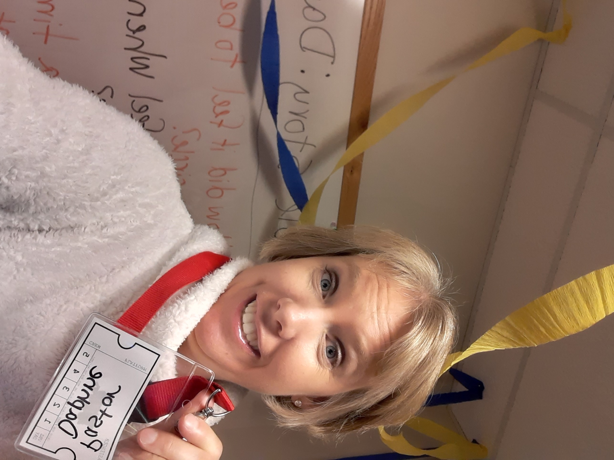
Pastor Daphne Urban is a first-year pastor at Bethany Lutheran Church in Red Lake Falls, Minnesota, ordained in January 2022. She completed her M.Div. at Luther Seminary in 2021 with an emphasis on Congregational Leadership and Mission. Daphne has an academic and professional background in meteorology. When not in Red Lake Falls serving Bethany half the week, she lives in Bemidji, Minnesota with her husband and three children. Her meteorology and ministry passions converge in her commitment to nurturing stewardship of the Earth/creation care/EcoFaith. She is actively working to build a creation care network in the Northwestern Minnesota Synod.

