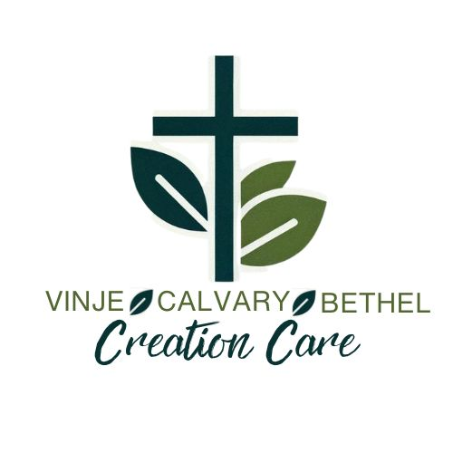
HEALTHY EARTH – HEALTHY KIDS COMMUNITY ECOFAIR 2024
WILLMAR, MINNESOTA

The purpose of the Calvary Creation Care Team is “to be a catalyst for encouraging creation care awareness and actions at Calvary, in the community and beyond”. One of our six (6) goals is to coordinate creation care with the community.

It was that purpose and goal that led to the encouragement for Karen Kraemer, a retired high school science teacher to become a Blessed Tomorrow Climate Ambassador. It was Karen who advocated for a communitywide EcoFair that would be patterned after a Richfield, MN event. As President elect of the LWV of the Willmar Area, she connected with the City of Willmar Director of Community Growth. They formed a planning group including representatives from the LWV, the City of Willmar, the YMCA, the Kandiyohi Power Cooperative, the Willmar School District, the Southwest Regional Sustainable Development Partnership (Southwest RSDP), and the Calvary Creation Care Team.

It was decided early on that the EcoFair would include the already annual YMCA Healthy Kids Day. The event was set for Saturday, April 27 at the Willmar Civic Center. There will be a fun run, main stage speakers and up to 50 exhibitors, with Vinje, Calvary and Bethel Lutheran Churches being one of them. The Creation Care exhibit booth will include: information on the “NexTrex Recycling Challenge” that has resulted in Calvary keeping 2 ½ tons of plastic film out of the landfill https://nextrex.com/jsfapp/cdocs/20230724221555_9_jsfwd_493_q2_1.pdf; a TREX bench made of recycled plastic film; photos of team projects; a list of team accomplishments; how to Reduce/Reuse/Recycle; a new Calvary Creation Care brochure; drawings for wildlife photography and art; and more.

Jack Behr, co-chair
Calvary Lutheran Church
Creation Care Team
Willmar, MN 56201

