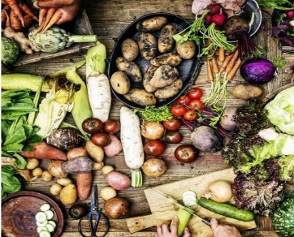 Holy Ground, Holy Table ~ so many to thank!

Holy Ground, Holy Table came together because of the 152 people who registered to participate, and a host of people and partners.
Storytellers: keynote presenters the Walkers (George, Anneliese, and Andy) from the Walker family regenerative farm, Pastor Jon Anderson, Director of Rural Ministry at Luther Seminary, Dani Pieratos of Harvest Nation, Bois Forte Band of Chippewa, Barbara Sogn-Frank from the Land Stewardship Project, Regina LaRoche, Diaspora Gardens, Marlise Riffel, Iron Range Partnership for Sustainability and many local food initiatives, Deacon Kari Olsen of Shobi’s Table, and Rachel Wyffels, Lutheran Advocacy-Minnesota Fellow and 2021 graduate of St. Olaf College.
Table Talk Hosts: Jon Anderson, Jan Bilden, Emilie Bouvier, David Carlson, Chris Erickaon, Kay Erickson, Kristin Foster, Jack Hurbanis, Diane and Paul Jacobson, Greg Kaufmann, Vernita Kennen, Amanda Kossow, Bob Lehner, Kate Nyquist, Bret Pence, Vern Rice, Russ Schultz, John Sippola, Krehl Stringer, Paula Thomsen, David Warner, Peggy White, Mark and Laurie Windisch
Presented by the EcoFaith Network of the Northeastern Minnesota Synod and the St. Paul Area Synod Care of Creation Work Group, the Summit was a partnership with the EcoFaith Network of the Minneapolis Area Synod, The Land Stewardship Project, Luther Seminary, Together Here Ministries, Lutheran Advocacy-Minnesota, Lutherans Restoring Creation, and Minnesota Interfaith Power and Light

