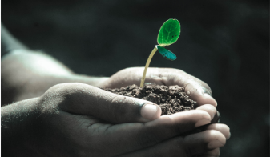

Green Blades Preaching Roundtable
Reflections on the texts
Second Sunday of Advent
December 10, 2023

Isaiah 40:1-11 - Psalm 85:1-2, 8-13 - 2 Peter 3:8-15a - Mark 1:1-8

Pastor Karen Behling (she/her)
Chippewa Falls, WI

“Ready or not! Here I come!” When that cry comes in a game of Hide-and-Seek, time is up, and a new course of action is about to begin. John the Baptist’s cry in the wilderness has similar intensity. Ready or not, God is coming. Ready or not - and if not, it’s not yet too late, and there’s still time to get ready - but be warned that everything is about to change.

This new course of action starts with Jesus coming to be baptized by John. Creation is involved in this proclamation, as the heavens are torn apart. The Greek word is “skidzo”, and this word will appear again at the end of the story when in 15:38, the curtain of the temple will be torn in two as Jesus on the cross breathes his last. That moment, too, will mark a momentous change in the course of action.

Back to John in the wilderness who roughly quotes Malachi 3:1 and Isaiah 40:3. John preaches in the wilderness, in a place where nature is primary. Mark begins the good news of Jesus in creation, the setting where “in the beginning”, God’s activity brought forth one “good” thing after another in Genesis 1. And specifically, within creation, this good news story begins in the wilderness, where we, who have been paying attention throughout the stories of the Old Testament, have witnessed many great transformations. Most notably, through Moses, God teaches in the wilderness so that God’s people can unlearn past ways of living and learn new ways of living for the future. We in today’s world are still striving to live more fully into these wilderness lessons. God’s vision for all of life on this planet is not yet reality. There is much work yet to be done regarding our care for the earth and its creatures and our responsible sharing of resources.

We need to hear the urgency of John’s call to prepare the way of the Lord. Ready or not, Jesus is coming, and Jesus will have a whole lot to say about how we live – how we live in right relationship with God, how we live in right relationship with all people, how we live in right relationship with all of creation. Our recent text in Matthew for Christ the King challenged us to focus on our human relationships. Today’s texts open the door to a more expansive consideration of living in right relationship with all of creation.

Creation is an important player in God’s transformative work. We hear that from John the Baptist. Our psalm for today celebrates that God’s gifts come first to the land, and then God’s gifts come to us through the land. Faithfulness springs up from earth to people.

And finally, here’s another image for consideration that comes out of this week’s Prayer of the Day. Throughout the season of Advent, each week’s Prayer of the Day begins with the words “stir up”.

When I bake, I stir up the ingredients so that something wonderful can come out of the oven. Baking often begins with stirring together butter and sugar, creaming them so well together that neither is recognizable as what it was. Once the ingredients are stirred together, they become something new and wonderful.

Stirring up a big pot of homemade soup sends out tantalizing aromas that can fill us with anticipation. Each of the ingredients may still be recognizable, but blended together, they create something beyond what any one ingredient could be on its own.

When we speak of someone stirring up the pot, it is rarely intended as a compliment. To many of us “stirring up the pot” implies causing trouble and challenging the norms, and yet, when we think about it, that’s precisely what Jesus will be doing throughout his ministry - stirring up good, holy trouble, as Jesus invites followers to live in contrast to the prevailing ways of the world. Together, with the Holy Spirit leading the way, we work towards something better than any of us could be on our own. It’s an important part of our identity as God’s people. The promises of Baptism and Affirmation of Baptism both include the promise to “strive for justice and peace in all the earth.” Such changes will require plenty of stirring up our current reality. Ready or not, the time is now!
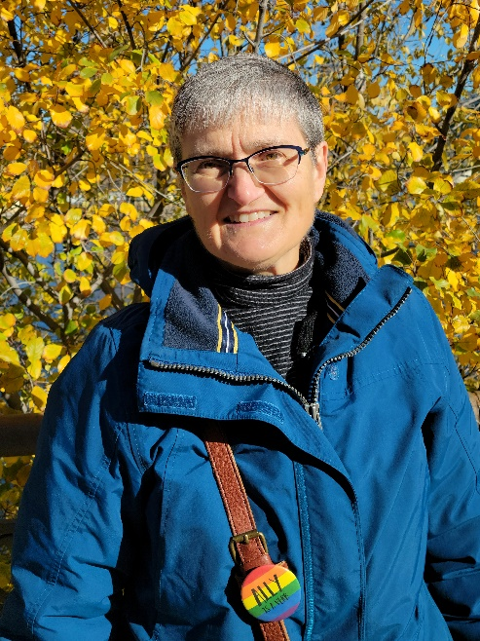
Pastor Karen Behling (she/her) lives within a mile of the congregation she serves - Our Saviour’s Lutheran Church in Chippewa Falls, WI - which means that most days, she enjoys walking as her primary mode of transportation. Previous calls have been in Minnesota, Iowa, and North Dakota in congregations small to large, with and without staff. Her primary creative outlets are quilting and replacing more and more of the front lawn with pollinator plants and stirring up the ingredients for delicious cookies to share with family, friends, and neighbors.

