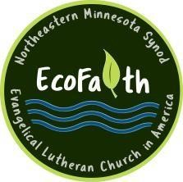The NE MN Synod EcoFaith Network thanks
our 2023 Partner Congregations
for your financial support and your leadership in EcoFaith Network
as we live out God’s call to be stewards of the earth for the sake of the whole creation!

Baptism River, Finland
Bethel-Trinity, Bovey
Calvary, Mora
Faith United, Iron
First, Aitkin
First, Duluth
First, Hibbing
Gloria Dei, Duluth
Holden, Isle
Immanuel, Princeton
Knife River Lutheran, Knife River
Lutheran Church of the Cross, Nisswa
Our Redeemer, Pine City
Our Savior’s, Outing
Trinity, Cass Lake
Trinity, Hovland
Zion WELCA, Grand Rapids
Zion, Milaca

