Green Blades Preaching Roundtable
Reflections on October 16
2022 RCL texts
Gen 32:22-31; Ps 121; 2 Tim 3:14-4:5; Luke 18:1-8

Gary Hedding

I am struck by two themes in these texts that relate to our relationships and stewardship of the creation of which we are a part: Place and Perseverance.

I became aware of Holy Place in my first parish. Prince of Peace Lutheran Church is in the village of Coloma, WI. The congregation had a building that most people recognized as being wildly impractical for worship, education, or fellowship. Situated at the top of the hill in the village, there were eight steps people needed to climb to get to the worship area (yes, I am aware of at least two coffins dropped by pall bearers and several falls in the winter on these steps), and from there you could get to the basement education/fellowship area and bathrooms by descending 14 steps - if you were healthy enough. The windows leaked and the furnace could barely keep up with cold weather even though we burned propane at an alarming rate. There was a large parcel of land that had been acquired years ago to build a new church building and the relatively new parsonage was already on the land. Plans had been drafted for the building, but they had sat for many years. What stopped them from proceeding? OK, money was part of the issue, but the other challenge was abandoning what was, for them, a Holy Place. For 80 years, that building had hosted baptisms, weddings, funerals, confirmations, Sunday and holiday worship, and people were connected to that place through their memories of precious, holy events and the expectations that this was the place where holy events ought to take place.

As it happened, the two-lane US highway 51 was turned into the four-lane I-39 in the 1980’s and a cloverleaf condemned the congregation’s building. The move had to be made. The new building gave them a chance to address all the practical issues that the old building presented. The new building was all on one level - from parking lot to every entrance with no steps inside. We had a new heating system. We also had a new and earth partnered cooling system; an earth berm around the whole building seven feet up the exterior walls, then some windows for natural lighting and ventilation, and a conventional roof. Not everyone thought it looked like a church should. Not everyone thought it looked like a Holy Place. However, baptisms, weddings, funerals, confirmations and worship filled the space, and it became holy. Ridiculously low heating bills and no cooling bills won over those who thought it didn’t look like a church building, and people quickly saw that partnering with the earth in central Wisconsin could also add a holy experience that went beyond saving money. Our Holy Place became more holy because we experienced God’s care for our needs through the beauty and thermodynamics of God’s creation, and we were grateful to God for the holiness of God’s earth.

Our Genesis text is full of the holiness of place. Jacob, soon to be Israel, relies on the Jabbok River to be part of the defense for his family. He wrestles with God and God honors him with a new name, reflecting a new character - Israel. So, Israel, seeking something tangible to hold the memory of this holy, life-changing encounter with God names the place of the encounter Peniel, the face of God. He limps by this Holy Place, the next morning and that helped him hang on to the holy experience as he goes to strive with his brother, for good or ill he does not know, but with a promise within his new name that he prevails. The text also mentions that the Israelites do not eat the sinew of the thigh because God had touched that place on Israel’s body and made it a holy place in the body of all living creatures. When God’s people set that piece of flesh aside, they are remembering and proclaiming God’s presence in the life of all Israel.

Native people know about Holy Places. The Black Hills of South Dakota are holy to the indigenous people of that region of the country. In 1868, the US entered into a treaty which designated the Black Hills as “unhedged Indian Territory” for the exclusive use of native peoples, as a recognition of them as a sacred area for the Sioux(Dakota, Lakota, and Nakota) and the Arapaho. A couple of years later gold was discovered in the Black Hills and in 1877 a new treaty was forced on native peoples which seized the Black Hills because, well, you know, there was gold there and gold is way more important than some Holy Place. In 1980, the US Supreme Court ruled that the US had illegally appropriated the Black Hills, but did not return their sacred land, rather awarding the Sioux nation $100 million dollars (over a billion dollars in today’s value). The Sioux refused the award because, to them, a Holy Place does not stop being a Holy Place just because someone offers a lot of money for it. Holy Places define people, root people and cultures to something that is at the heart of their spirit and what is divine to them. Without Holy Places, the spiritual life of a people can fade.

Psalm 121 also focuses on Holy Places. “I lift my eyes to the hills. From whence does my help come? My help comes from the LORD, who made heaven and earth.” The bit about my help comes from the LORD does not contradict the lifting up of the eyes of God’s people to the hills. There are too many references to God coming to God’s people on hills and mountains. Holy Places are such because people have found a Holy Presence there. Sinai, Zion, Jesus’ sermon on the mount, Transfiguration, the mountain in Galilee to which Jesus directed them for his ascension. The psalmist is not foolish or superstitious in lifting eyes up to the hills. It is where God’s people have found God before.

Now a few words about perseverance. Jacob perseveres so well as he wrestles with God that God blesses him with a new and really interesting name, “the one who strives with God and with humans and prevails”. That is a name that has power and real guts to it. It is a name that can change a person’s life. Don’t give up. Go ahead and meet with your brother, Esau. Don’t be afraid, God has given you a persevering name.

2 Timothy 4:2f tells us that the writer urges the readers to “proclaim the message; be persistent whether the time is favorable or unfavorable; convince, rebuke, and encourage, with the utmost patience in teaching. For the time is coming when people will not put up with sound doctrine, but having itching ears, they will accumulate for themselves teachers to suit their own desires, and will turn away from listening to the truth and wander away to myths.” The sound doctrine that the earth is God’s and not our own and that we are to be stewards to care for it as God cares for it, has been lost to people who desire to turn it into spendable currency and a convenient life. Even sound science loses out to myths like, you can’t trust science or scientists, the climate change stuff is just left--wing political nonsense. The idea that sometime soon some right-thinking scientists will pull a scientific rabbit out of their hats that will fix all the climate stuff without us having to change the way we act is a myth. The thought that this is a problem for our grandchildren to fix, if they can, is a delusion. Followers of Jesus are called on to be persistent whether the time is favorable or unfavorable. It would be nice to pick our moment, but we can’t wait any longer for that. It is as urgent as the Good News because the Good News is for the redemption of the world.

Our Luke text reinforces this urging of persistence. The parable of the widow and the disrespectful judge has a clear message. While it is lovely to be able through reason and inspiring talk to convince people of the truth about care for the earth, especially when the wounds of the creation are still being applied to its “body”, sometimes we just have to wear down the disrespectful judges of the creation. Sometimes the most effective thing is to let them think what they want and annoy them until they grudgingly give justice to the earth just to shut us up. And if we get tired before they do, we have a wonderful promise. “I tell you, [God] will quickly grant justice to [creation].” That will spark new energy driven by a deep and abiding love for all that God has created, all that God sustains, all that God redeems, and all that God loves. That love is granted to us continually through the sustaining power of the same Holy Spirit that blew over the waters at the time of creation.

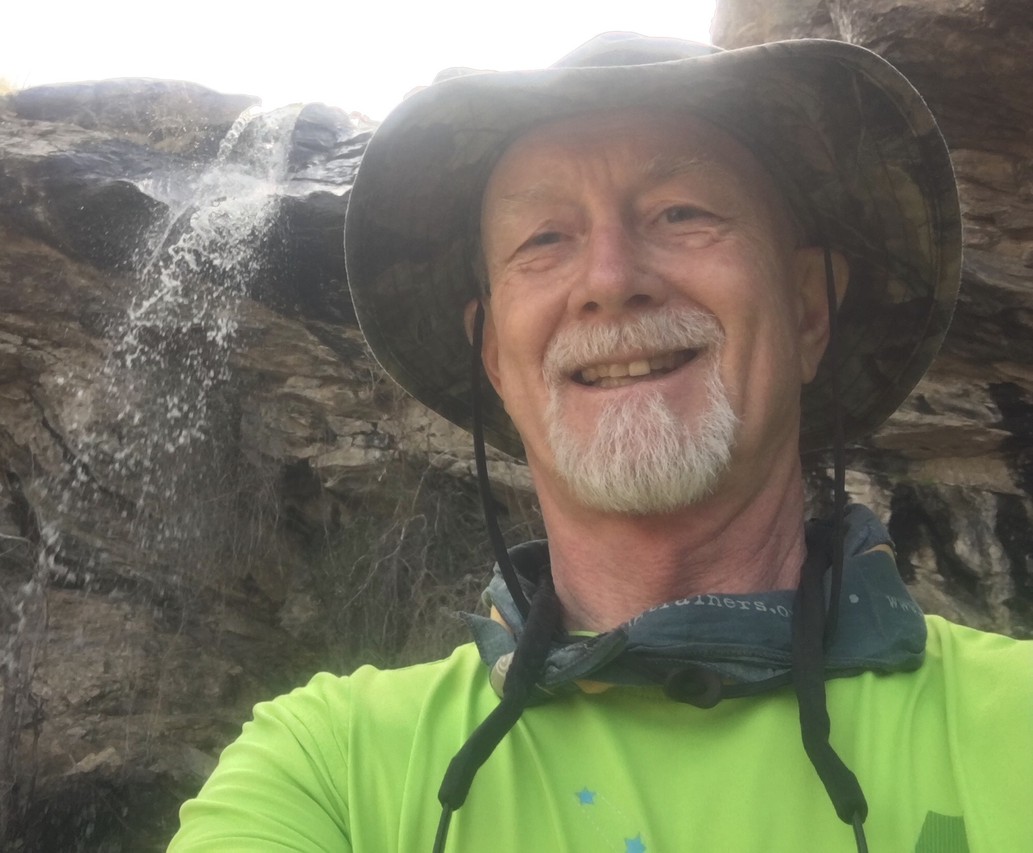
*A, hopefully, interesting sidebar. Psalm 121 mentions the moon. I majored in chemistry as well as religion in college and adore science, not only chemistry, but I have a serious crush on astronomy. I don’t think God meddles often in creation, but every once in a while, just for the fun of it, just to inspire wonder, I think God has the right to do some “custom work” within the evolution of the universe. Take our moon. First of all, it is way too big for a planet like ours. No planet our size has ever been found to have a moon that is as huge as the one we have. It is way too big for a planet our size to capture it as it swings by. Most planetologist guess that it took an object the size of Mars to crash into the earth billions of years ago to dislodge the mass of the moon from the earth itself, which the planet could hold in its gravitational embrace. Not only that, but (here is the fun part) the sun’s diameter is 400 times larger than the moon’s diameter; and the sun is 400 times farther from the earth than the moon is from the earth. This means that the sun and moon appear to be the same size and that should the moon pass directly across the sun it would produce a total eclipse of the sun. And if the planet in question had intelligent life on it, wouldn’t that inspire some “wonder”. Coincidence? You
be the judge.

Gary Hedding is a retired pastor who graduated from Luther Seminary in 1978. He served his internship in Brooklyn, NY. His first call was Prince of Peace Lutheran Church in Coloma, WI; then as associate pastor and later lead pastor at Faith Lutheran Church in Marshfield, WI; followed by serving six years as assistant to the bishop in the Northwest Synod of WI; then as pastor of Bethlehem Lutheran Church in Cedar Falls, IA. Gary has been retired since 2018. Gary is married to Linda and they live in Chippewa Falls, WI with their dog, Strider. Their daughter, son-in-law and two grandsons live in the Fort Worth, TX and their son and daughter-in-law and one granddaughter live in Eau Claire, WI. Gary enjoys wilderness canoe tripping, sprint triathlons, fishing and hunting, reading science fiction and urban fantasy, and vegetable gardening.

