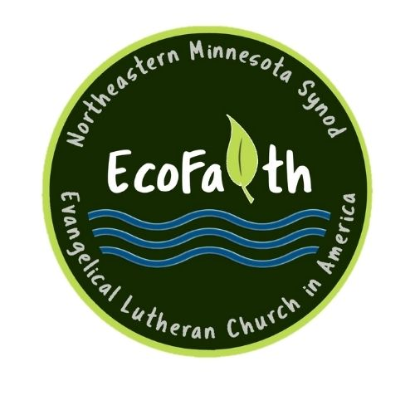Inviting you and your congregation to a

Season of Creation Workshop
Thursday, May 27, 2021
6:30-8:00 p.m. via Zoom

Hosted by Pastor Mark Ditmanson and Pastor David Carlson
Ecofaith Network, Northeastern MN Synod

Register (free) to receive the Zoom link at https://docs.google.com/forms/d/e/1FAIpQLSciqu_LJq9iLVY06FXmU7RtLpRGZ_JpIPRx6QGhFmykma3cew/viewform?usp=sf_link

Christians worship with all creation! Along with the heavens that declare the glory of God and with the trees of the field that clap their hands, we lift our voices “with earth and sea and all their creatures,” praising God who creates and sustains us and all that is. With endangered species, climate change, and impaired waterways, we also hear the groaning of creation that longs for liberation, and we seek the care and redemption of all God has made, trusting in the Spirit who calls, equips, and raises us with Christ to participate in the healing and renewal of earth’s community.

One of the best ways to cultivate earth-honoring faith in congregations is by emphasizing creation in worship. Not just with hymns and prayers that highlight God’s love for all creation, and not just with an occasional sermon illustration or outdoor service. Many Lutherans are incorporating a multi-year five-week alternate lectionary series in their worship life sometime during the “green” season after Pentecost.

Workshop participants will hear an overview of the Season of Creation, its scriptural references and themes, and how two congregations introduced it and have used it for years in their contexts, along with ecologically conscious liturgies. Through large group and breakout room discussions, participants will have the opportunity to hear about more resources and practices and also share their own ideas about the joys and challenges of integrating creation care in worship.

Consider bringing a team from your congregation! All are welcome – musicians and worship committee members, lay and rostered leaders, youth and elders, anyone who wants to deepen and broaden their worship practices for the well being of God’s creation.

