Green Blade Preaching Roundtable
Lectionary Reflections
Baptism of our Lord
January 9, 2022
Lectionary 1, Year C
Isaiah 43:1-7; Psalm 29, Acts 8:14-17; Luke 3:15-17,21-22
Pastor Amanda Kossow

Whether it happens as an infant or an adult, baptism is central to our lives of faith. It is a wholehearted welcome into Jesus’ movement. It is a tangible means of God’s grace. It is the seal of the Spirit. And it is a covenant teeming with both promise and call.

I was in college in the Upper Peninsula of Michigan when I first observed a full immersion baptism. It took place in a small bay of what the Ojibwe people call Gichigami, or Lake Superior. That experience bubbles to the surface when I read any of the gospel baptismal narratives. I imagine people of all ages, of varying conditions and from divergent situations crowding around where water and land kiss one another. As my imagination sails through the tributaries of my mind, it flows past multiple banks. The shores of the story my mom told me about my own immersion into the Way. The coastline of the first baptism at which I presided. And a beach where I came to a new realization.

In April of 2020 I attended a one-day digital conference, Creation in Crisis: Science and Theology Respond, hosted by Wartburg Theological Seminary in Dubuque, IA. One of the speakers was Dr. Larry Rasmussen and the title of his topic was “Criteria for Spiritual Practices for Creation in Crisis.” One comment and one question in particular stripped the sheath of my incomplete understanding. He asserted that God isn’t making more water and air, but it’s a recycle system, so we’re using the same water as John the Baptizer. This fresh wave of thought immediately shipped me back to the gospel texts. The water that plunged Jesus, and everyone else on the banks of the Jordan, into the Creator’s mission field is the same life-giving liquid that caressed creation at the beginning of time. It is the same substance that parted to give safe passage to enslaved Israel, but that also took the lives of the Egyptians ordered to hunt them down. It is the same element that dripped from the heads of the Samaritans who Peter and John laid hands upon. And it is the same supply of two parts hydrogen and one part oxygen that nourishes earth’s inhabitants still today. Dr. Rasmussen went on to reason that creation justice includes social justice, a.k.a person-to-person justice. So if there is no creation justice then there is no social justice. He then went on to pose this question: what if we said no more baptisms until all have safe drinking water, or what if we all baptize with dirty water? Would we as the church be willing to move in such a bold, insistent direction? To accompany our neighbors in such a proclamatory fashion? To make that sort of sacrifice so as to shine a spotlight on in the intersection of environmental and social justice? To approach the call placed upon us in the water and Word that washed over us, “to proclaim Christ through word and deed, care for others and the world God made, and work for justice and peace” in a new way?

What if? What if it is the hard, fibrous material of our ignorant indifference that the voice of the Lord is breaking? What if it is this disconnect between our sacramental practices and our creation advocacy that the voice of the Lord is shaking? What if, instead of making this Sunday a quaint time of romanticized reminiscence, we asked ourselves such provocative questions? What if?
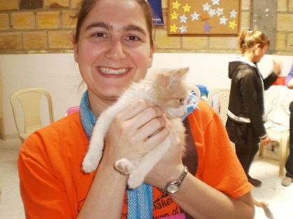 (This photo is taken from the building of Luz Y Vida, the companion church in Colombia to the congregation I previously served) My name is Amanda and I currently serve as pastor at Trinity Lutheran Church in Cass Lake, MN. There is a t-shirt from Grand Island, MI which describes me to a “T.” It states, “Into the woods I go to lose my mind and find my soul.” I am an avid animal and nature lover who hikes, kayaks, and snowshoes as often as possible. Growing up in the Upper Peninsula of Michigan, I feel a strong kinship with creation, particularly trees. During my time in seminary and in both my first and now second calls, I’ve also been gaining a deeper appreciation for and learning from my bond with human neighbors whose culture differs from mine.

