The NE MN Synod EcoFaith Network and the St. Paul Area Care of Creation Work Group present the
2022 EcoFaith Summit
Holy Ground, Holy Table
Regenerative Practices for the Wholeness of the Earth

Saturday, March 26, 2022
9:00a.m. – 12:30p.m. via Zoom

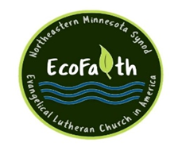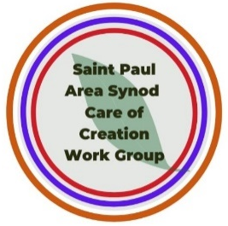
Original Music Videos + Keynote Presenters Minnesota farmers George and Annaliese Walker + Seven Diverse Storytellers sharing regenerative practices from farms to tables + Table Talk breakout discussions
Event partners include: the EcoFaith Network Minneapolis Area Synod, the Land Stewardship Project, Lutheran Advocacy-Minnesota, Lutherans Restoring Creation, Luther Seminary, Minnesota Interfaith Power and Light, and Together Here Ministries
To learn more and register using this link or the QR code below
https://ecofaithsummit2022-holygroundholytable.eventbrite.com

The NE MN Synod EcoFaith Network and the St. Paul Area Care of Creation Work Group present the
2022 EcoFaith Summit
Holy Ground, Holy Table
Regenerative Practices for the Wholeness of the Earth

Saturday, March 26, 2022
9:00a.m. – 12:30p.m. via Zoom

Original music videos + Keynote Presenters Minnesota farmers George and Annaliese Walker + Seven diverse storytellers sharing regenerative practices from farms to tables + Table Talk breakout discussions
Event partners include: the EcoFaith Network Minneapolis Area Synod, the Land Stewardship Project, Lutheran Advocacy-Minnesota, Lutherans Restoring Creation, Luther Seminary, Minnesota Interfaith Power and Light, and Together Here Ministries
To learn more and register use this link or the QR code below
https://ecofaithsummit2022-holygroundholytable.eventbrite.com

