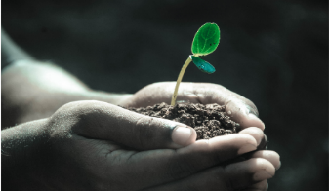
Green Blades Preaching Roundtable
Lectionary 23
16th Sunday after Pentecost
September 8, 2024

Pastor Karen Behling (she/her)
Chippewa Falls, WI

Isaiah 35:4-7a - Psalm 146 - James 2:1-17 - Mark 7:24-37

Healing is a theme that runs throughout all these readings – the healing of human bodies, healing beyond inequities, healing that focuses on the most vulnerable amongst us, healing that brings us into life-giving relationships with one another. The final verses in the Isaiah passage invite us to look beyond humanity to include creation in this healing and to remember that life-giving waters are crucial to a hopeful future. This would be a great day for worship to include Thanksgiving at the Font.

Claimed by God in the waters of Baptism, we are sent out into the world to love and care for all created by God – all people, all creatures, all plants, all resources, all of creation. We are sent to do God’s work using our hands. For those ELCA congregations who may be marking this day as God’s Work Our Hands Sunday, the following prayer may be meaningful.

God be in my mind (rest hands on head) and in my thinking.
God be in my ears (hands to ears) and in my hearing.
God be in my eyes (hands to eyes) and in my seeing.
God be in my mouth (hands to lips) and in my speaking.
God be in my hands (palms up and open) and in my doing.

The work of living as God’s people involves on-going learning which leads to new insights which leads to new action and deeper understanding of God’s vision for all of life on this planet. Throughout life’s journey, God frequently leads us beyond what feels comfortable and familiar. Today’s gospel offers insight into Jesus’ own learning about the magnitude of God’s mission. Each of the encounters involves Jesus healing a foreign person in a foreign land, but the second time is different and reveals a changed Jesus. We look to Jesus as our role model for how to welcome, how to serve, how to forgive, how to live, how to love. And here, in today’s gospel reading, Jesus becomes our role model for how to grow in faith and action. As committed as Jesus was to God’s will, Jesus was also fully human. Jesus spent his childhood surrounded mostly by people who were like him and who shaped him, and now, the adult Jesus is growing in his understanding of just how expansive and inclusive is the love of God.

When a desperate, foreign mother comes begging Jesus to heal her demon-possessed little daughter, Jesus responds to her plea with harsh words. To this woman, these offensive words are not unexpected. She pushes back. She came seeking help for her daughter, and she is not going to leave empty-handed - even the scraps, the leftovers from Jesus’ ministry among “his own” people, will be enough, she trusts, to help her daughter.

Imagine a light bulb going off in Jesus’ head! Jesus has been sent by God the Creator to save God’s people, but God’s people are not just the children of Israel – not just the Jews – not just whomever we define as “us”. God’s love and mercy is also for “them” – even the gentiles -- even the people of Tyre and Sidon -- even the people who seem so very different and “other.” And supported by the larger biblical context, God’s love and mercy is for all of creation. Jesus gains new insight. Jesus learns. And Jesus changes his behavior, as we see when Jesus goes from Tyre to Sidon and encounters another “outsider” in need of healing. This time, Jesus does not resist.

Today’s gospel offers an opportunity for preachers to share about a time when they have gained new insight which led to new action. For example, as I have grown in my care of creation:

- My gardening practices have changed. As I have learned more about this planet’s dependency upon pollinators and their shrinking populations related to diminishing habitat, I have made it my mission to convert more and more of my lawn to pollinator plants, and my front lawn is now a registered Monarch Waystation.

- Within the past year, my standard request at any restaurant has become, “Water, no straw.” I came to recognize that if I was genuinely serious about striving to eliminate single-use plastics from my life, I needed to take proactive steps. Requesting “no straw” is one of many action steps that I have added to my life.

Questions for the Preacher to Consider:

- What more does God want us to see and to hear in order to learn more about life on this planet?
- What new actions is God calling us to take - as individual households and as congregations?
- How is God working to expand our understanding of God’s love for all of creation?
- How can we learn with and from one another?
- Together, how can we grow to more fully embody God’s expansive love for all of creation?

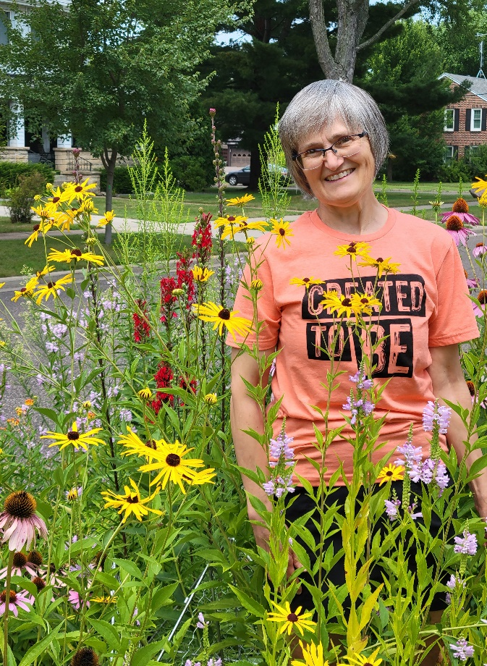

Since moving to Wisconsin five years ago, Pastor Karen Behling (she/her) has been transforming their lawn into more and more pollinator habitat. Such a glorious front lawn has sparked many meaningful conversations with neighbors of all ages. Living in the heart of Chippewa Falls and within a mile from Our Saviour’s Lutheran Church in Chippewa Falls, WI allows for walking to be Karen’s primary mode of transportation most days. Previous calls over these past 34 years have been in Minnesota, Iowa, and North Dakota in congregations small, medium and large.

