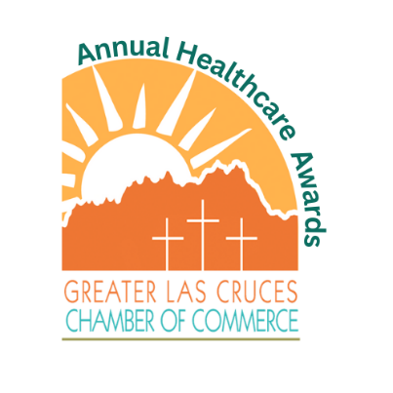**Recognizing the tremendous contribution, the healthcare industry gives to our community, the Greater Las Cruces Chamber of Commerce is proud to announce the 2025 Annual Healthcare Awards Banquet. This event recognizes extraordinary achievements in areas of public health service that protect and promote the health of the Mesilla Valley. These awards were created to honor the role of public/private collaborations that advance optimal health and wellness in the county’s diverse populations. These various awards will recognize workers in the industry to include physicians, techs, nurses and support services such as medical records, case managers, therapists, veterinarian services, environmental services and administration.**

2025

Nomination Form

Awards event will be held August

1

(

Burrell School of Osteopathic Medicine

)

***NOMINATIONS MUST BE RECEIVED BY 3:00pm,***

***Wednesday. July 16th***

2025

# Complete the following information (only one nomination per form) No hand-written nominations accepted

**Your nomination must include: a) Completed application (no-hand-written nominations); b) One-page summary of the nominee’s achievements; b) Picture of the Nominee (If emailing photo, please submit in .jpg format.) The Chamber reserves the right to request two letters of reference from a third party. WOULD YOU GIVE THE CHAMBER AUTHORIZATION TO INFORM YOUR NOMINEE OF YOUR NAME. Please indicate your answer: YES  NO**

*See the description of each category on the second page*

**Crisis Response  Emerging Leader  Impact  Innovation  Mayor’s Legacy**

## Nominee or Group/Team Name: Click or tap here to enter text.

## Nominee Employer: Click or tap here to enter text. Nominee Phone: Click or tap here to enter text.

## Nominee Email: Click or tap here to enter text. Nominator: Click or tap here to enter text.

**Name:** Click or tap here to enter text. **Phone:** Click or tap here to enter text.

## Email: Click or tap here to enter text.

## 

**Completed applications (following the above referenced documentation) can be emailed, mailed or hand delivered**

|  |  |
| --- | --- |
| **Email:** | **Debbi Moore, dmoore@lascruces.org** |
| **Mail:** | **PO Drawer 519**  **Las Cruces, NM 88004** |
| **In Person:** | **150 E. Lohman**  **Las Cruces, NM 88001** |

**Event partnership opportunities are available.**

**For additional information, please contact the Chamber at 575.524.1968.**

***Greater Las Cruces Chamber of Commerce***

***150 E. Lohman Ave. Las Cruces, NM 88001***

## *NOMINATIONS MUST BE RECEIVED BY 3:00pm, Wednesday, July 16th*

2025

202

5

Nomination Form for Awards

Awards event will be held August

1

(Burrell College of Oestopathic Medicine)

***NOMINATIONS***

***MUST BE RECEIVED BY 3:00pm, Wednesday,***

***July 16th***

* Mayor’s Legacy Award recognizes a healthcare professional whom has left a lasting and significant mark on the history and culture of the Las Cruces healthcare community and has exhibited an extended track record of improving the quality of life. Nominee must have served in the healthcare industry 7 years & more.
* Impact Award recognizes a healthcare professional that has had a direct impact on a patients care & exhibited true compassion.
* Teamwork Award recognizes a healthcare professional team who have developed and implemented a project or program with a significant outcome. This award will be presented to a team, not an individual.

* Innovation Award recognizes the healthcare professional who has creatively improved a process or system within their work environment by utilizing unconventional and out of the box thinking.
* Emerging Leader Award recognizes an up and coming healthcare professional

that has motivated and inspired others while “paving their own path” to make a true difference in the lives of others. Nominee must have served in the healthcare industry 4 years or less.

* Crisis Response Award recognizes a business or individual who has gone above and beyond to help in response to a public crisis.