One of the most widely known Catholic prayers to the Blessed Virgin Mary, almost as popular as the Hail Mary, is the Memorare. It is an ancient prayer that has a miraculous reputation. The Memorare was popularized by Father Claude Bernard in the 17th century. Fr. Claude believed that the recitation of the prayer was the cause of his miraculous healing. He printed over 200,000 leaflets with the prayer on it in different languages to distribute wherever he could. St. Francis de Sales said the prayer daily and St. Teresa of Calcutta taught others to pray it when they most needed help. Mother Teresa would pray it whenever she was faced with an emergency situation and most needed a miracle. It never failed her and has proven its miraculous character over the years through thousands of testimonials (including Mrs. Kadel’s!).

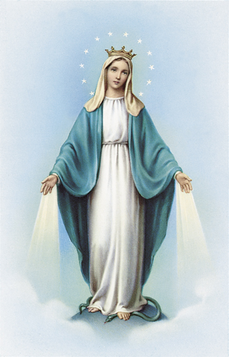
Remember, O most gracious Virgin Mary, that never was it known that anyone who fled to thy protection, implored thy help, or sought thy intercession was left unaided. Inspired by this confidence, I fly unto thee, O Virgin of virgins, my Mother. To thee do I come, before thee I stand, sinful and sorrowful. O Mother of the Word Incarnate, despise not my petitions, but in thy mercy, hear and answer me. Amen.

https://aleteia.org/

