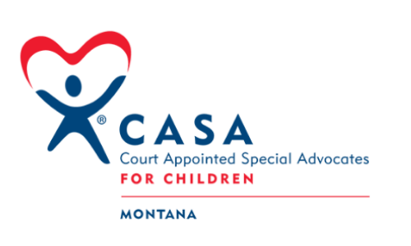
Montana Legislative Session 2023
Summary
On behalf of the 16 Montana Local CASA/GAL Programs we represent, MTCASA provided information and education to legislators, child welfare stakeholders and the public regarding the work of CASA and children and families we serve. The CASA network and CASA supporters worked together in our efforts to maintain, support growth and advocate for the wellbeing of children and families in the dependency and neglect court system. Below are highlights of the work accomplished by MTCASA and the CASA Network during the 2023 Montana Legislative Session.
Issues Addressed by MTCASA
CASA Standing in the Court Room
SB 180: A bill for an act to generally revise related to court appointed special advocates. (Died In Process)
We were able to support the defeat of this bill that would have made CASA optional in dependency and neglect courtrooms by changing the original phrase “shall appoint” to “may appoint”. This bill was specific to the Montana Code governing CASA in our state. We specifically testified requesting that the original language stay intact.
Funding Support for Growth and Expansion of CASA services to Children in Montana
HB 2: A BILL FOR AN ACT ENTITLED: "AN ACT APPROPRIATING MONEY TO VARIOUS STATE AGENCIES FOR THE BIENNIUM ENDING JUNE 30, 2025; AND PROVIDING AN EFFECTIVE 6 DATE." (Enacted)
We were successful in our efforts to obtain 1 million dollars in TANF funds for MTCASA and all Montana CASA Local Programs. This was done with the support of Rep. Mary Caferro in the Joint Appropriations Committee. MTCASA provided written testimony and information regarding use of funds. MTCASA will receive $500,000 in 2023 and $500,000 in 2024 to grow and expand CASA in local programs and where CASA does not currently exist.
CASA’s Access To Information and Ability to Fully Advocate for Children
HB 37: A large bill containing several revisions to child abuse and neglect laws including-Warrants for Removals, Revising Definitions for Child Abuse and Neglect, Revising the Timeframe for EPS Hearings, and Requirements for Case Dismissals (Vetoed by the Governor and Veto Override was Unsuccessful
Early in the session this bill would have restricted CASA’s access to records if a parent, child or guardian did not agree with CASA’s access. We were successful in having this bill amended. In addition to CASA public testimony, Rep. Laurie Bishop was critical in putting forth the amendment in the House Judicial Committee.
Future Partnerships With Childrens’ Attorneys
SB 148: Child’s Right to Council (attorneys for every child) (Enacted)
Sponsored by Senator Dennis Lenz, every child in a dependency and neglect proceeding shall be assigned an attorney.
Having a Voice for Children in the Dependency and Neglect Court System and Its Impact on Children
SB 182: Create a Task Force on a Court System for Dependency and Neglect Cases (Enacted)
Sponsored by Senator Dennis Lenz, the standing committee will begin meeting soon. CASA hopes to have a seat at this table and has reached out to the Governor’s office requesting an assignment. We requested that the bill be amended to include more opportunities for CASA to participate in this task force and were successful in that an amendment was made to include sub work groups. If not appointed by the Governor, we hope to participate in this way.
A CASA For Every Child In Need
SB 318: Revise Laws re: Appointment of Guardian ad litem (Died in Process)
Sponsored by Senator Ellie Boldman, the intent of the bill was to guarantee CASAs in courtrooms where CASAs do not currently exist in lieu of paid guardians. MTCASA participated as an informational witness.
HB 317: The Montana Indian Child Welfare Act (Enacted)
The bill is meant to strengthen protections under the federal ICWA law, which was recently upheld by the U.S. Supreme Court.


The Work Continues-Share Your Voice
The Montana CASA network continues to work on behalf of all CASA programs and the children and families we serve through ongoing legislative and statewide stakeholders and partnership efforts. The MTCASA Legislative Task Force is guided by the MTCASA Legislative Criteria, Strategic Plan and continual partnerships with the local programs we serve. The Task Force meets year-round as the work that we do requires continual engagements, projects and awareness outreach.
We welcome ALL VOICES. Please join us in advocating for children and families. Reach out to our MTCASA office to find out how you may be able to help: aprils@montanacasagal.org, maggiej@montanacasagal.org, 406-461-2111

