WOMEN’S RETREAT
Radiant
Life has natural bright moments. Think of how we might call a bride on her wedding day radiant. The Holy Family are depicted with haloes;
a bright star guides the Magi.
Then there are life’s dark moments: tragedies, cruelties, family dysfunctions. The marriage vows list them as poverty, sickness and death. Enduring love moves through these. When it does, there is light in the darkness. Light flows through the wounds of the Crucified One and from the wounded hearts of Jesus and Mary.
Join the women of Christ the King for a Lenten retreat
through the joys and sorrows of our own lives.

FRIDAY MARCH 8: 6 PM – 9 PM SATURDAY MARCH 9: 9 AM – 5 PM
prESENTER: Fr. Nathan Castle, OP
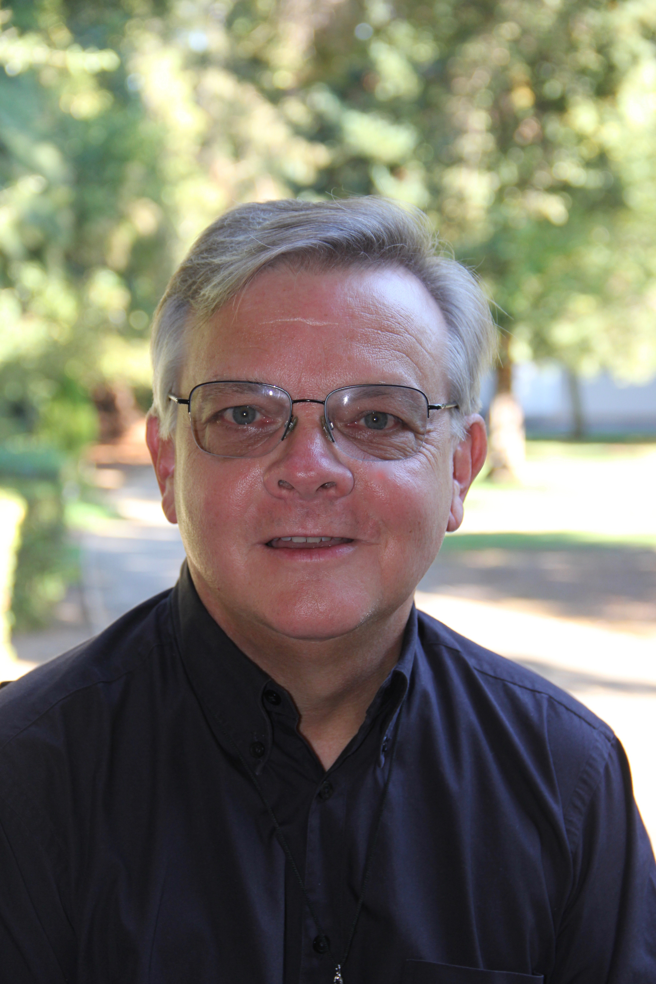
St. Stephen Church
1101 Keaveny Ct. Walnut Creek
PARISH HALL

Suggested free will offering $25.

Please sign up with name & contact info & purchase tickets at:
St. Stephen Parish Office or
Christ the King Parish Office

