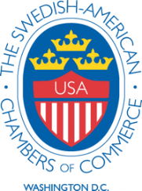

BALLOT & PROXY 2026 – SACC WASHINGTON DC

I am unable to attend the Annual Meeting of the Swedish-American Chamber of Commerce of
Washington, DC, Inc. on January 22, 2026. In accordance with the bylaws, I hereby designate _____________________________________ as a proxy to cast my vote for the election of Directors of the Board as indicated below.

Nominations for Directors of the Board (Two-Year Term 2026-2028)
Nominees | For | Against
Jesica Lindgren (re-election); Chair
Dorothy Hildebrandt (re-election); President and Membership Chair
Sofia Hassander (re-election); Secretary
Magnus Larsson (re-election); Treasurer
Jim Creevy (re-election); Golf Committee Chair
Jim Solyst (re-election); Program Committee Chair
Christer Bergman (re-election)
Peter Borsos (election)
Magnus Carlsson (re-election)
Douglas Faulkner (re-election)
Magnus Friberg (re-election)
Tomas Hagström (election)
Dave McCarthy (election)

Additional Nominations:
Name: Affiliation: Telephone:

__________________________________________________________________________

Signature of Member________________________________________
_________________________________________________________________________
Print Name Date
The Swedish-American Chamber of Commerce of Washington, DC, Inc.
House of Sweden, Suite 402
2900 K St NW, Washington, DC 20007

