2019 KAB/MBA
Sports Seminar
May 7 (1pm start time)
Sporting Kansas City
Children’s Mercy Park
(park in plaza on west side)

SCHEDULE

12:30 – 1:00PM Registration
1:00 – 1:15PM Welcome, Introductions and
Presentation of Hod Humiston Award
Kent Cornish, KAB President
Mark Gordon, MBA President
1:15 – 2:50PM Round Tables (some are tentative)
- Play-by-Play Critiques –(bring samples on laptop/IPad) Tom Hedrick, Rocky Downing – KCLY FM

- Producing a Sports Talk Show – Jake Lebahn, Dan Lucero – WIBW AM

- Jayhawk Radio Network – Brian Hanni

- K-State Sports Network – Wyatt Thompson, Stan Weber

- Learfield Sports Network – Danielle Brower, Ben Connelly, Matt Winegardner, Bob Ramsey

- Kansas City Chiefs Radio Network – Dan Israel, Kendall Gammon

- Sports Promotions – Matt Schulte, Kansas City Royals

- Selling Sports for Radio – Mark Miller - Entercom Radio

- Kansas Shrine Bowl – B.J. Harris

- Sporting Kansas City – Nate Bukaty

- KSHSAA – Bill Faflick, Jeremy Holaday

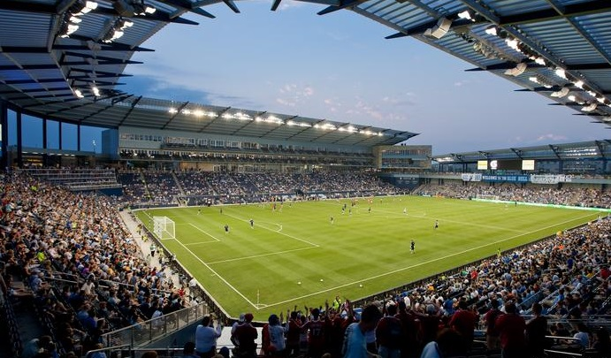

3:00 – 3:45PM SKC Staff and Announcers

3:45 – 4:30PM Tour Children’s Mercy Park

A special thanks to Selena Corpus for her hard work in assisting us to put this great seminar together!

Registration Information
2019 KAB/MBA Sports Seminar
Tuesday, May 7 (Start Time of 1:00PM)

214 SW 6th St, Suite 300 Topeka KS 66603
(785) 235-1307 * FAX (785) 233-3052
kent@kab.net

Registration Fees:
KAB Members: $10 per person
Non-members: $15 per person
- - - - - - - - - - - - - - - - - - - - - - - - - - - - - - - - - - - - - - - - - - - - - - - - - - - - - - - - - - - - - -
Registration Form/ 2019 KAB/MBA Sports Seminar
Please return with payment to KAB by MAY 2
(We accept check or you can phone in a credit card)

Station(s) _________________ City_______________ Contact Person ______________________

Tel. (____)__________E-mail: _________________________you’ll receive email confirmation of registration

Names
_______________________________ _______________________________

_______________________________ ______________________________

_______________________________ ______________________________

_______________________________ ______________________________

_______________________________ ______________________________

_______________________________ ______________________________

