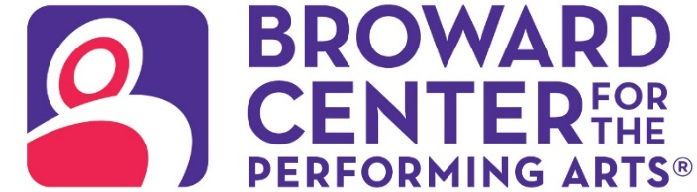

May 31, 2024
Media Contacts:
Carlos Goycochea
cgoycochea@piersongrant.com
Jasmine Souverein, 954-776-1999 ext. 234
jsouverein@piersongrant.com
Jan Goodheart, Broward Center
jgoodheart@browardcenter.org

HITS ON FIFTH TO DAZZLE AUDIENCES
Broward Center’s Arts Access performance supports Heart Sista Inc.

FORT LAUDERDALE – Hair in the Spirit Inc. presents HITS on Fifth, an annual charity performance which this year supports Heart Sista Inc., in the Amaturo Theater at the Broward Center for the Performing Arts on Saturday, August 17 at 7:30 p.m. as part of the Broward Center’s Arts Access program.
The synergy of artistic expression is on display in this captivating showcase of dance, spoken word, jazz and haute couture, where every step, word and design contribute to a greater cause, Heart Sista, which is committed to providing essential tools and resources for women who have experienced heart attacks and strokes, helping them on their journey to recovery.
Audiences will delight in this multifaceted performance. Professional dancers performing ballet and contemporary dance routines bring talent, grace and emotion to the stage that’s choreographed by Radical Change Production, ensuring a seamless and dynamic presentation that will leave a lasting impression. Sponsored by All Dolled Up Salons and Stores, the high-energy fashion show features cutting-edge hairstyles and the latest in fashion trends, demonstrating the creative artistry of top stylists and designers. Renowned poet Jasmine Green will captivate the audience with her powerful and moving spoken word performance, addressing themes of resilience and empowerment. The evening’s festivities will be accompanied by the soulful sounds of a well-known saxophonist, adding a touch of musical elegance.
"We are honored to host this event to support Heart Sista," said Faye Bailey-Lucas, founder of Hair in the Spirit, Inc. "Our goal is to raise awareness and funds to help women who have suffered heart attacks and strokes. The support from our community, and the incredible talent involved in this event will make a significant impact."
HITS on Fifth is presented as part of the Broward Center’s Arts Access Program, which assists community-based organizations in presenting arts and cultural performances at the Broward Center. The program provides technical assistance and marketing support to local community groups enabling them to develop and build their audiences.

Ticketmaster is the only official ticketing service of the Broward Center and The Parker. Buy tickets online at BrowardCenter.org, or Ticketmaster.com; by phone at 954.462.0222; in person at the Broward Center’s AutoNation Box Office.

The Broward Center for the Performing Arts is located at 201 SW Fifth Ave. in Fort Lauderdale. For more information visit BrowardCenter.org, like us on Facebook at Facebook.com/BrowardCenter and Facebook.com/BrowardCenterEducation, follow us on Twitter and Instagram @BrowardCenter, subscribe to our channel at YouTube.com/user/BrowardCenter and join the conversation with #BrowardCenter.
The Broward Center 2023/2024 season is supported by the Broward Performing Arts Foundation. AutoNation, Greater Fort Lauderdale Convention & Visitors Bureau, Spirit and UHealth University of Miami Health System. Programs are also sponsored in part by the State of Florida through the Division of Arts and Culture and the National Endowment for the Arts.

  - About The Broward Center for the Performing Arts
One of America’s premier performing arts venues, the Broward Center for the Performing Arts presents more than 700 performances each year to more than 700,000 patrons, showcasing a wide range of exciting cultural programming and events. Guest experiences at the Broward Center include the all-inclusive Spirit Club Level and UHealth-University of Miami Health System Intermezzo Lounge, special events in the Huizenga Pavilion, waterfront dining at Marti’s New River Bistro and innovative classes and workshops for all ages at the Rose Miniaci Arts Education Center. With one of the largest arts-in-education programs in the United States, the Broward Center serves more than 100,000 students annually. The Broward Center for the Performing Arts is located at 201 SW Fifth Ave. in Fort Lauderdale. For more information, visit BrowardCenter.org.

###

